Netwerken III

Samenvatting

Gilles De Praeter

Contents

14 - Routing Concepts 4

14.1 - Path Determination 4

14.2 - Packet Forwarding 6

14.3 - Basic Router Configuration Review 9

14.4 - IP Routing Table 9

14.5 - Static and Dynamic Routing 14

15 - IP Static Routing 18

15.1 - Static Routes 18

15.2 - Configure IP Static Routes 19

15.3 - Configure IP Default Static Routes 23

15.4 - Configure Floating Static Routes 24

15.5 - Configure Static Host Routes 26

16 - Troubleshoot Static and Default Routes 28

16.1 - Packet Processing with Static Routes 28

16.2 - Troubleshoot IPv4 Static and Default Route Configuration 29

1 - Single-Area OSPFv2 Concepts 30

1.1 - OSPF Features and Characteristics 30

1.2 - OSPF Packets 34

1.3 - OSPF Operation 36

2 - Single-Area OSPFv2 Configuration 43

2.1 - OSPF Router ID 43

2.2 - Point-to-Point OSPF Networks 46

2.3 - Multiaccess OSPF Networks 49

2.4 - Modify Single-Area OSPFv2 53

2.5 - Default Route Propagation 58

2.6 - Verify Single-Area OSPFv2 59

4 - ACL Concepts 61

4.1 - Purpose of ACLs 61

4.2 - Wildcard Masks in ACLs 62

4.3 - Guidelines for ACL Creation 65

4.4 - Types of IPv4 ACLs 66

5 - ACLs for IPv4 Configuration 68

5.1 - Configure Standard IPv4 ACLs 68

5.2 - Modify IPv4 ACLs 69

5.3 - Secure VTY Ports with a Standard IPv4 ACL 72

5.4 - Configure Extended IPv4 ACLs 72

6 - NAT for IPv4 80

6.1 - NAT Characteristics 80

6.2 - Types of NAT 82

6.3 - NAT Advantages and Disadvantages 86

6.4 - Static NAT 87

6.5 - Dynamic NAT 89

6.6 – PAT 92

6.7 - NAT64 94

# 14 - Routing Concepts

## 14.1 - Path Determination

* Ethernet switches are used to connect end devices and other intermediary devices, such as other Ethernet switches, to the same network.
* A router connects multiple networks, which means that it has multiple interfaces that each belong to a different IP network.
* When a router receives an IP packet on one interface, it determines which interface to use to forward the packet to the destination. This is known as routing.
  + The interface that the router uses to forward the packet may be the final destination, or it may be a network connected to another router that is used to reach the destination network. Each network that a router connects to typically requires a separate interface, but this may not always be the case.
* The primary functions of a router are to determine the best path to forward packets based on the information in its routing table, and to forward packets toward their destination.
* The router uses its IP routing table to determine which path (route) to use to forward a packet.
* The best path in the routing table is also known as the longest match.
  + The longest match is a process the router uses to find a match between the destination IP address of the packet and a routing entry in the routing table.
* The routing table contains route entries consisting of a prefix (network address) and prefix length. For there to be a match between the destination IP address of a packet and a route in the routing table, a minimum number of far-left bits must match between the IP address of the packet and the route in the routing table. The prefix length of the route in the routing table is used to determine the minimum number of far-left bits that must match. Remember that an IP packet only contains the destination IP address and not the prefix length.
* The longest match is the route in the routing table that has the greatest number of far-left matching bits with the destination IP address of the packet. The route with the greatest number of equivalent far-left bits, or the longest match, is always the preferred route.
* Example IPv4;
  + In the table, an IPv4 packet has the destination IPv4 address 172.16.0.10. The router has three route entries in its IPv4 routing table that match this packet: 172.16.0.0/12, 172.16.0.0/18, and 172.16.0.0/26. Of the three routes, 172.16.0.0/26 has the longest match and would be chosen to forward the packet. Remember, for any of these routes to be considered a match there must be at least the number of matching bits indicated by the subnet mask of the route.

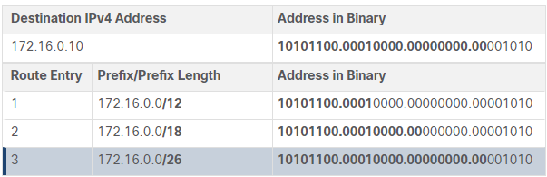

* Example IPv6:
  + For the destination IPv6 packet with the address 2001:db8:c000::99, consider the following three route entries:

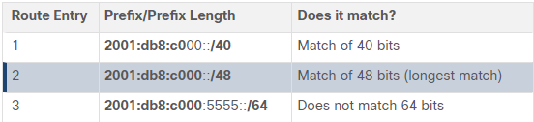

* A routing table consists of prefixes and their prefix lengths.
  + Directly connected networks are networks that are configured on the active interfaces of a router. A directly connected network is added to the routing table when an interface is configured with an IP address and subnet mask (prefix length) and is active (up and up).
  + Remote networks are networks that are not directly connected to the router. Routers learn about remote networks in two ways:
    - Static routes - Added to the routing table when a route is manually configured.
    - Dynamic routing protocols - Added to the routing table when routing protocols dynamically learn about the remote network. Dynamic routing protocols include Enhanced Interior Gateway Routing Protocol (EIGRP), Open Shortest Path First (OSPF), as well as several others.
  + A default route specifies a next-hop router to use when the routing table does not contain a specific route that matches the destination IP address. The default route can be entered manually as a static route or learned automatically from a dynamic routing protocol.
    - A default route over IPv4 has a route entry of 0.0.0.0/0 and a default route over IPv6 has a route entry of ::/0. The /0 prefix length indicates that zero bits or no bits need to match the destination IP address for this route entry to be used. If there are no routes with a longer match, more than 0 bits, then the default route is used to forward the packet. The default route is sometimes referred to as a gateway of last resort.

## 14.2 - Packet Forwarding

* Packet forwarding decision process

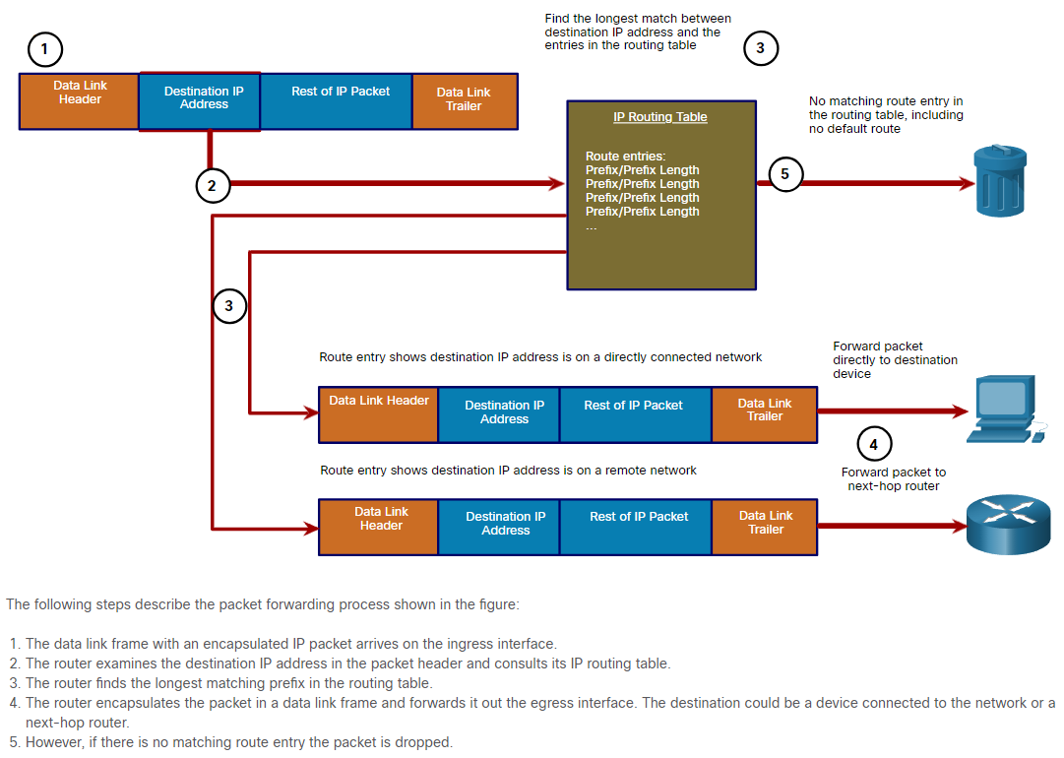

* Forwards the Packet to a Device on a Directly Connected Network
  + If the route entry indicates that the egress interface is a directly connected network, this means that the destination IP address of the packet belongs to a device on the directly connected network. Therefore, the packet can be forwarded directly to the destination device. The destination device is typically an end device on an Ethernet LAN, which means the packet must be encapsulated in an Ethernet frame.
  + To encapsulate the packet in the Ethernet frame, the router needs to determine the destination MAC address associated with the destination IP address of the packet. The process varies based on whether the packet is an IPv4 or IPv6 packet:
    - IPv4 packet - The router checks its ARP table for the destination IPv4 address and an associated Ethernet MAC address. If there is no match, the router sends an ARP Request. The destination device will return an ARP Reply with its MAC address. The router can now forward the IPv4 packet in an Ethernet frame with the proper destination MAC address.
    - IPv6 packet - The router checks its neighbor cache for the destination IPv6 address and an associated Ethernet MAC address. If there is no match, the router sends an ICMPv6 Neighbor Solicitation (NS) message. The destination device will return an ICMPv6 Neighbor Advertisement (NA) message with its MAC address. The router can now forward the IPv6 packet in an Ethernet frame with the proper destination MAC address.
* Forwards the Packet to a Next-Hop Router
  + If the route entry indicates that the destination IP address is on a remote network, this means the destination IP address of the packet belongs to a device on network that is not directly connected. Therefore, the packet must be forwarded to another router, specifically a next-hop router. The next-hop address is indicated in the route entry.
  + If the forwarding router and the next-hop router are on an Ethernet network, a similar process (ARP and ICMPv6 Neighbor Discovery) will occur for determining the destination MAC address of the packet as described previously. The difference is that the router will search for the IP address of the next-hop router in its ARP table or neighbor cache, instead of the destination IP address of the packet.
  + Note: This process will vary for other types of Layer 2 networks.
* Drops the Packet - No Match in Routing Table
  + If there is no match between the destination IP address and a prefix in the routing table, and if there is no default route, the packet will be dropped.
* The primary responsibility of the packet forwarding function is to encapsulate packets in the appropriate data link frame type for the outgoing interface. The more efficiently a router can perform this task, the faster packets can be forwarded by the router. Routers support the following three packet forwarding mechanisms:
  + Process switching:
    - An older packet forwarding mechanism still available for Cisco routers. When a packet arrives on an interface, it is forwarded to the control plane where the CPU matches the destination address with an entry in its routing table, and then determines the exit interface and forwards the packet. It is important to understand that the router does this for every packet, even if the destination is the same for a stream of packets. This process-switching mechanism is very slow and is rarely implemented in modern networks.

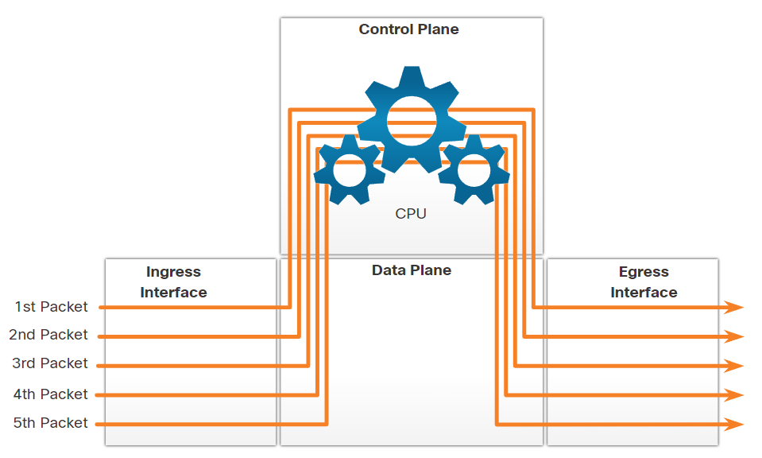

* + Fast switching:
    - Fast switching is another, older packet forwarding mechanism which was the successor to process switching. Fast switching uses a fast-switching cache to store next-hop information. When a packet arrives on an interface, it is forwarded to the control plane where the CPU searches for a match in the fast-switching cache. If it is not there, it is process-switched and forwarded to the exit interface. The flow information for the packet is also stored in the fast-switching cache. If another packet going to the same destination arrives on an interface, the next-hop information in the cache is re-used without CPU intervention.

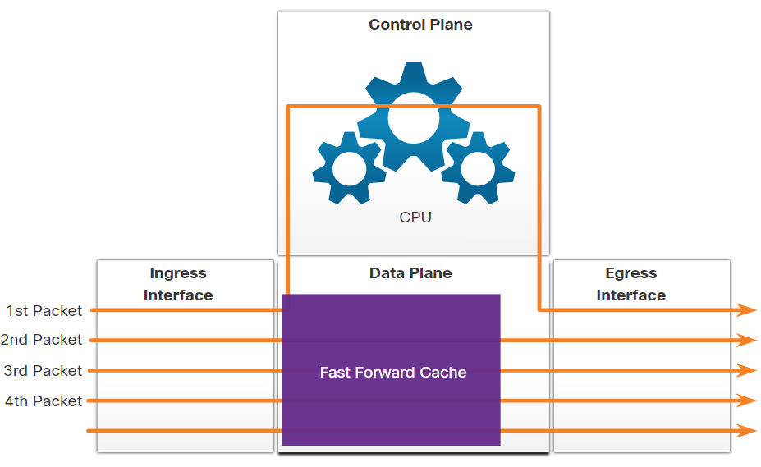

* + Cisco Express Forwarding (CEF):
    - CEF is the most recent and default Cisco IOS packet-forwarding mechanism. Like fast switching, CEF builds a Forwarding Information Base (FIB), and an adjacency table. However, the table entries are not packet-triggered like fast switching but change-triggered, such as when something changes in the network topology. Therefore, when a network has converged, the FIB and adjacency tables contain all the information that a router would have to consider when forwarding a packet. Cisco Express Forwarding is the fastest forwarding mechanism and the default on Cisco routers and multilayer switches.
    - CEF builds the FIB and adjacency tables after the network has converged. All five packets are quickly processed in the data plane.

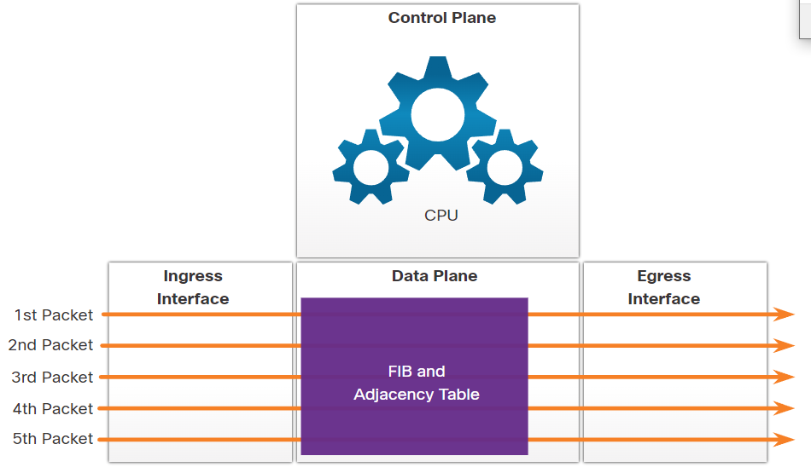

* A common analogy used to describe these three different packet-forwarding mechanisms is as follows:
  + Process switching solves a problem by doing math long hand, even if it is the identical problem that was just solved.
  + Fast switching solves a problem by doing math long hand one time and remembering the answer for subsequent identical problems.
  + CEF solves every possible problem ahead of time in a spreadsheet.

## 14.3 - Basic Router Configuration Review

* See Packet Tracer or Netacad

## 14.4 - IP Routing Table

* The sources for each route are identified by a code. The code identifies how the route was learned. For instance, common codes include the following:
  + L - Identifies the address assigned to a router interface. This allows the router to efficiently determine when it receives a packet for the interface instead of being forwarded.
  + C - Identifies a directly connected network.
  + S - Identifies a static route created to reach a specific network.
  + O - Identifies a dynamically learned network from another router using the OSPF routing protocol.
  + * - This route is a candidate for a default route.
* Routing table principles:

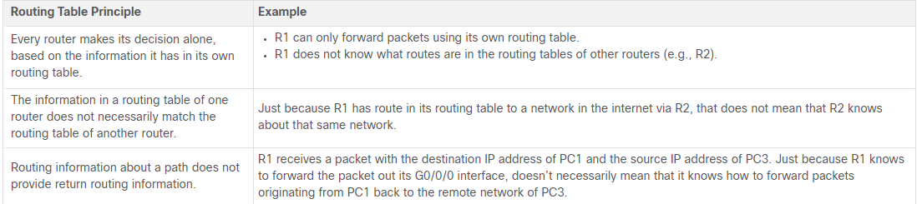

* Directly Connected Networks:
  + Before a router can learn about any remote networks, it must have at least one active interface configured with an IP address and subnet mask (prefix length). This is known as a directly connected network or a directly connected route. Routers add a directly connected route to its routing table when an interface is configured with an IP address and is activated.
  + A directly connected network is denoted by a status code of C in the routing table. The route contains a network prefix and prefix length.
  + The routing table also contains a local route for each of its directly connected networks, indicated by the status code of L. This is the IP address that is assigned to the interface on that directly connected network. For IPv4 local routes the prefix length is /32 and for IPv6 local routes the prefix length is /128. This means the destination IP address of the packet must match all the bits in the local route for this route to be a match. The purpose of the local route is to efficiently determine when it receives a packet for the interface instead of a packet that needs to be forwarded.
* Static Routes
  + After directly connected interfaces are configured and added to the routing table, static or dynamic routing can be implemented for accessing remote networks.
  + Static routes are manually configured. They define an explicit path between two networking devices. Unlike a dynamic routing protocol, static routes are not automatically updated and must be manually reconfigured if the network topology changes. The benefits of using static routes include improved security and resource efficiency. Static routes use less bandwidth than dynamic routing protocols, and no CPU cycles are used to calculate and communicate routes. The main disadvantage to using static routes is the lack of automatic reconfiguration if the network topology changes.
  + Static routing has three primary uses:
    - It provides ease of routing table maintenance in smaller networks that are not expected to grow significantly.
    - It uses a single default route to represent a path to any network that does not have a more specific match with another route in the routing table. Default routes are used to send traffic to any destination beyond the next upstream router.
    - It routes to and from stub networks. A stub network is a network accessed by a single route, and the router has only one neighbor.

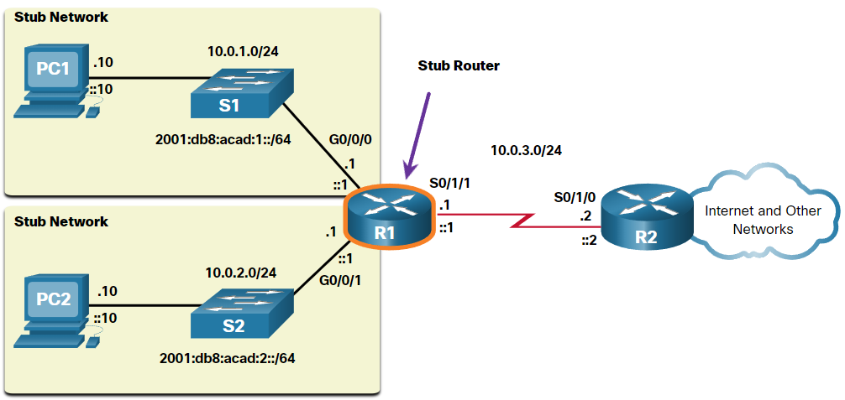

* + In this example, a static route can be configured on R2 to reach the R1 networks. Additionally, because R1 has only one way to send out non-local traffic, a default static route can be configured on R1 to point to R2 as the next hop for all other networks.
* Static Routes in the IP routing table

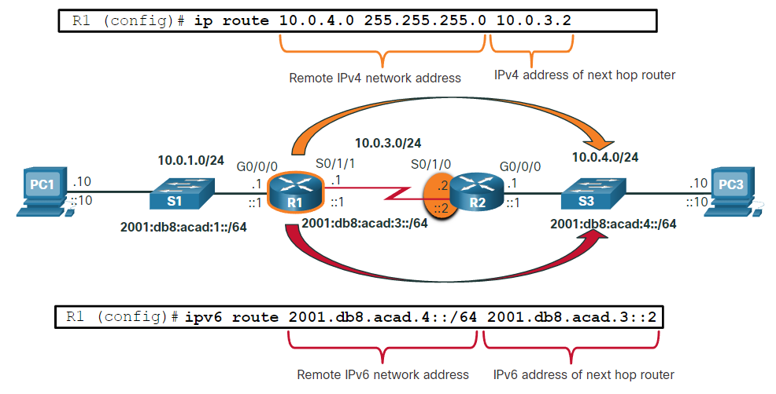

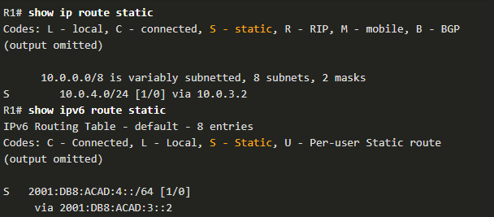

* Dynamic Routing Protocols
  + Dynamic routing protocols are used by routers to automatically share information about the reachability and status of remote networks.
  + Dynamic routing protocols perform several activities, including network discovery and maintaining routing tables.
  + Important advantages of dynamic routing protocols are the ability to select a best path, and the ability to automatically discover a new best path when there is a change in the topology.
  + Network discovery is the ability of a routing protocol to share information about the networks that it knows about with other routers that are also using the same routing protocol. Instead of depending on manually configured static routes to remote networks on every router, a dynamic routing protocol allows the routers to automatically learn about these networks from other routers. These networks, and the best path to each, are added to the routing table of the router, and identified as a network learned by a specific dynamic routing protocol.
* Dynamic Routing in the IP routing table

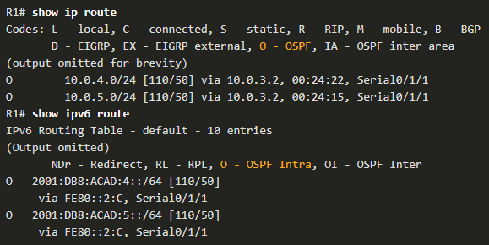

* + Note: IPv6 routing protocols use the link-local address of the next-hop router.
  + Note: OSPF routing configuration for IPv4 and IPv6 is beyond the scope of this course.
* Default Route
  + A default route is similar to a default gateway on a host. The default route specifies a next-hop router to use when the routing table does not contain a specific route that matches the destination IP address.
  + A default route can be either a static route or learned automatically from a dynamic routing protocol. A default route has an IPv4 route entry of 0.0.0.0/0 or an IPv6 route entry of ::/0. This means that zero or no bits need to match between the destination IP address and the default route.
  + Most enterprise routers have a default route in their routing table. This is to reduce the number of routes in a routing table.
  + A router, such as a home or small office router that only has one LAN, may reach all its remote networks through a default route. This is useful when the router has only directly connected networks and one exit point to a service provider router.

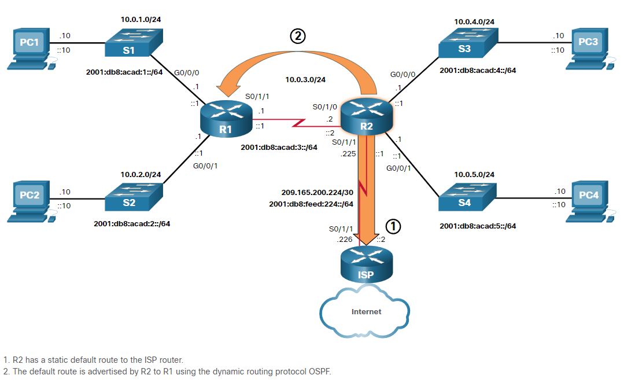

* + R2 has shared its default route with R1 using OSPF. R1 will now have a default route in its routing table that it learned dynamically from OSPF. R1 will also forward any packets with a destination IP address that does not specifically match one of the networks in its routing table to R2
* Structure of an IPv4 Routing Table
  + IPv4 was standardized in the early 1980s using the now obsolete classful addressing architecture. The IPv4 routing table is organized using this same classful structure. In the show ip route output, notice that some route entries are left justified while others are indented. This is based on how the routing process searches the IPv4 routing table for the longest match. This was all because of classful addressing. Although the lookup process no longer uses classes, the structure of the IPv4 routing table still retains in this format.

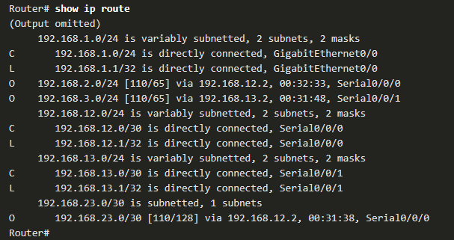

* + An indented entry is known as a child route. A route entry is indented if it is the subnet of a classful address (class A, B or C network). Directly connected networks will always be indented (child routes) because the local address of the interface is always entered in the routing table as a /32. The child route will include the route source and all the forwarding information such as the next-hop address. The classful network address of this subnet will be shown above the route entry, less indented, and without a source code. That route is known as a parent route.
* Structure of an IPv6 Routing Table
  + Every IPv6 route entry is formatted and aligned the same way.

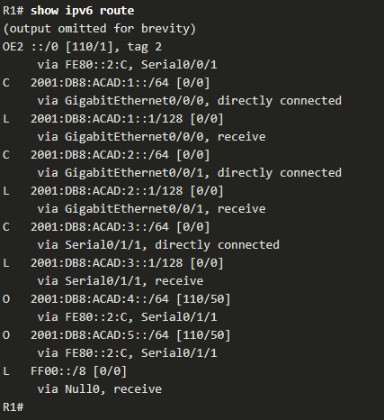

* Administrative Distance
  + A route entry for a specific network address (prefix and prefix length) can only appear once in the routing table. However, it is possible that the routing table learns about the same network address from more than one routing source.
  + Except for very specific circumstances, only one dynamic routing protocol should be implemented on a router. However, it is possible to configure both OSPF and EIGRP on a router, and both routing protocols may learn of the same destination network. Each routing protocol may decide on a different path to reach the destination based on the metric of that routing protocol.
  + This raises a few questions, such as the following:
  + How does the router know which source to use?
  + Which route should it install in the routing table? The route learned from OSPF, or the route learned from EIGRP?
  + Cisco IOS uses what is known as the administrative distance (AD) to determine the route to install into the IP routing table. The AD represents the "trustworthiness" of the route. The lower the AD, the more trustworthy the route source. Because EIGRP has an AD of 90 and OSPF has an AD of 110, the EIGRP route entry would be installed in the routing table.
  + Note: The AD does not necessarily represent which dynamic routing protocol is best.
  + A more common example is a router learning the same network address from a static route and a dynamic routing protocol, such as OSPF. A static route has an AD of 1, whereas an OSPF-discovered route has an AD of 110. Given two separate route sources to the same destination, the router chooses to install the route with the lowest AD. When a router has the choice of a static route and an OSPF route, the static route takes precedence.

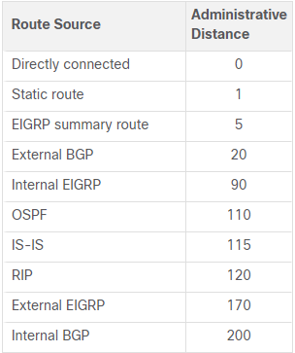

## 14.5 - Static and Dynamic Routing

* Should you use static or dynamic routing? The answer is both! Static and dynamic routing are not mutually exclusive. Rather, most networks use a combination of dynamic routing protocols and static routes.
* Static routes are commonly used in the following scenarios:
  + As a default route forwarding packets to a service provider
  + For routes outside the routing domain and not learned by the dynamic routing protocol
  + When the network administrator wants to explicitly define the path for a specific network
  + For routing between stub networks
* Static routes are useful for smaller networks with only one path to an outside network. They also provide security in a larger network for certain types of traffic, or links to other networks that need more control.
* Dynamic routing protocols are commonly used in the following scenarios:
  + In networks consisting of more than just a few routers
  + When a change in the network topology requires the network to automatically determine another path
  + For scalability. As the network grows, the dynamic routing protocol automatically learns about any new networks.

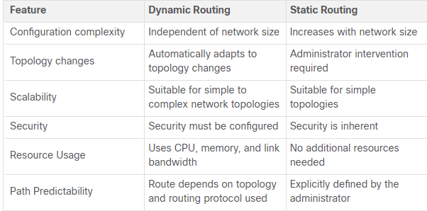

* Dynamic routing protocols have been used in networks since the late 1980s. One of the first routing protocols was RIP. RIPv1 was released in 1988, but some of the basic algorithms within the protocol were used on the Advanced Research Projects Agency Network (ARPANET) as early as 1969.
* As networks evolved and became more complex, new routing protocols emerged. The RIP protocol was updated to RIPv2 to accommodate growth in the network environment. However, RIPv2 still does not scale to the larger network implementations of today. To address the needs of larger networks, two advanced routing protocols were developed: OSPF and Intermediate System-to-Intermediate System (IS-IS). Cisco developed the Interior Gateway Routing Protocol (IGRP), which was later replaced by Enhanced IGRP (EIGRP), which also scales well in larger network implementations.
* Additionally, there was the need to connect the different routing domains of different organizations and provide routing between them. The Border Gateway Protocol (BGP), the successor of Exterior Gateway Protocol (EGP) is used between Internet Service Providers (ISPs). BGP is also used between ISPs and some private organizations to exchange routing information.

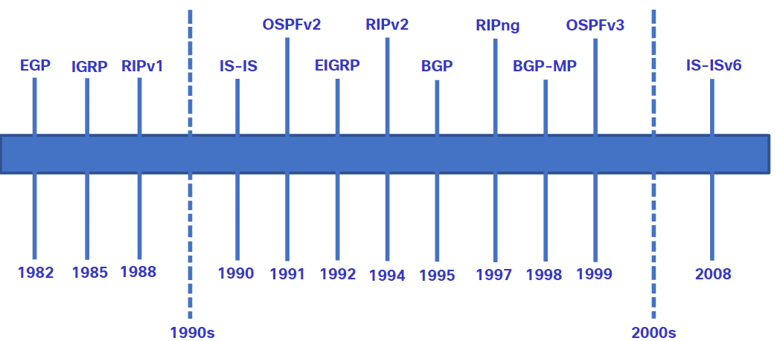

* The table classifies the current routing protocols. Interior Gateway Protocols (IGPs) are routing protocols used to exchange routing information within a routing domain administered by a single organization. There is only one EGP and it is BGP. BGP is used to exchange routing information between different organizations, known as autonomous systems (AS). BGP is used by ISPs to route packets over the internet. Distance vector, link-state, and path vector routing protocols refer to the type of routing algorithm used to determine best path.

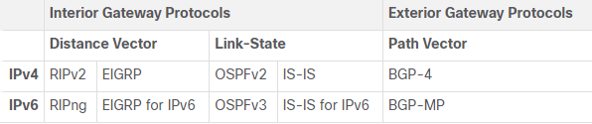

* A routing protocol is a set of processes, algorithms, and messages that are used to exchange routing information and populate the routing table with the choice of best paths. The purpose of dynamic routing protocols includes the following:
  + Discovery of remote networks
  + Maintaining up-to-date routing information
  + Choosing the best path to destination networks
  + Ability to find a new best path if the current path is no longer available
* The main components of dynamic routing protocols include the following:
  + Data structures - Routing protocols typically use tables or databases for their operations. This information is kept in RAM.
  + Routing protocol messages - Routing protocols use various types of messages to discover neighboring routers, exchange routing information, and other tasks to learn and maintain accurate information about the network.
  + Algorithm - An algorithm is a finite list of steps used to accomplish a task. Routing protocols use algorithms for facilitating routing information and for the best path determination.
* Routing protocols determine the best path, or route, to each network. That route is then offered to the routing table. The route will be installed in the routing table if there is not another routing source with a lower AD. A primary benefit of dynamic routing protocols is that routers exchange routing information when there is a topology change. This exchange allows routers to automatically learn about new networks and to find alternate paths when there is a link failure to a current network.
* Before a path to a remote network is offered to the routing table, the dynamic routing protocol must determine the best path to that network. Determining the best path may involve the evaluation of multiple paths to the same destination network and selecting the optimum or shortest path to reach that network. Whenever multiple paths to the same network exist, each path uses a different exit interface on the router to reach that network.
* The best path is selected by a routing protocol based on the value or metric it uses to determine the distance to reach a network. A metric is the quantitative value used to measure the distance to a given network. The best path to a network is the path with the lowest metric.
* Dynamic routing protocols typically use their own rules and metrics to build and update routing tables. The routing algorithm generates a value, or a metric, for each path through the network. Metrics can be based on either a single characteristic or several characteristics of a path. Some routing protocols can base route selection on multiple metrics, combining them into a single metric.

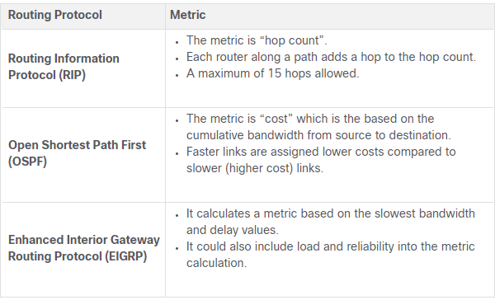

* When a router has two or more paths to a destination with equal cost metrics, then the router forwards the packets using both paths equally. This is called equal cost load balancing. The routing table contains the single destination network, but has multiple exit interfaces, one for each equal cost path. The router forwards packets using the multiple exit interfaces listed in the routing table.
* If configured correctly, load balancing can increase the effectiveness and performance of the network.
* Equal cost load balancing is implemented automatically by dynamic routing protocols. It is enabled with static routes when there are multiple static routes to the same destination network using different next-hop routers.
* Note: Only EIGRP supports unequal cost load balancing.
* Note: In the routing table entry, S 10.2.0.0 [1/0] via 172.16.2.2, the numbers inside the bracket indicate the administrative distance and metric respectively.

# 15 - IP Static Routing

## 15.1 - Static Routes

* Static routes are commonly implemented on a network. This is true even when there is a dynamic routing protocol configured. For instance, an organization could configure a default static route to the service provider and advertise this route to other corporate routers using the dynamic routing protocol.
* Static routes can be configured for IPv4 and IPv6. Both protocols support the following types of static routes:
  + Standard static route
  + Default static route
  + Floating static route
  + Summary static route
* Static routes are configured using the **ip route** and **ipv6 route** global configuration commands.
* The next hop can be identified by an IP address, exit interface, or both. How the destination is specified creates one of the three following types of static route:
  + Next-hop route - Only the next-hop IP address is specified
  + Directly connected static route - Only the router exit interface is specified
  + Fully specified static route - The next-hop IP address and exit interface are specified
* IPv4 static route command:



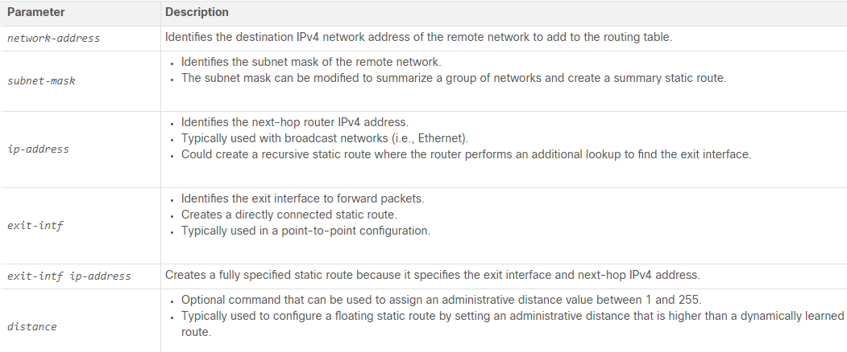

* IPv6 static route command:



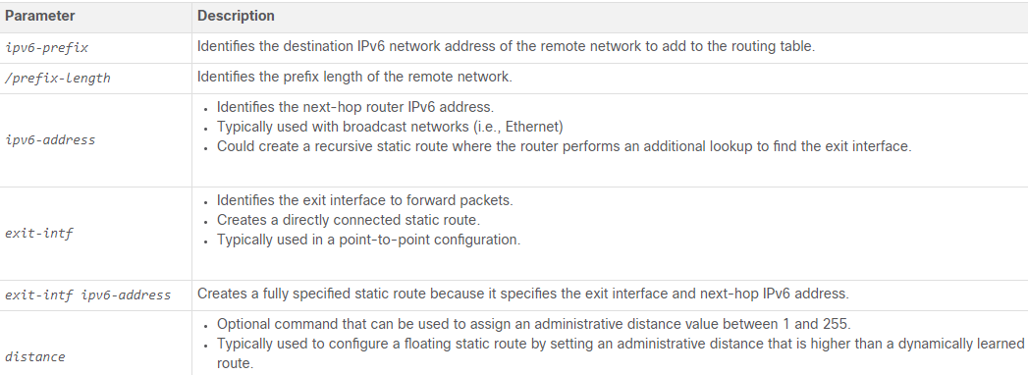

* + Note: The ipv6 unicast-routing global configuration command must be configured to enable the router to forward IPv6 packets.

## 15.2 - Configure IP Static Routes

* IPv4 next-hop static route:
  + In a next-hop static route, only the next-hop IP address is specified. The exit interface is derived from the next hop. For example, three next-hop IPv4 static routes are configured on R1 using the IP address of the next hop, R2.
  + Topology for this entire chapter:

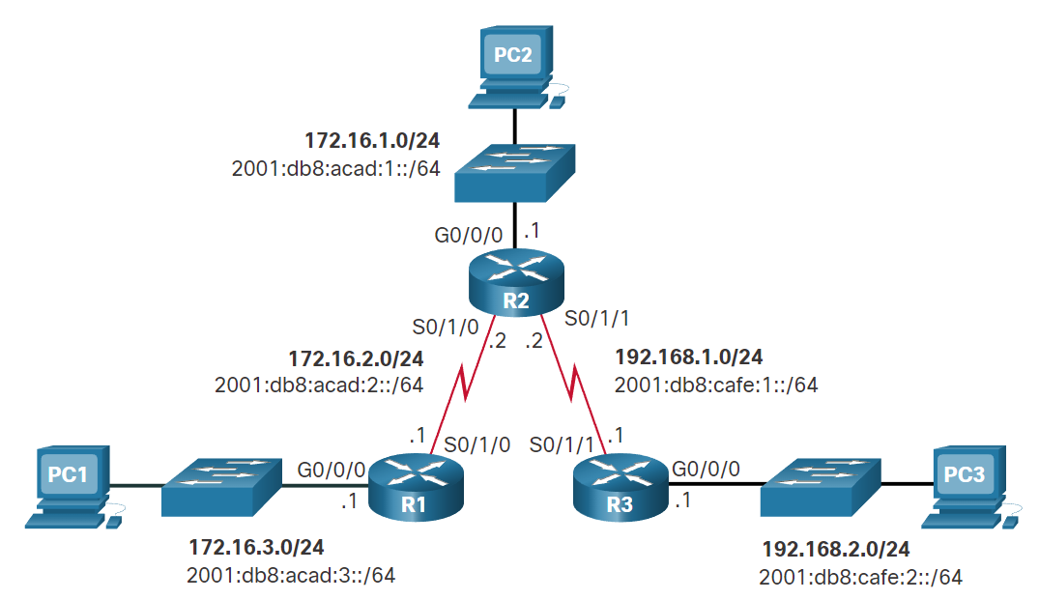

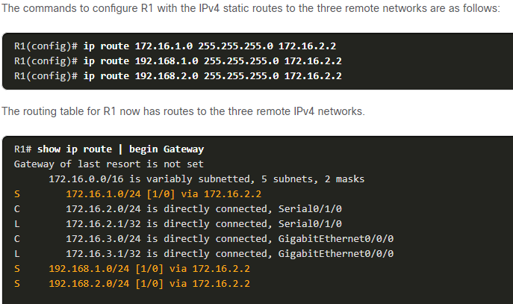

* IPv6 next-hop static route:

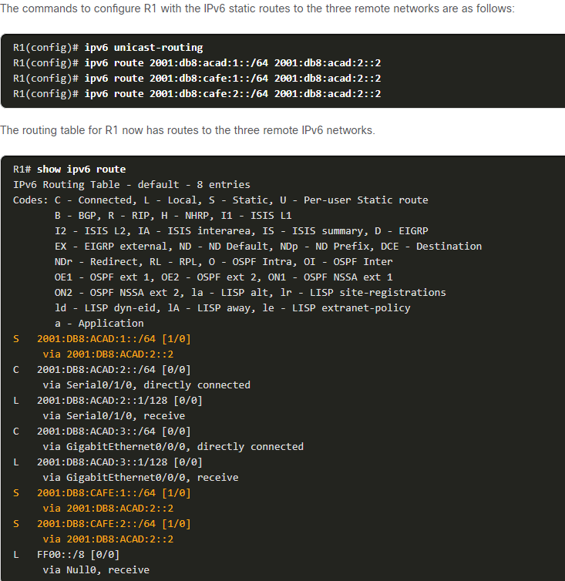

* IPv4 Directly connected static route:
  + When configuring a static route, another option is to use the exit interface to specify the next-hop address.
  + Three directly connected IPv4 static routes are configured on R1 using the exit interface.

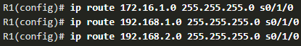

* + The IPv4 routing table for R1 shows that when a packet is destined for the 192.168.2.0/24 network, R1 looks for a match in the routing table, and finds that it can forward the packet out of its Serial 0/1/0 interface.
  + Note: Using a next-hop address is generally recommended. Directly connected static routes should only be used with point-to-point serial interfaces, as in this example.

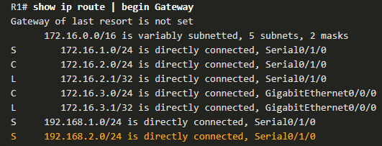

* IPv6 directly connected static route:
  + Three directly connected IPv6 static routes are configured on R1 using the exit interface.

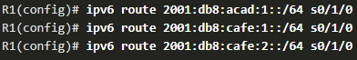

* + The IPv6 routing table for R1 in the example output shows that when a packet is destined for the 2001:db8:cafe:2::/64 network, R1 looks for a match in the routing table and finds that it can forward the packet out of its Serial 0/1/0 interface.
  + Note: Using a next-hop address is generally recommended. Directly connected static routes should only be used with point-to-point serial interfaces, as in this example.

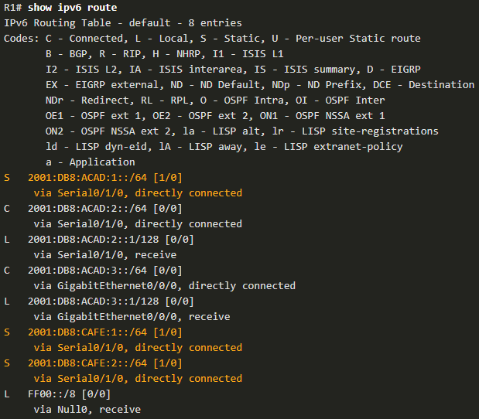

* IPv4 fully specified static route:
  + In a fully specified static route, both the exit interface and the next-hop IP address are specified. This form of static route is used when the exit interface is a multi-access interface and it is necessary to explicitly identify the next hop. The next hop must be directly connected to the specified exit interface. Using an exit interface is optional, however it is necessary to use a next-hop address.
  + Suppose that the network link between R1 and R2 is an Ethernet link and that the GigabitEthernet 0/0/1 interface of R1 is connected to that network, as shown in the figure.

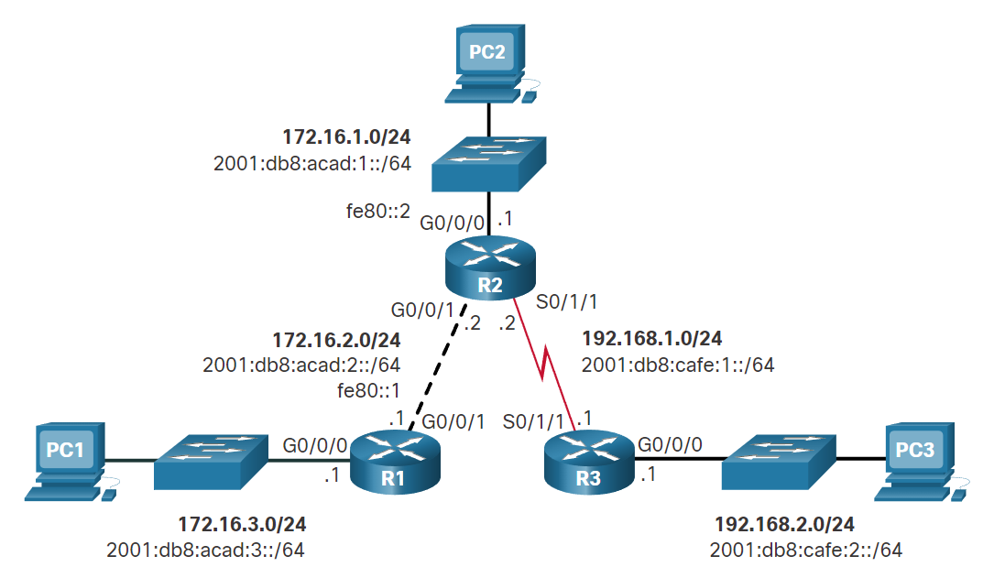

* + The difference between an Ethernet multi-access network and a point-to-point serial network is that a point-to-point serial network has only one other device on that network, the router at the other end of the link. With Ethernet networks, there may be many different devices sharing the same multi-access network, including hosts and even multiple routers.
  + It is recommended that when the exit interface is an Ethernet network, that the static route includes a next-hop address. You can also use a fully specified static route that includes both the exit interface and the next-hop address.

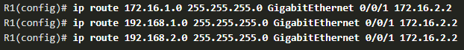

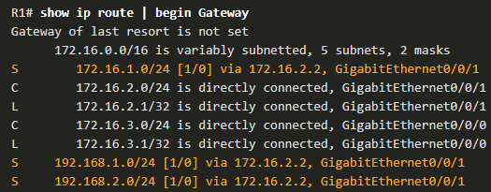

* IPv6 fully specified static route:
  + In a fully specified IPv6 static route, both the exit interface and the next-hop IPv6 address are specified. There is a situation in IPv6 when a fully specified static route must be used. If the IPv6 static route uses an IPv6 link-local address as the next-hop address, use a fully specified static route.

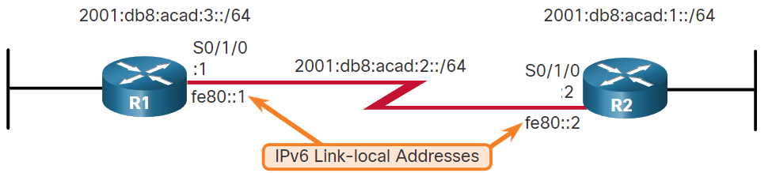

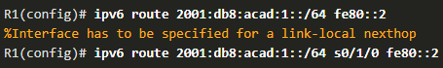

* + The reason a fully specified static route must be used is because IPv6 link-local addresses are not contained in the IPv6 routing table. Link-local addresses are only unique on a given link or network. The next-hop link-local address may be a valid address on multiple networks connected to the router. Therefore, it is necessary that the exit interface be included.

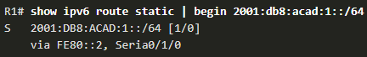

* Verify a static route:
  + Show ip route
  + Ping
  + Traceroute
  + show ip route static
  + show ip route network
  + show running-config | section ip route
  + Replace ip with ipv6 for the IPv6 versions of the command.

## 15.3 - Configure IP Default Static Routes

* A default route is a static route that matches all packets. Instead of routers storing routes for all of the networks in the internet, they can store a single default route to represent any network that is not in the routing table.
* Routers commonly use default routes that are either configured locally or learned from another router, using a dynamic routing protocol. A default route does not require any far-left bits to match between the default route and the destination IP address. A default route is used when no other routes in the routing table match the destination IP address of the packet. In other words, if a more specific match does not exist, then the default route is used as the Gateway of Last Resort.
* Default static routes are commonly used when connecting an edge router to a service provider network, or a stub router (a router with only one upstream neighbor router).
* IPv4 static default route



* IPv6 default static route:



* Example:



* Verify:
  + Show ip route
  + Show ip route static

## 15.4 - Configure Floating Static Routes

* Floating static routes are static routes that are used to provide a backup path to a primary static or dynamic route, in the event of a link failure. The floating static route is only used when the primary route is not available.
  + To accomplish this, the floating static route is configured with a higher administrative distance than the primary route. The administrative distance represents the trustworthiness of a route. If multiple paths to the destination exist, the router will choose the path with the lowest administrative distance.

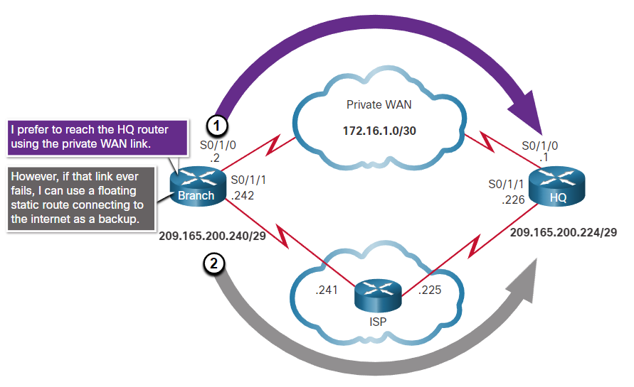

* By default, static routes have an administrative distance of 1, making them preferable to routes learned from dynamic routing protocols. For example, the administrative distances of some common interior gateway dynamic routing protocols are:
  + EIGRP = 90
  + OSPF = 110
  + IS-IS = 115
* The administrative distance of a static route can be increased to make the route less desirable than that of another static route or a route learned through a dynamic routing protocol. In this way, the static route “floats” and is not used when the route with the better administrative distance is active. However, if the preferred route is lost, the floating static route can take over, and traffic can be sent through this alternate route.
* IP floating static routes are configured by using the **distance** argument to specify an administrative distance. If no administrative distance is configured, the default value (1) is used.

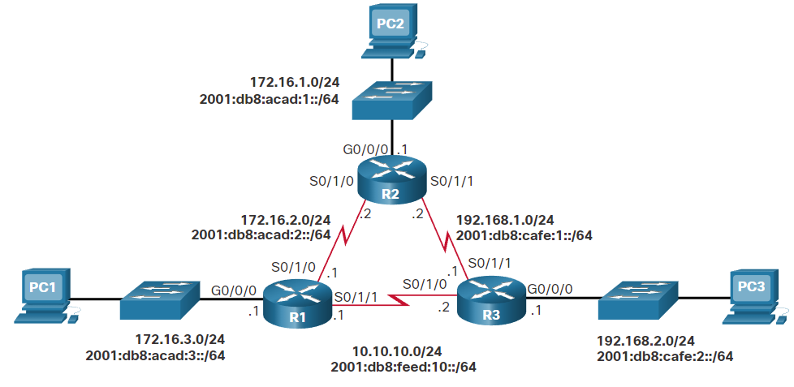

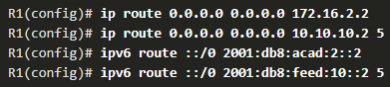

* + R1 is configured with IPv4 and IPv6 default static routes pointing to R2. Because no administrative distance is configured, the default value (1) is used for these static routes. R1 is also configured with IPv4 and IPv6 floating static default routes pointing to R3 with an administrative distance of 5. This value is greater than the default value of 1 and therefore; this route floats and is not present in the routing table unless the preferred route fails.
* In the figure, what would happen if R2 failed?
  + To simulate this failure, both serial interfaces of R2 are shut down, as shown in the configuration.

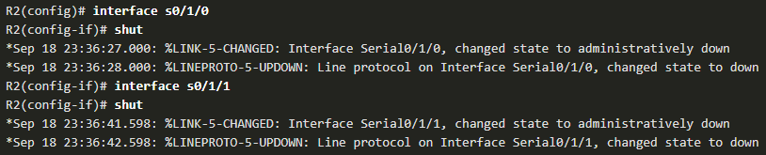

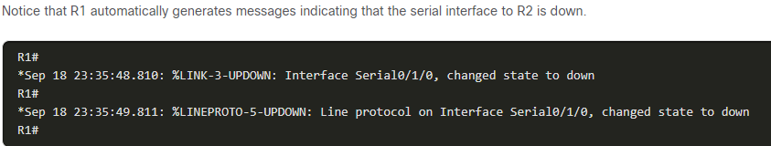

* + A look at the IP routing tables of R1 verifies that the floating static default routes are now installed as the default routes and are pointing to R3 as the next-hop router.

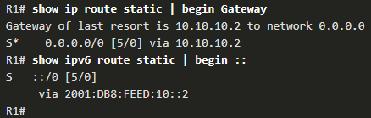

## 15.5 - Configure Static Host Routes

* A host route is an IPv4 address with a 32-bit mask, or an IPv6 address with a 128-bit mask. The following shows the three ways a host route can be added to the routing table:
  + Automatically installed when an IP address is configured on the router (as shown in the figures)
  + Configured as a static host route
  + Host route automatically obtained through other methods (discussed in later courses)
* Automatically Installed Host Routes
  + Cisco IOS automatically installs a host route, also known as a local host route, when an interface address is configured on the router. A host route allows for a more efficient process for packets that are directed to the router itself, rather than for packet forwarding. This is in addition to the connected route, designated with a C in the routing table for the network address of the interface.
  + When an active interface on a router is configured with an IP address, a local host route is automatically added to the routing table. The local routes are marked with L in the output of the routing table.

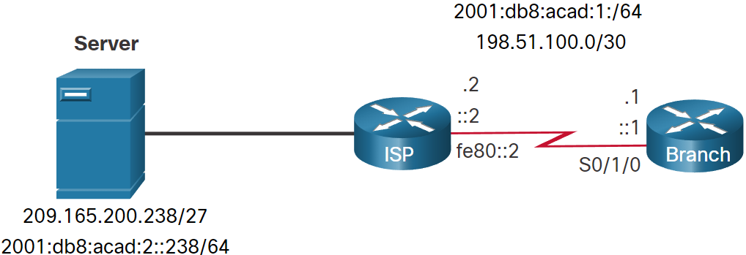

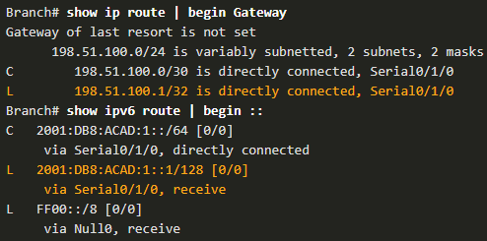

* + The IP addresses assigned to the Branch Serial0/1/0 interface are 198.51.100.1/30 and 2001:db8:acad:1::1/64. The local routes for the interface are installed by the IOS in the IPv4 and IPv6 routing tables, as shown in the example.
* Static Host Routes:
  + A host route can be a manually configured static route to direct traffic to a specific destination device, such as the server shown in the figure. The static route uses a destination IP address and a 255.255.255.255 (/32) mask for IPv4 host routes, and a /128 prefix length for IPv6 host routes.
* Configure static host routes:
  + The example shows the IPv4 and IPv6 static host route configuration on the Branch router to access the server.

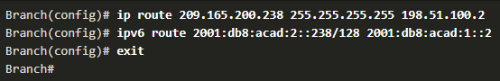

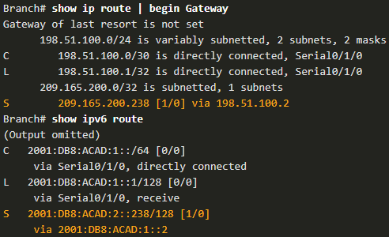

* Configure IPv6 Static Host Route with Link-Local Next-Hop:

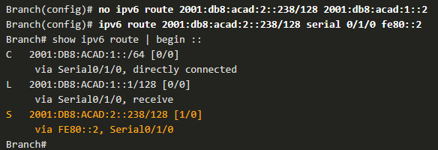

# 16 - Troubleshoot Static and Default Routes

## 16.1 - Packet Processing with Static Routes

* Static Routes and Packet Forwarding

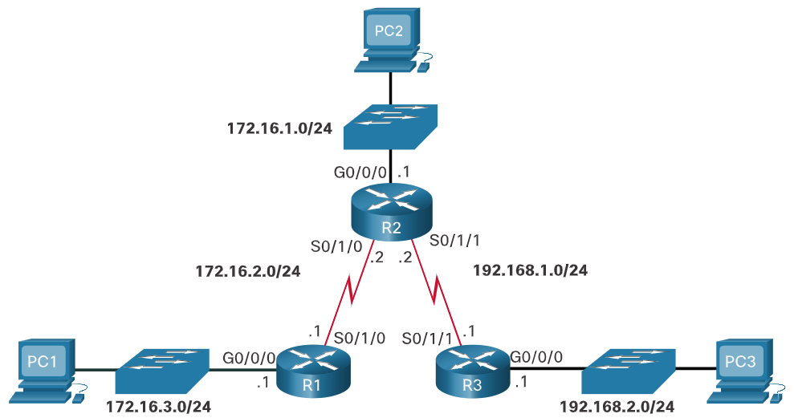

* The following describes the packet forwarding process with static routes, as demonstrated in the animation:
  1. The packet arrives on the GigabitEthernet 0/0/0 interface of R1.
  2. R1 does not have a specific route to the destination network, 192.168.2.0/24. Therefore, R1 uses the default static route.
  3. R1 encapsulates the packet in a new frame. Because the link to R2 is a point-to-point link, R1 adds an "all 1s" address for the Layer 2 destination address.
  4. The frame is forwarded out of the Serial 0/1/0 interface. The packet arrives on the Serial 0/1/0 interface on R2.
  5. R2 de-encapsulates the frame and looks for a route to the destination. R2 has a static route to 192.168.2.0/24 out of the Serial 0/1/1 interface.
  6. R2 encapsulates the packet in a new frame. Because the link to R3 is a point-to-point link, R2 adds an "all 1s" address for the Layer 2 destination address.
  7. The frame is forwarded out of the Serial 0/1/1 interface. The packet arrives on the Serial 0/1/1 interface on R3.
  8. R3 de-encapsulates the frame and looks for a route to the destination. R3 has a connected route to 192.168.2.0/24 out of the GigabitEthernet 0/0/0 interface.
  9. R3 looks up the ARP table entry for 192.168.2.10 to find the Layer 2 Media Access Control (MAC) address for PC3. If no entry exists, R3 sends an Address Resolution Protocol (ARP) request out of the GigabitEthernet 0/0/0 interface, and PC3 responds with an ARP reply, which includes the PC3 MAC address.
  10. R3 encapsulates the packet in a new frame with the MAC address of the GigabitEthernet 0/0/0 interface as the source Layer 2 address, and the MAC address of PC3 as the destination MAC address.
  11. The frame is forwarded out of GigabitEthernet 0/0/0 interface. The packet arrives on the network interface card (NIC) interface of PC3.

## 16.2 - Troubleshoot IPv4 Static and Default Route Configuration

* Common troubleshooting commands:
  + **ping**
  + **traceroute**
  + **show ip route**
  + **show ip interface brief**
  + **show cdp neighbors detail**
* Solve a connection problem:
  + Look in textbook for example

# 1 - Single-Area OSPFv2 Concepts

## - OSPF Features and Characteristics

* This topic is a brief overview of Open Shortest Path First (OSPF), which includes single-area and multiarea. OSPFv2 is used for IPv4 networks. OSPFv3 is used for IPv6 networks.
* OSPF is a link-state routing protocol that was developed as an alternative for the distance vector Routing Information Protocol (RIP). RIP was an acceptable routing protocol in the early days of networking and the internet. However, the RIP reliance on hop count as the only metric for determining best route quickly became problematic. Using hop count does not scale well in larger networks with multiple paths of varying speeds. OSPF has significant advantages over RIP in that it offers faster convergence and scales to much larger network implementations.
* OSPF is a link-state routing protocol that uses the concept of areas. A network administrator can divide the routing domain into distinct areas that help control routing update traffic. A link is an interface on a router. A link is also a network segment that connects two routers, or a stub network such as an Ethernet LAN that is connected to a single router. Information about the state of a link is known as a link-state. All link-state information includes the network prefix, prefix length, and cost.
* Components of OSPF:
  + All routing protocols share similar components. They all use routing protocol messages to exchange route information. The messages help build data structures, which are then processed using a routing algorithm.
  + Routing Protocol Messages:
    - Routers running OSPF exchange messages to convey routing information using five types of packets. These packets, as shown in the figure, are as follows:
      * Hello packet
      * Database description packet
      * Link-state request packet
      * Link-state update packet
      * Link-state acknowledgment packet
    - These packets are used to discover neighbouring routers and also to exchange routing information to maintain accurate information about the network.
  + Data structures:
    - OSPF messages are used to create and maintain three OSPF databases, as follows:
      * Adjacency database - This creates the neighbor table.
      * Link-state database (LSDB) - This creates the topology table.
      * Forwarding database - This creates the routing table.
    - These tables contain a list of neighboring routers to exchange routing information. The tables are kept and maintained in RAM. In the following table, take a particular note of the command used to display each table

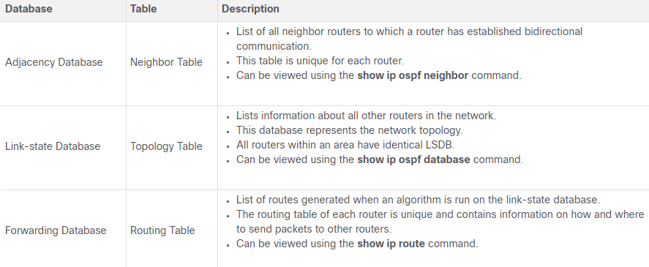

* + Algorithm:
    - The router builds the topology table using results of calculations based on the Dijkstra shortest-path first (SPF) algorithm. The SPF algorithm is based on the cumulative cost to reach a destination.
    - The SPF algorithm creates an SPF tree by placing each router at the root of the tree and calculating the shortest path to each node. The SPF tree is then used to calculate the best routes. OSPF places the best routes into the forwarding database, which is used to make the routing table.
* Link-state operation:
  + To maintain routing information, OSPF routers complete a generic link-state routing process to reach a state of convergence. The figure shows a five router topology. Each link between routers is labeled with a cost value. In OSPF, cost is used to determine the best path to the destination. The following are the link-state routing steps that are completed by a router:
  1. Establish Neighbor Adjacencies:
     + OSPF-enabled routers must recognize each other on the network before they can share information. An OSPF-enabled router sends Hello packets out all OSPF-enabled interfaces to determine if neighbors are present on those links. If a neighbor is present, the OSPF-enabled router attempts to establish a neighbor adjacency with that neighbor.
  2. Exchange Link-State Advertisements:
     + After adjacencies are established, routers then exchange link-state advertisements (LSAs). LSAs contain the state and cost of each directly connected link. Routers flood their LSAs to adjacent neighbors. Adjacent neighbors receiving the LSA immediately flood the LSA to other directly connected neighbors, until all routers in the area have all LSAs.
  3. Build the Link State Database:
     + After LSAs are received, OSPF-enabled routers build the topology table (LSDB) based on the received LSAs. This database eventually holds all the information about the topology of the area.
  4. Execute the SPF Algorithm:
     + Routers then execute the SPF algorithm. The SPF algorithm creates the SPF tree.
  5. Choose the Best Route:
     + After the SPF tree is built, the best paths to each network are offered to the IP routing table. The route will be inserted into the routing table unless there is a route source to the same network with a lower administrative distance, such as a static route. Routing decisions are made based on the entries in the routing table.

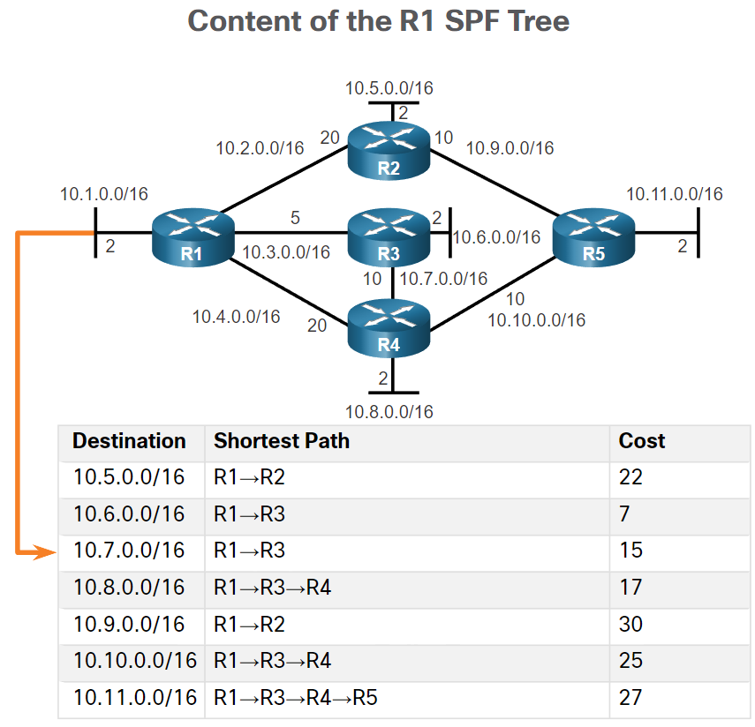

* Single-area and multiarea OSPF:
  + To make OSPF more efficient and scalable, OSPF supports hierarchical routing using areas. An OSPF area is a group of routers that share the same link-state information in their LSDBs. OSPF can be implemented in one of two ways, as follows:
    - Single-Area OSPF - All routers are in one area. Best practice is to use area 0.
    - Multiarea OSPF - OSPF is implemented using multiple areas, in a hierarchical fashion. All areas must connect to the backbone area (area 0). Routers interconnecting the areas are referred to as Area Border Routers (ABRs).

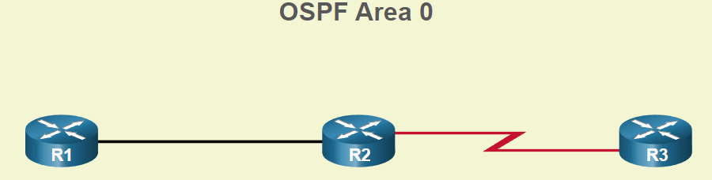

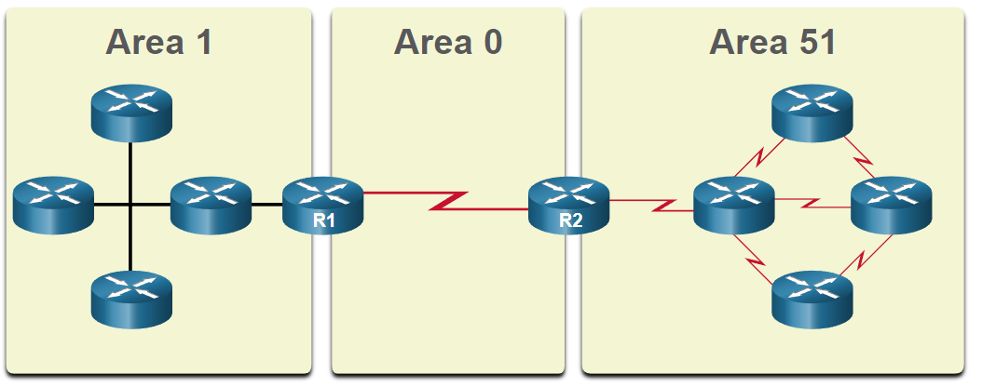

* Multiarea OSPF:
  + With multiarea OSPF, one large routing domain can be divided into smaller areas, to support hierarchical routing. Routing still occurs between the areas (interarea routing), while many of the processor intensive routing operations, such as recalculating the database, are kept within an area.
  + For instance, any time a router receives new information about a topology change within the area (including the addition, deletion, or modification of a link) the router must rerun the SPF algorithm, create a new SPF tree, and update the routing table. The SPF algorithm is CPU-intensive and the time it takes for calculation depends on the size of the area.
  + Note: Routers in other areas receive updates regarding topology changes, but these routers only update the routing table, not rerun the SPF algorithm.
  + Too many routers in one area would make the LSDBs very large and increase the load on the CPU. Therefore, arranging routers into areas effectively partitions a potentially large database into smaller and more manageable databases.
  + The hierarchical-topology design options with multiarea OSPF can offer the following advantages.
    - Smaller routing tables - Tables are smaller because there are fewer routing table entries. This is because network addresses can be summarized between areas. Route summarization is not enabled by default.
    - Reduced link-state update overhead - Designing multiarea OSPF with smaller areas minimizes processing and memory requirements.
    - Reduced frequency of SPF calculations - Multiarea OSPF localize the impact of a topology change within an area. For instance, it minimizes routing update impact because LSA flooding stops at the area boundary.

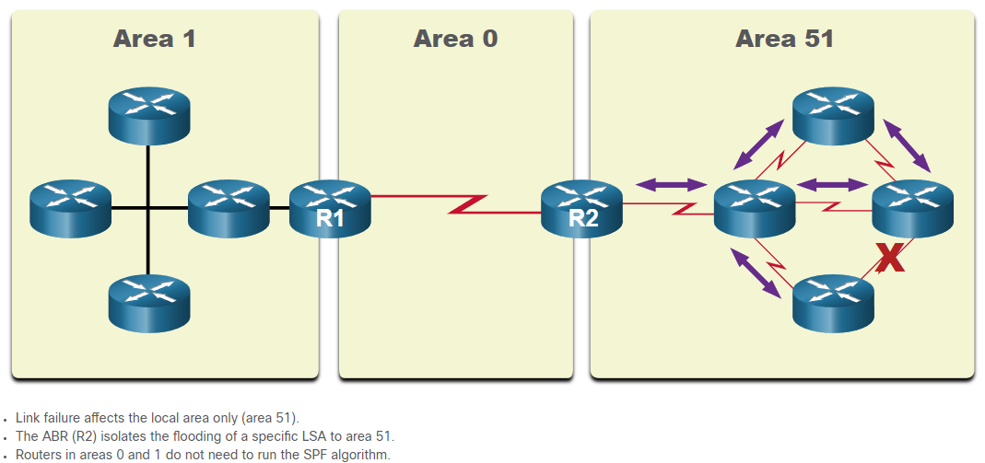

* OSPFv3:
  + OSPFv3 is the OSPFv2 equivalent for exchanging IPv6 prefixes. Recall that in IPv6, the network address is referred to as the prefix and the subnet mask is called the prefix-length.
  + Similar to its IPv4 counterpart, OSPFv3 exchanges routing information to populate the IPv6 routing table with remote prefixes.
  + Note: With the OSPFv3 Address Families feature, OSPFv3 includes support for both IPv4 and IPv6. OSPF Address Families is beyond the scope of this curriculum.
  + OSPFv2 runs over the IPv4 network layer, communicating with other OSPF IPv4 peers, and advertising only IPv4 routes.
  + OSPFv3 has the same functionality as OSPFv2, but uses IPv6 as the network layer transport, communicating with OSPFv3 peers and advertising IPv6 routes. OSPFv3 also uses the SPF algorithm as the computation engine to determine the best paths throughout the routing domain.
  + OSPFv3 has separate processes from its IPv4 counterpart. The processes and operations are basically the same as in the IPv4 routing protocol, but run independently. OSPFv2 and OSPFv3 each have separate adjacency tables, OSPF topology tables, and IP routing tables.
  + The OSPFv3 configuration and verification commands are similar to those used in OSPFv2.

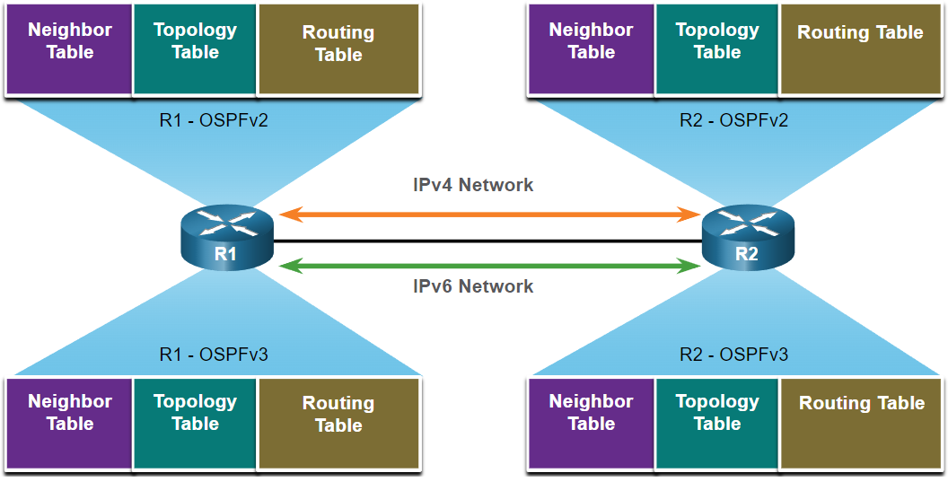

## - OSPF Packets

* Types of OSPF packets:
  + Link-state packets are the tools used by OSPF to help determine the fastest available route for a packet. OSPF uses the following link-state packets (LSPs) to establish and maintain neighbor adjacencies and exchange routing updates. Each packet serves a specific purpose in the OSPF routing process, as follows:
    - Type 1: Hello packet - This is used to establish and maintain adjacency with other OSPF routers.
    - Type 2: Database Description (DBD) packet - This contains an abbreviated list of the LSDB of the sending router and is used by receiving routers to check against the local LSDB. The LSDB must be identical on all link-state routers within an area to construct an accurate SPF tree.
    - Type 3: Link-State Request (LSR) packet - Receiving routers can then request more information about any entry in the DBD by sending an LSR.
    - Type 4: Link-State Update (LSU) packet - This is used to reply to LSRs and to announce new information. LSUs contain several different types of LSAs.
    - Type 5: Link-State Acknowledgment (LSAck) packet - When an LSU is received, the router sends an LSAck to confirm receipt of the LSU. The LSAck data field is empty.

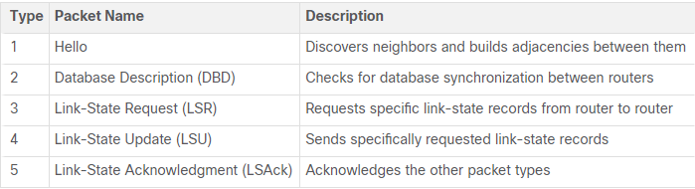

* Link-state updates:
  + Routers initially exchange Type 2 DBD packets, which is an abbreviated list of the LSDB of the sending router. It is used by receiving routers to check against the local LSDB.
  + A Type 3 LSR packet is used by the receiving routers to request more information about an entry in the DBD.
  + The Type 4 LSU packet is used to reply to an LSR packet.
  + A Type 5 packet is used to acknowledge the receipt of a Type 4 LSU.
  + LSUs are also used to forward OSPF routing updates, such as link changes. Specifically, an LSU packet can contain 11 different types of OSPFv2 LSAs, with some of the more common ones shown in the figure. OSPFv3 renamed several of these LSAs and also contains two additional LSAs.
  + Note: The difference between the LSU and LSA terms can sometimes be confusing because these terms are often used interchangeably. However, an LSU contains one or more LSAs.

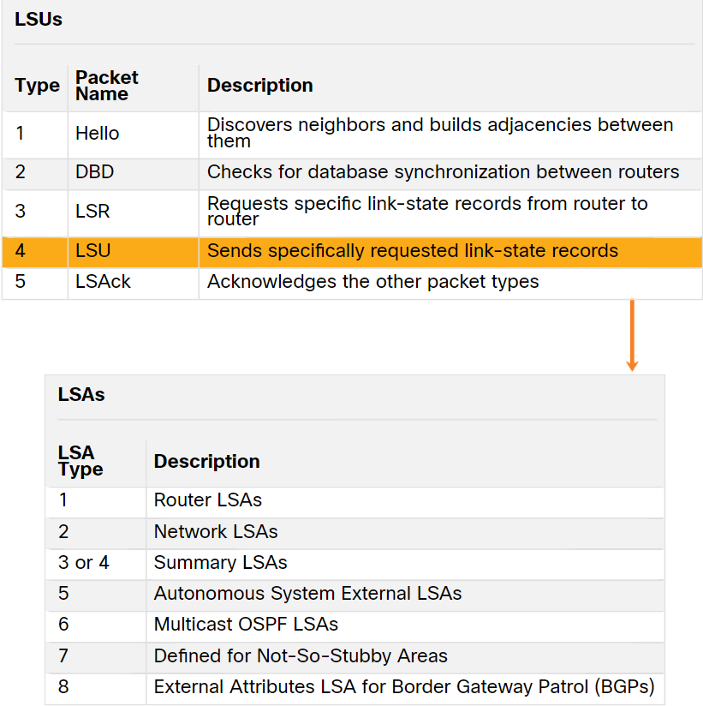

* Hello packet:
  + The OSPF Type 1 packet is the Hello packet. Hello packets are used to do the following:
    - Discover OSPF neighbors and establish neighbor adjacencies.
    - Advertise parameters on which two routers must agree to become neighbors.
    - Elect the Designated Router (DR) and Backup Designated Router (BDR) on multiaccess networks like Ethernet. Point-to-point links do not require DR or BDR.
  + The figure displays the fields contained in the OSPFv2 Type 1 Hello packet.

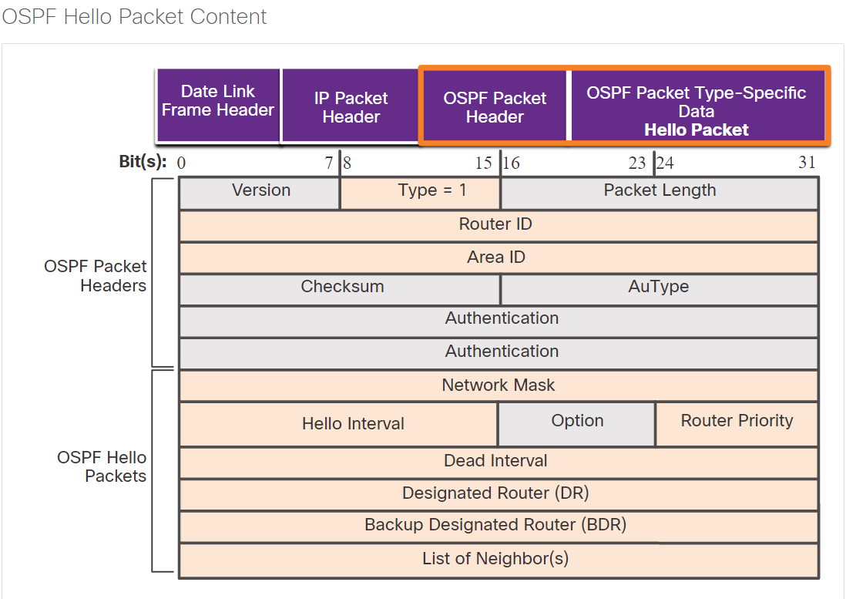

## - OSPF Operation

* OSPF operational states:
  + Now that you know about the OSPF link-state packets, this topic explains how they work with OSPF-enabled routers. When an OSPF router is initially connected to a network, it attempts to:
    - Create adjacencies with neighbors
    - Exchange routing information
    - Calculate the best routes
    - Reach convergence
  + The table details the states OSPF progresses through while attempting to reach convergence:

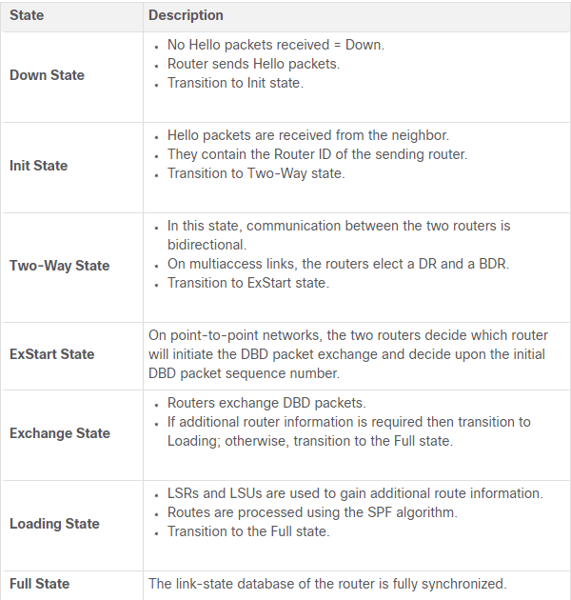

* Establish neighbour adjacencies:
  + When OSPF is enabled on an interface, the router must determine if there is another OSPF neighbor on the link. To accomplish this, the router sends a Hello packet that contains its router ID out all OSPF-enabled interfaces. The Hello packet is sent to the reserved All OSPF Routers IPv4 multicast address 224.0.0.5. Only OSPFv2 routers will process these packets. The OSPF router ID is used by the OSPF process to uniquely identify each router in the OSPF area. A router ID is a 32-bit number formatted like an IPv4 address and assigned to uniquely identify a router among OSPF peers.
  + When a neighboring OSPF-enabled router receives a Hello packet with a router ID that is not within its neighbor list, the receiving router attempts to establish an adjacency with the initiating router.
  + Down state to init state:
    - When OSPFv2 is enabled, the enabled Gigabit Ethernet 0/0 interface transitions from the Down state to the Init state. R1 starts sending Hello packets out all OSPF-enabled interfaces to discover OSPF neighbors to develop adjacencies with.

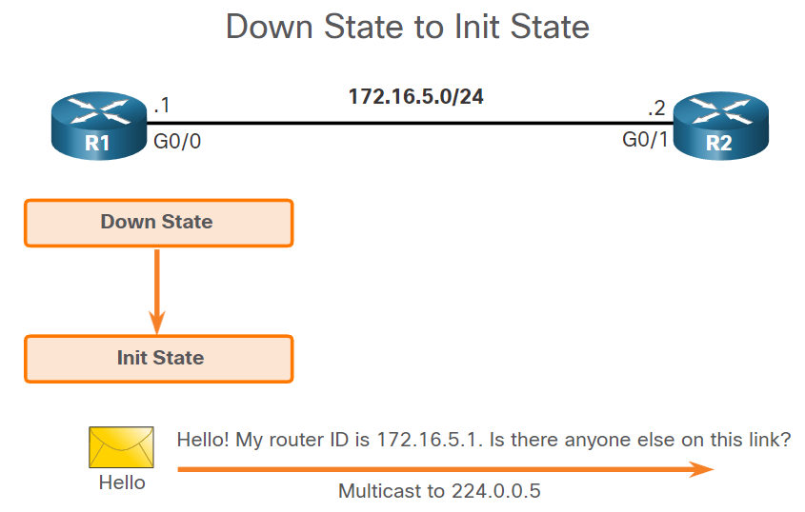

* + The init state:
    - R2 receives the Hello packet from R1 and adds the R1 router ID to its neighbor list. R2 then sends a Hello packet to R1. The packet contains the R2 Router ID and the R1 Router ID in its list of neighbors on the same interface.

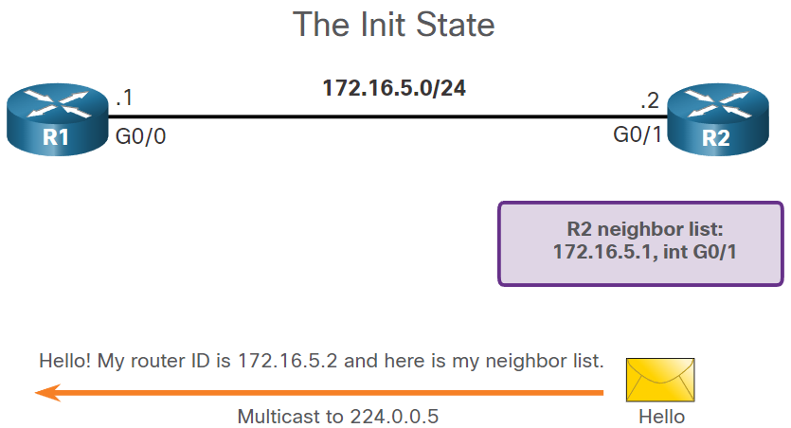

* + Two-way state:
    - R1 receives the Hello and adds the R2 Router ID to its list of OSPF neighbors. It also notices its own Router ID in the list of neighbors of the Hello packet. When a router receives a Hello packet with its Router ID listed in the list of neighbors, the router transitions from the Init state to the Two-Way state.
    - The action performed in Two-Way state depends on the type of interconnection between the adjacent routers, as follows:
      * If the two adjacent neighbors are interconnected over a point-to-point link, then they immediately transition from the Two-Way state to the ExStart state.
      * If the routers are interconnected over a common Ethernet network, then a designated router DR and a BDR must be elected.

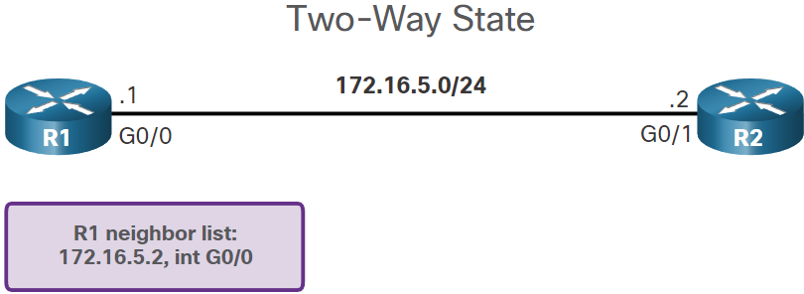

* + Elect the DR and BDR:
    - Because R1 and R2 are interconnected over an Ethernet network, a DR and BDR election takes place. As shown in the figure, R2 becomes the DR and R1 is the BDR. This process only occurs on multiaccess networks such as Ethernet LANs.
    - Hello packets are continually exchanged to maintain router information.

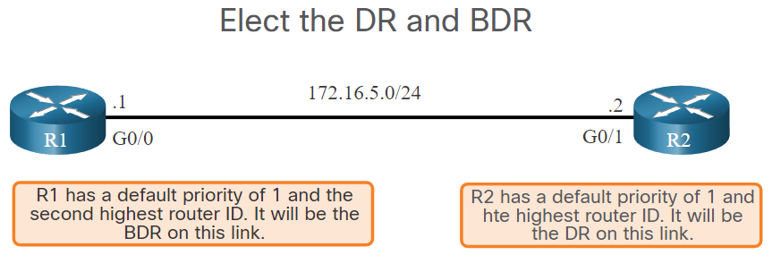

* Synchronizing OSPF databases:
  + After the Two-Way state, routers transition to database synchronization states. While the Hello packet was used to establish neighbor adjacencies, the other four types of OSPF packets are used during the process of exchanging and synchronizing LSDBs. This is a three step process, as follows:
  + Decide first router:
    - In the ExStart state, the two routers decide which router will send the DBD packets first. The router with the higher router ID will be the first router to send DBD packets during the Exchange state. In the figure, R2 has the higher router ID and sends its DBD packets first.

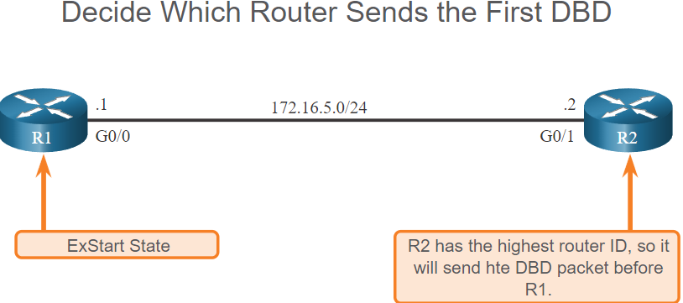

* + Exchange DBDs:
    - In the Exchange state, the two routers exchange one or more DBD packets. A DBD packet includes information about the LSA entry header that appears in the LSDB of the router. The entries can be about a link or about a network. Each LSA entry header includes information about the link-state type, the address of the advertising router, the cost of the link, and the sequence number. The router uses the sequence number to determine the newness of the received link-state information.

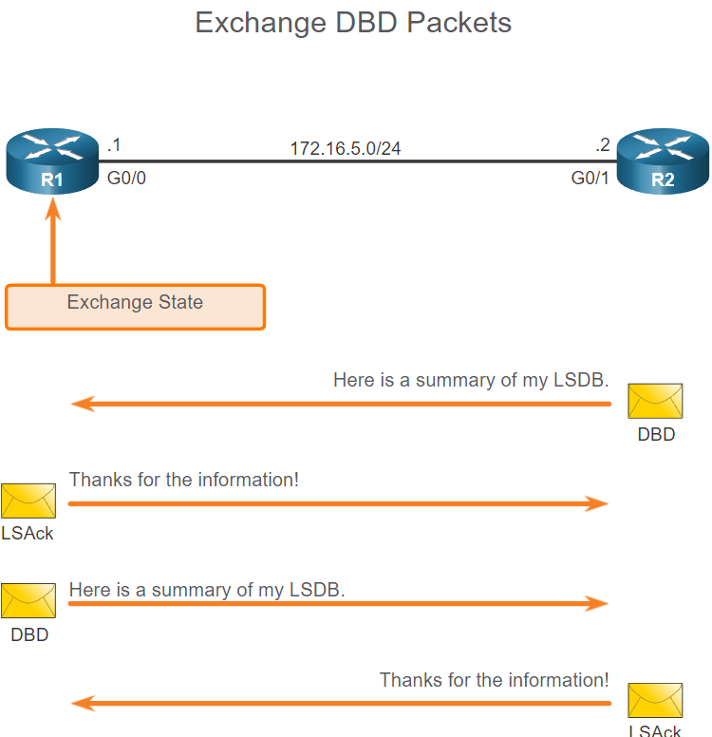

* + Send an LSR:
    - R1 compares the information received with the information it has in its own LSDB. If the DBD packet has a more current link-state entry, the router transitions to the Loading state.
    - After all LSRs have been satisfied for a given router, the adjacent routers are considered synchronized and in a full state. Updates (LSUs) are sent only to neighbors in the following conditions:
      * When a change is perceived (incremental updates)
      * Every 30 minutes

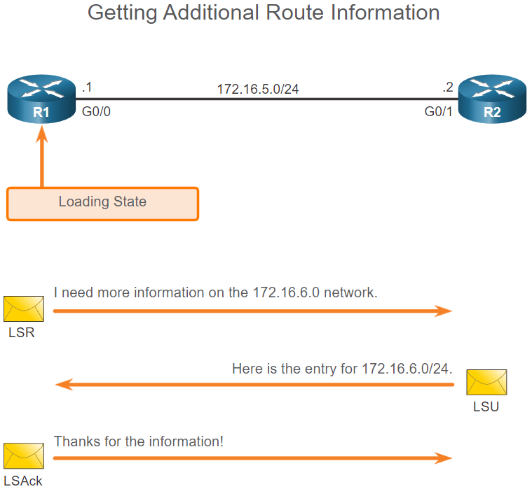

* The need for a DR:
  + Multiaccess networks can create two challenges for OSPF regarding the flooding of LSAs, as follows:
    - Creation of multiple adjacencies - Ethernet networks could potentially interconnect many OSPF routers over a common link. Creating adjacencies with every router is unnecessary and undesirable. It would lead to an excessive number of LSAs exchanged between routers on the same network.
    - Extensive flooding of LSAs - Link-state routers flood their LSAs any time OSPF is initialized, or when there is a change in the topology. This flooding can become excessive.
  + To understand the problem with multiple adjacencies, we must study a formula:
  + For any number of routers (designated as n) on a multiaccess network, there are n (n – 1) / 2 adjacencies.
  + For example, the figure shows a simple topology of five routers, all of which are attached to the same multiaccess Ethernet network. Without some type of mechanism to reduce the number of adjacencies, collectively these routers would form 10 adjacencies:
  + 5 (5 – 1) / 2 = 10
  + This may not seem like much, but as routers are added to the network, the number of adjacencies increases dramatically. For example, a multiaccess network with 20 routers would create 190 adjacencies.
* LSA flooding with DR:
  + A dramatic increase in the number of routers also dramatically increases the number of LSAs exchanged between the routers. This flooding of LSAs significantly impacts the operation of OSPF.
  + The solution to managing the number of adjacencies and the flooding of LSAs on a multiaccess network is the DR. On multiaccess networks, OSPF elects a DR to be the collection and distribution point for LSAs sent and received. A BDR is also elected in case the DR fails. All other routers become DROTHERs. A DROTHER is a router that is neither the DR nor the BDR.
  + Note: The DR is only used for the dissemination of LSAs. The router will still use the best next-hop router indicated in the routing table for the forwarding of all other packets.

# 2 - Single-Area OSPFv2 Configuration

## 2.1 - OSPF Router ID

* To get you started, this topic discusses the foundation on which OSPF bases its entire process, the OSPF router ID.
* The figure shows the topology used for configuring OSPFv2 in this module. The routers in the topology have a starting configuration, including interface addresses. There is currently no static routing or dynamic routing configured on any of the routers. All interfaces on R1, R2, and R3 (except the loopback 1 on R2) are within the OSPF backbone area. The ISP router is used as the gateway to the internet of the routing domain.
* Note: In this topology the loopback interface is used to simulate the WAN link to the Internet and a LAN connected to each router. This is done to allow this topology to be duplicated for demonstration purposes on routers that only have two Gigabit Ethernet interfaces.

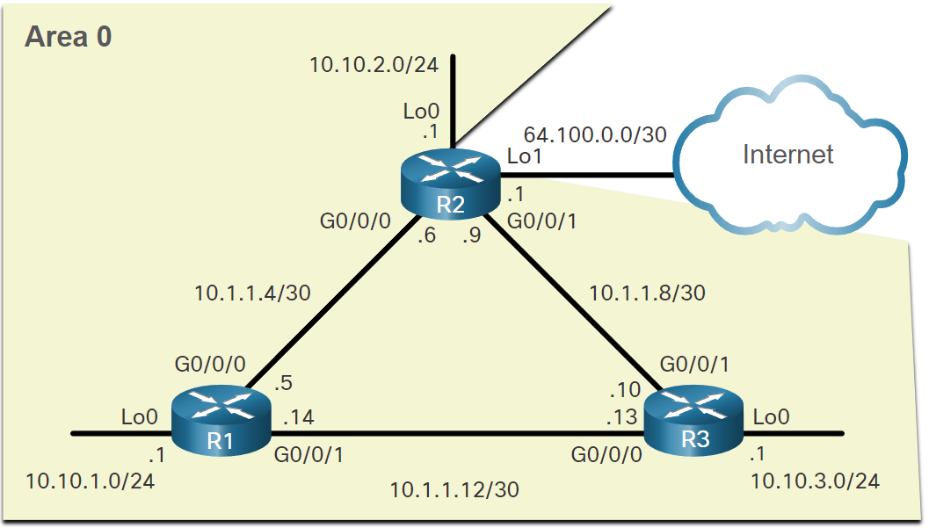

* Router configuration mode for OSPF:
  + OSPFv2 is enabled using the **router ospf *process-id*** global configuration mode command. The process-id value represents a number between 1 and 65,535 and is selected by the network administrator. The process-id value is locally significant, which means that it does not have to be the same value on the other OSPF routers to establish adjacencies with those neighbors. It is considered best practice to use the same process-id on all OSPF routers.

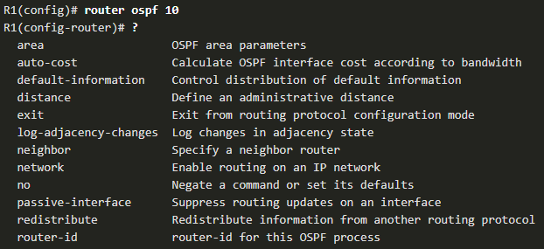

* Router IDs:
  + An OSPF router ID is a 32-bit value, represented as an IPv4 address. The router ID is used to uniquely identify an OSPF router. All OSPF packets include the router ID of the originating router. Every router requires a router ID to participate in an OSPF domain. The router ID can be defined by an administrator or automatically assigned by the router. The router ID is used by an OSPF-enabled router to do the following:
    - Participate in the synchronization of OSPF databases – During the Exchange State, the router with the highest router ID will send their database descriptor (DBD) packets first.
    - Participate in the election of the designated router (DR) - In a multiaccess LAN environment, the router with the highest router ID is elected the DR. The routing device with the second highest router ID is elected the backup designated router (BDR).
* Router ID order of precedence:
  + But how does the router determine the router ID? Cisco routers derive the router ID based on one of three criteria, in the following preferential order:
    - The router ID is explicitly configured using the OSPF router-id rid router configuration mode command. The rid value is any 32-bit value expressed as an IPv4 address. This is the recommended method to assign a router ID.
    - If the router ID is not explicitly configured, the router chooses the highest IPv4 address of any of configured loopback interfaces. This is the next best alternative to assigning a router ID.
    - If no loopback interfaces are configured, then the router chooses the highest active IPv4 address of any of its physical interfaces. This is the least recommended method because it makes it more difficult for administrators to distinguish between specific routers.

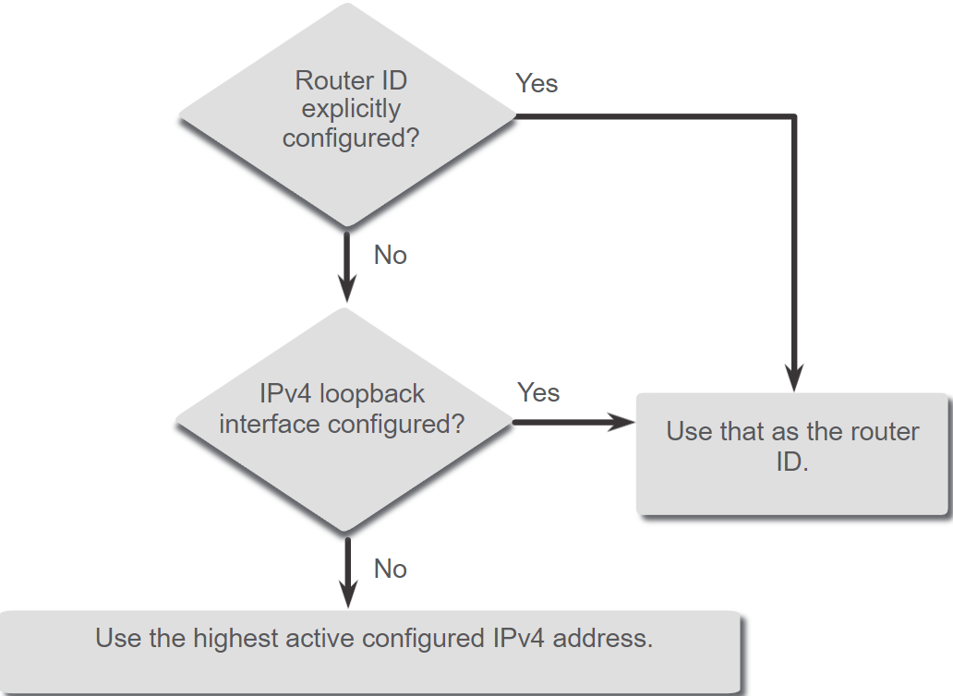

* Configure a loopback interface as the router ID:
  + Note: OSPF does not need to be enabled on an interface for that interface to be chosen as the router ID.
  + Instead of relying on physical interface, the router ID can be assigned to a loopback interface. Typically, the IPv4 address for this type of loopback interface should be configured using a 32-bit subnet mask (255.255.255.255). This effectively creates a host route. A 32-bit host route would not get advertised as a route to other OSPF routers.
  + The example shows how to configure a loopback interface on R1. Assuming the router ID was not explicitly configured or previously learned, R1 will use IPv4 address 1.1.1.1 as its router ID. Assume R1 has not yet learned a router ID.

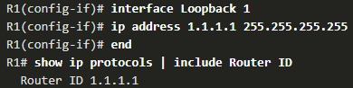

* Explicitly configure a router ID:
  + Use the **router-id *rid*** router configuration mode command to manually assign a router ID. In the example, the router ID 1.1.1.1 is assigned to R1. Use the **show ip protocols** command to verify the router ID.

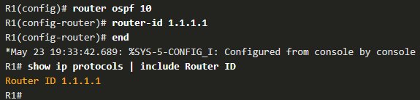

* Modify a router ID:
  + After a router selects a router ID, an active OSPF router does not allow the router ID to be changed until the router is reloaded or the OSPF process is reset.

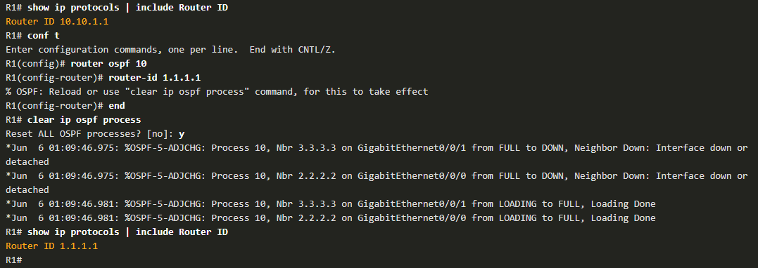

* + Notice how an informational message appears stating that the OSPF process must be cleared or that the router must be reloaded. The reason is because R1 already has adjacencies with other neighbors using the router ID 10.10.1.1. Those adjacencies must be renegotiated using the new router ID 1.1.1.1. Use the clear ip ospf process command to reset the adjacencies. You can then verify that R1 is using the new router ID command with the show ip protocols command piped to display only the router ID section.
  + Clearing the OSPF process is the preferred method to reset the router ID.

## 2.2 - Point-to-Point OSPF Networks

* The network command syntax:
  + One type of network classified by OSPF is a point-to-point network. You can specify the interfaces that belong to a point-to-point network by configuring the network command. You can also configure OSPF directly on the interface with the ip ospf command, as we will see later.
  + Both commands are used to determine which interfaces participate in the routing process for an OSPFv2 area.



* + The network-address wildcard-mask syntax is used to enable OSPF on interfaces. Any interfaces on a router that match the network address in the network command are enabled to send and receive OSPF packets.
  + The area area-id syntax refers to the OSPF area. When configuring single-area OSPFv2, the network command must be configured with the same area-id value on all routers. Although any area ID can be used, it is good practice to use an area ID of 0 with single-area OSPFv2. This convention makes it easier if the network is later altered to support multiarea OSPFv2.
* The wildcard mask:
  + The wildcard mask is typically the inverse of the subnet mask configured on that interface. In a subnet mask, binary 1 is equal to a match and binary 0 is not a match. In a wildcard mask, the reverse is true, as shown in here:
  + Wildcard mask bit 0 - Matches the corresponding bit value in the address.
  + Wildcard mask bit 1 - Ignores the corresponding bit value in the address.
  + The easiest method for calculating a wildcard mask is to subtract the network subnet mask from 255.255.255.255

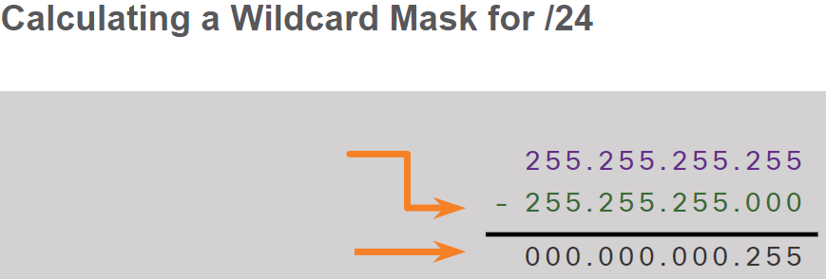

* + /26 mask:

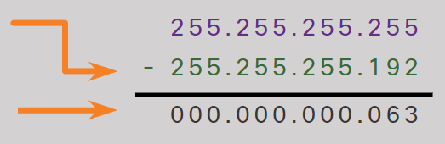

* Configure OSPF using the network command:
  + Within routing configuration mode, there are two ways to identify the interfaces that will participate in the OSPFv2 routing process.
  + In the first example, the wildcard mask identifies the interface based on the network addresses. Any active interface that is configured with an IPv4 address belonging to that network will participate in the OSPFv2 routing process.

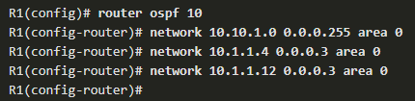

* + Note: Some IOS versions allow the subnet mask to be entered instead of the wildcard mask. The IOS then converts the subnet mask to the wildcard mask format.
  + As an alternative, the second example shows how OSPFv2 can be enabled by specifying the exact interface IPv4 address using a quad zero wildcard mask. Entering network 10.1.1.5 0.0.0.0 area 0 on R1 tells the router to enable interface Gigabit Ethernet 0/0/0 for the routing process. As a result, the OSPFv2 process will advertise the network that is on this interface (10.1.1.4/30).

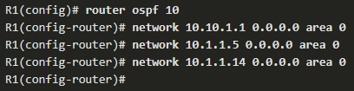

* Configure OSPF using the ip ospf command:
  + You can also configure OSPF directly on the interface instead of using the network command. To configure OSPF directly on the interface, use the **ip ospf** interface configuration mode command



* + For R1, remove the network commandsby using the no form of the network commands. And then go to each interface and configure the ip ospf command, as shown in the command window.

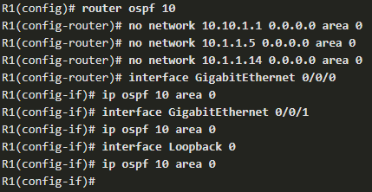

* Passive interface:
  + By default, OSPF messages are forwarded out all OSPF-enabled interfaces. However, these messages really only need to be sent out interfaces that are connecting to other OSPF-enabled routers.
  + Sending out unneeded messages on a LAN affects the network in three ways, as follows:
    - Inefficient Use of Bandwidth - Available bandwidth is consumed transporting unnecessary messages.
    - Inefficient Use of Resources - All devices on the LAN must process and eventually discard the message.
    - Increased Security Risk - Without additional OSPF security configurations, OSPF messages can be intercepted with packet sniffing software. Routing updates can be modified and sent back to the router, corrupting the routing table with false metrics that misdirect traffic.
* Configure passive interfaces:
  + Use the **passive-interface** router configuration mode command to prevent the transmission of routing messages through a router interface, but still allow that network to be advertised to other routers.
  + Note: The loopback interface in this example is representing an Ethernet network. In production networks, loopback interfaces do not require to be passive.
  + The **show ip protocols** command is then used to verify that the Loopback 0 interface is listed as passive. The interface is still listed under the heading, “Routing on Interfaces Configured Explicitly (Area 0)”, which means that this network is still included as a route entry in OSPFv2 updates that are sent to R2 and R3.

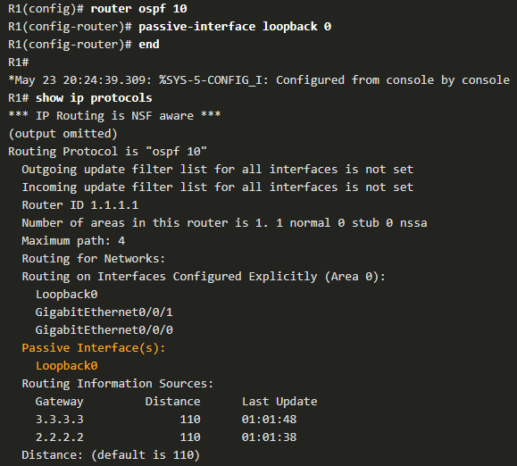

* OSPF point-to-point networks:
  + By default, Cisco routers elect a DR and BDR on Ethernet interfaces, even if there is only one other device on the link.
  + The DR/ BDR election process is unnecessary as there can only be two routers on the point-to-point network between R1 and R2. Notice in the output that the router has designated the network type as BROADCAST. To change this to a point-to-point network, use the interface configuration command **ip ospf network point-to-point** on all interfaces where you want to disable the DR/BDR election process.

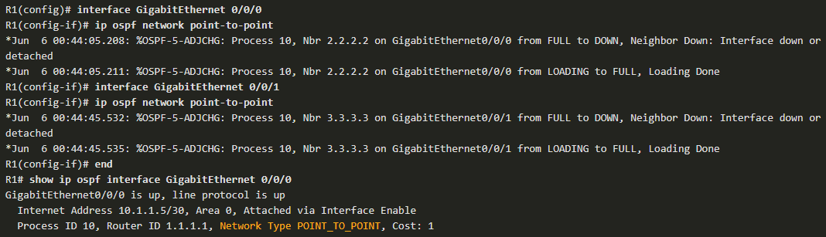

* Loopbacks and point-to-point networks:
  + We use loopbacks to provide additional interfaces for a variety of purposes. In this case, we are using loopbacks to simulate more networks than the equipment can support. By default, loopback interfaces are advertised as /32 host routes. For example, R1 would advertise the 10.10.1.0/24 network as 10.10.1.1/32 to R2 and R3.



* + To simulate a real LAN, the Loopback 0 interface is configured as a point-to-point network so that R1 will advertise the full 10.10.1.0/24 network to R2 and R3

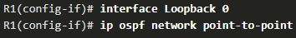

* + Now R2 receives the more accurate, simulated LAN network address of 10.10.1.0/24.



* + Note: At the time of this writing, Packet Tracer does not support the ip ospf network point-to-point command on Gigabit Ethernet interfaces. However, it is supported on Loopback interfaces.

## 2.3 - Multiaccess OSPF Networks

* OSPF Network Types:
  + Another type of network that uses OSPF is the multiaccess OSPF network. Multiaccess OSPF networks are unique in that one router controls the distribution of LSAs. The router that is elected for this role should be determined by the network administrator through proper configuration.
  + OSPF may include additional processes depending on the type of network. The previous topology used point-to-point links between the routers. However, routers can be connected to the same switch to form a multiaccess network, as shown in the figure. Ethernet LANs are the most common example of broadcast multiaccess networks. In broadcast networks, all devices on the network see all broadcast and multicast frames.

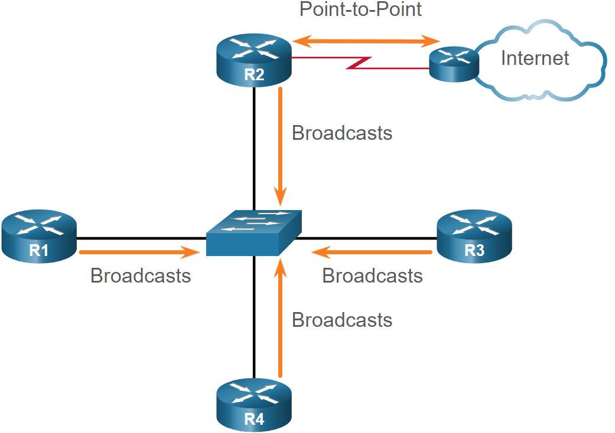

* OSPF Designated Router:
  + Recall that, in multiaccess networks, OSPF elects a DR and BDR as a solution to manage the number of adjacencies and the flooding of link-state advertisements (LSAs). The DR is responsible for collecting and distributing LSAs sent and received. The DR uses the multicast IPv4 address 224.0.0.5 which is meant for all OSPF routers.
  + A BDR is also elected in case the DR fails. The BDR listens passively and maintains a relationship with all the routers. If the DR stops producing Hello packets, the BDR promotes itself and assumes the role of DR.
  + All other routers become a DROTHER (a router that is neither the DR nor the BDR). DROTHERs use the multiaccess address 224.0.0.6 (all designated routers) to send OSPF packets to the DR and BDR. Only the DR and BDR listen for 224.0.0.6.
* OSPF Multiaccess reference topology:
  + In the multiaccess topology shown in the figure, there are three routers interconnected over a common Ethernet multiaccess network, 192.168.1.0/24. Each router is configured with the indicated IPv4 address on the Gigabit Ethernet 0/0/0 interface.
  + Because the routers are connected over a common multiaccess network, OSPF has automatically elected a DR and BDR. In this example, R3 has been elected as the DR because its router ID is 3.3.3.3, which is the highest in this network. R2 is the BDR because it has the second highest router ID in the network.

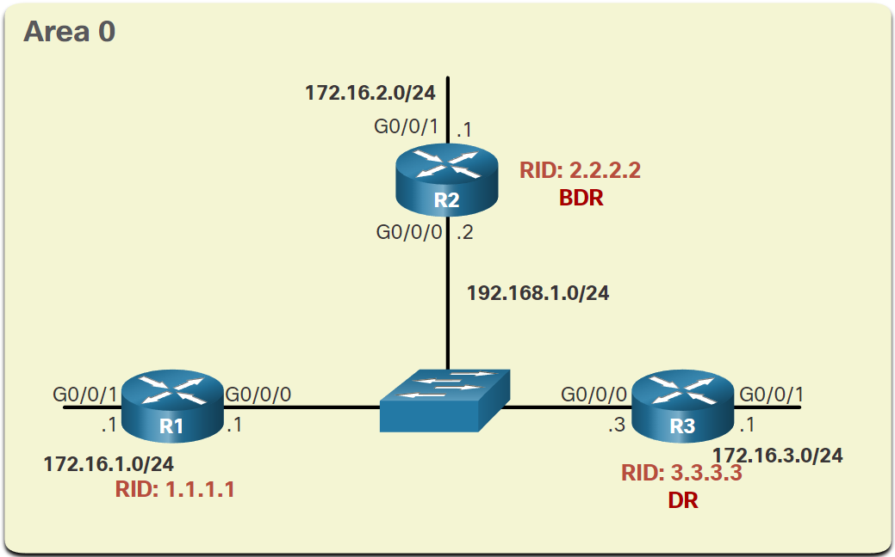

* Verify OSPF Router Roles:
  + To verify the roles of the OSPFv2 router, use the **show ip ospf interface** command.
* Verify DR/BDR Adjacencies:
  + To verify the OSPFv2 adjacencies, use the **show ip ospf neighbor** command. The state of neighbors in multiaccess networks can be as follows:
    - FULL/DROTHER - This is a DR or BDR router that is fully adjacent with a non-DR or BDR router. These two neighbors can exchange Hello packets, updates, queries, replies, and acknowledgments.
    - FULL/DR - The router is fully adjacent with the indicated DR neighbor. These two neighbors can exchange Hello packets, updates, queries, replies, and acknowledgments.
    - FULL/BDR - The router is fully adjacent with the indicated BDR neighbor. These two neighbors can exchange Hello packets, updates, queries, replies, and acknowledgments.
    - 2-WAY/DROTHER - The non-DR or BDR router has a neighbor relationship with another non-DR or BDR router. These two neighbors exchange Hello packets.
  + The normal state for an OSPF router is usually FULL. If a router is stuck in another state, it is an indication that there are problems in forming adjacencies. The only exception to this is the 2-WAY state, which is normal in a multiaccess broadcast network. For examples, DROTHERs will form a 2-WAY neighbor adjacency with any DROTHERs that join the network. When this happens, the neighbor state displays as 2-WAY/DROTHER.

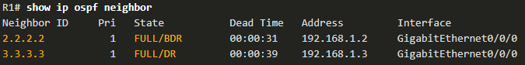

* Default DR/BDR Election Process:
  + How do the DR and BDR get elected? The OSPF DR and BDR election decision is based on the following criteria, in sequential order:
    1. The routers in the network elect the router with the highest interface priority as the DR. The router with the second highest interface priority is elected as the BDR. The priority can be configured to be any number between 0 – 255. If the interface priority value is set to 0, that interface cannot be elected as DR nor BDR. The default priority of multiaccess broadcast interfaces is 1. Therefore, unless otherwise configured, all routers have an equal priority value and must rely on another tie breaking method during the DR/BDR election.
    2. If the interface priorities are equal, then the router with the highest router ID is elected the DR. The router with the second highest router ID is the BDR.
  + Recall that the router ID is determined in one of the following three ways:
    1. The router ID can be manually configured.
    2. If no router IDs are configured, the router ID is determined by the highest loopback IPv4 address.
    3. If no loopback interfaces are configured, the router ID is determined by the highest active IPv4 address.
  + The DR and BDR election process takes place as soon as the first router with an OSPF-enabled interface is active on the multiaccess network. This can happen when the preconfigured OSPF routers are powered on, or when OSPF is activated on the interface. The election process only takes a few seconds. If all of the routers on the multiaccess network have not finished booting, it is possible that a router with a lower router ID becomes the DR.
  + OSPF DR and BDR elections are not pre-emptive. If a new router with a higher priority or higher router ID is added to the network after the DR and BDR election, the newly added router does not take over the DR or the BDR role. This is because those roles have already been assigned. The addition of a new router does not initiate a new election process.
* DR Failure and Recovery:
  + After the DR is elected, it remains the DR until one of the following events occurs:
    - The DR fails.
    - The OSPF process on the DR fails or is stopped.
    - The multiaccess interface on the DR fails or is shutdown.
  + If the DR fails, the BDR is automatically promoted to DR. This is the case even if another DROTHER with a higher priority or router ID is added to the network after the initial DR/BDR election. However, after a BDR is promoted to DR, a new BDR election occurs and the DROTHER with the highest priority or router ID is elected as the new BDR.
* The ip ospf priority command:
  + If the interface priorities are equal on all routers, the router with the highest router ID is elected the DR. It is possible to configure the router ID to manipulate the DR/BDR election. However, this process only works if there is a stringent plan for setting the router ID on all routers. Configuring the router ID can help control this. However, in large networks this can be cumbersome.
  + Instead of relying on the router ID, it is better to control the election by setting interface priorities. This also allows a router to be the DR in one network and a DROTHER in another. To set the priority of an interface, use the command **ip ospf priority *value***, where value is 0 to 255. A value of 0 does not become a DR or a BDR. A value of 1 to 255 on the interface makes it more likely that the router becomes the DR or the BDR.
* Configure OSPF priority:
  + In the topology, the ip ospf priority command will be used to change the DR and BDR as follows:
    - R1 should be the DR and will be configured with a priority of 255.
    - R2 should be the BDR and will be left with the default priority of 1.
    - R3 should never be a DR or BDR and will be configured with a priority of 0.
  + Change the R1 G0/0/0 interface priority from 1 to 255.

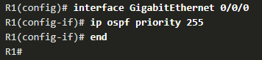

* + Change the R3 G0/0/0 interface priority from 1 to 0.

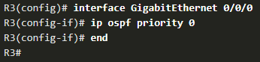

* + The following example, shows how to clear the OSPF process on R1. The **clear** **ip ospf process** command also must be entered on R2 and R3 (not shown). Notice the OSPF state information that is generated.

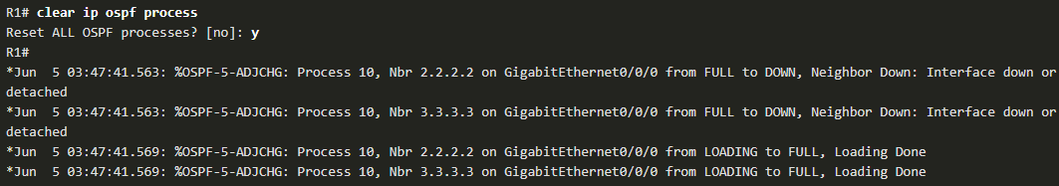

* + The output from the show in ospf interface g0/0/0 command on R1 confirms that R1 is now the DR with a priority of 255 and identifies the new neighbor adjacencies of R1.

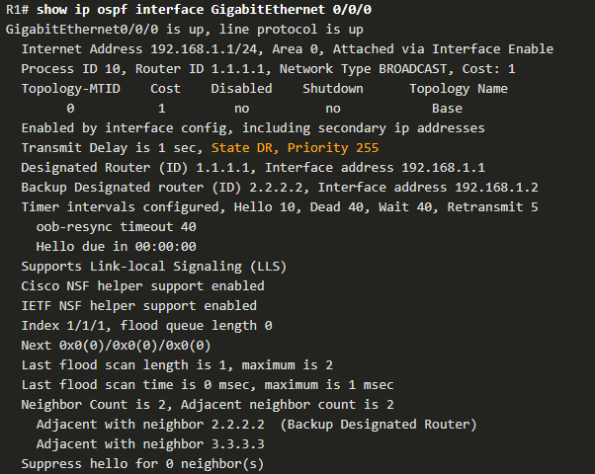

## 2.4 - Modify Single-Area OSPFv2

* Cisco OSPF Cost Metric:
  + Recall that a routing protocol uses a metric to determine the best path of a packet across a network. A metric gives indication of the overhead that is required to send packets across a certain interface. OSPF uses cost as a metric. A lower cost indicates a better path than a higher cost.
  + The Cisco cost of an interface is inversely proportional to the bandwidth of the interface. Therefore, a higher bandwidth indicates a lower cost. The formula used to calculate the OSPF cost is:
    - **Cost = reference bandwidth / interface bandwidth**
  + The default reference bandwidth is 108 (100,000,000); therefore, the formula is:
    - Cost = 100,000,000 bps / interface bandwidth in bps

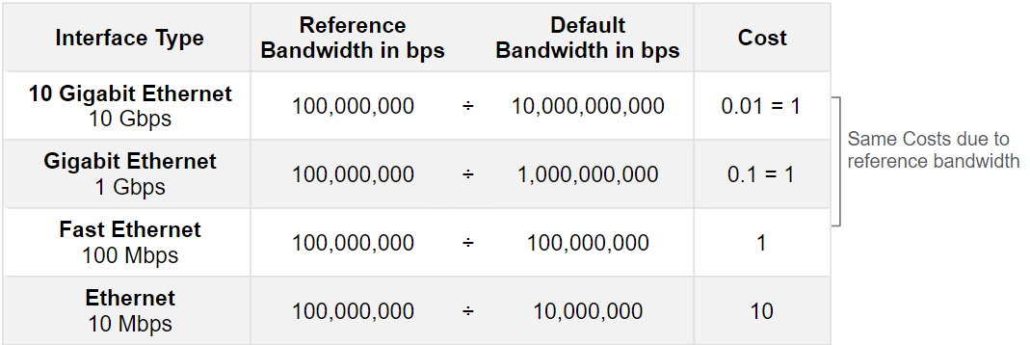

* + Because the OSPF cost value must be an integer, FastEthernet, Gigabit Ethernet, and 10 Gigabit Ethernet (10 GigE) interfaces share the same cost. To correct this situation, you can:
    - Adjust the reference bandwidth with the **auto-cost reference-bandwidth** command on each OSPF router.
    - Manually set the OSPF cost value with the **ip ospf cost** command on necessary interfaces.
* Adjust the Reference Bandwidth:
  + The cost value must be an integer. If something less than an integer is calculated, OSPF rounds up to the nearest integer. Therefore, the OSPF cost assigned to a Gigabit Ethernet interface with the default reference bandwidth of 100,000,000 bps would equal 1, because the nearest integer for 0.1 is 0 instead of 1.
  + For this reason, all interfaces faster than Fast Ethernet will have the same cost value of 1 as a Fast Ethernet interface. To assist OSPF in making the correct path determination, the reference bandwidth must be changed to a higher value to accommodate networks with links faster than 100 Mbps.
  + Changing the reference bandwidth does not actually affect the bandwidth capacity on the link; rather, it simply affects the calculation used to determine the metric. To adjust the reference bandwidth, use the **auto-cost reference-bandwidth *Mbps*** router configuration command.



* + This command must be configured on every router in the OSPF domain. Notice that the value is expressed in Mbps; therefore, to adjust the costs for Gigabit Ethernet, use the command auto-cost reference-bandwidth 1000. For 10 Gigabit Ethernet, use the command auto-cost reference-bandwidth 10000.
  + To return to the default reference bandwidth, use the auto-cost reference-bandwidth 100 command.

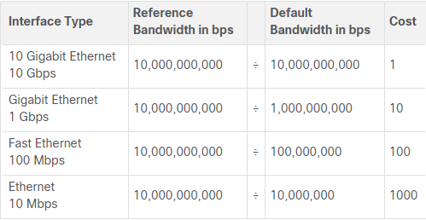

* + The reference bandwidth should be adjusted anytime there are links faster than FastEthernet (100 Mbps).
  + Note: The auto-cost reference-bandwidth command must be configured consistently on all routers in the OSPF domain to ensure accurate route calculations
* OSPF Accumulates costs:
  + The cost of an OSPF route is the accumulated value from one router to the destination network. Assuming the auto-cost reference-bandwidth 10000 command has been configured on all three routers, the cost of the links between each router is now 10. The loopback interfaces have a default cost of 1, as shown in the figure.

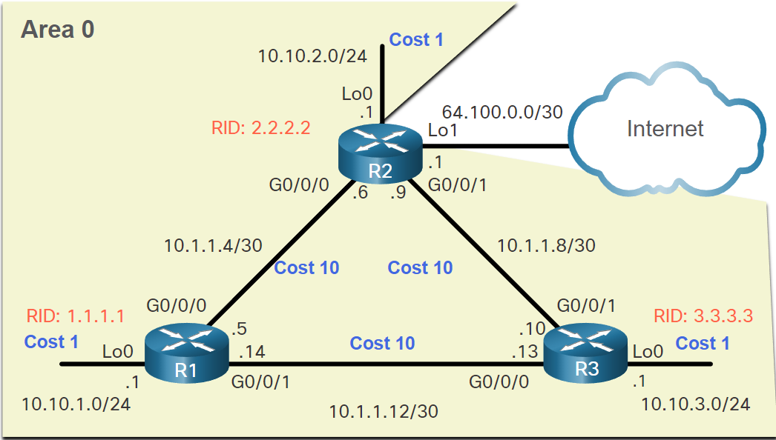

* + Therefore, we can calculate the cost for each router to reach each network. For example, the total cost for R1 to reach the 10.10.2.0/24 network is 11. This is because the link to R2 cost = 10 and the loopback default cost = 1. 10 + 1 = 11.
  + The routing table of R1 in Figure 2 confirms that the metric to reach the R2 LAN is a cost of 11.

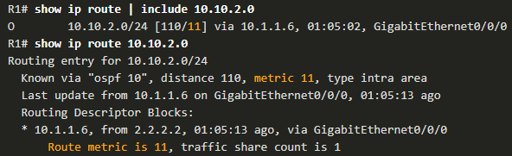

* Manually set OSPF cost value:
  + Note: Changing the cost of link may have undesired consequences. Therefore, adjusting interface cost values should only be configured when the outcome is fully understood.
  + The administrator may want traffic to go through R2 and use R3 as a backup route in case the link between R1 and R2 goes down.
  + Another reason to change the cost value is because other vendors may calculate OSPF in a different manner. By manipulating the cost value, the administrator can make sure the route costs shared between OSPF multivendor routers are accurately reflected in routing tables.
  + To change the cost value reported by the local OSPF router to other OSPF routers, use the interface configuration command **ip ospf cost *value***. In the figure, we need to change cost of the loopback interfaces to 10 to simulate Gigabit Ethernet speeds. In addition, we will change the cost of the link between R2 and R3 to 30 so that this link is used as a backup link.

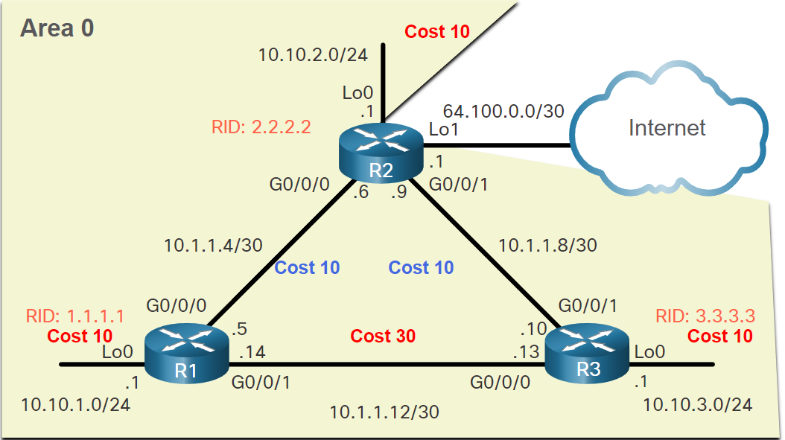

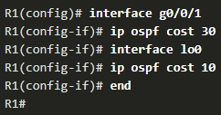

* + Assuming OSPF costs for R2 and R3 have been configured to match the topology in the above figure, the OSPF routes for R1 would have the following cost values. Notice that R1 is no longer load balancing to the 10.1.1.8/30 network. In fact, all routes go through R2 via 10.1.1.6, as desired by the network administrator.

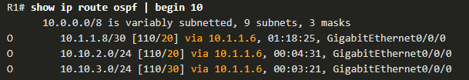

* + Note: Although using the **ip ospf cost** command is the recommended method to manipulate the OSPF cost values, an administrator could also do this by using the interface configuration **bandwidth *kbps*** command. However, that would only work if all the routers are Cisco routers.
* Hello Packet Intervals:
  + OSPFv2 Hello packets are transmitted to multicast address 224.0.0.5 (all OSPF routers) every 10 seconds. This is the default timer value on multiaccess and point-to-point networks.
  + The Dead interval is the period that the router waits to receive a Hello packet before declaring the neighbor down. If the Dead interval expires before the routers receive a Hello packet, OSPF removes that neighbor from its link-state database (LSDB). The router floods the LSDB with information about the down neighbor out all OSPF-enabled interfaces. Cisco uses a default of 4 times the Hello interval. This is 40 seconds on multiaccess and point-to-point networks.
  + Note: On non-broadcast multiaccess (NBMA) networks, the default Hello interval is 30 seconds and the default dead interval is 120 seconds
* Verify Hello and Dead Intervals:
  + The OSPF Hello and Dead intervals are configurable on a per-interface basis. The OSPF intervals must match or a neighbor adjacency does not occur. To verify the currently configured OSPFv2 interface intervals, use the **show ip ospf interface** command

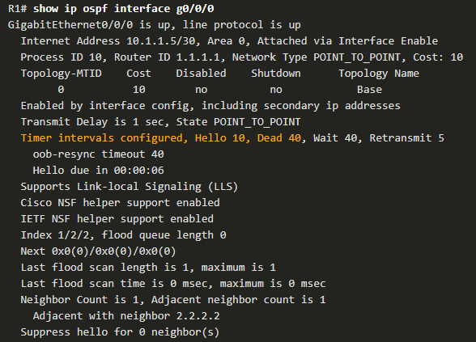

* + Use the show ip ospf neighbor command to see the Dead Time counting down from 40 seconds, as shown in the following example. By default, this value is refreshed every 10 seconds when R1 receives a Hello from the neighbor.

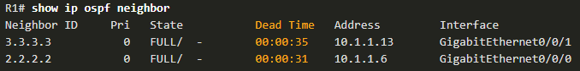

* Modify OSPFv2 Intervals:
  + It may be desirable to change the OSPF timers so that routers detect network failures in less time. Doing this increases traffic, but sometimes the need for quick convergence is more important than the extra traffic it creates.
  + Note: The default Hello and Dead intervals are based on best practices and should only be altered in rare situations.
  + OSPFv2 Hello and Dead intervals can be modified manually using the following interface configuration mode commands:

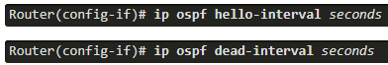

* + Use the **no ip ospf hello-interval** and **no ip ospf dead-interval** commands to reset the intervals to their default.

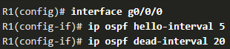

## 2.5 - Default Route Propagation

* Propagate a default static route in OSPFv2:
  + Your network users will need to send packets out of your network to non-OSPF networks, such as the internet. This is where you will need to have a default static route that they can use. In the topology in the figure, R2 is connected to the internet and should propagate a default route to R1 and R3. The router connected to the internet is sometimes called the edge router or the gateway router. However, in OSPF terminology, the router located between an OSPF routing domain and a non-OSPF network is called the autonomous system boundary router (ASBR).

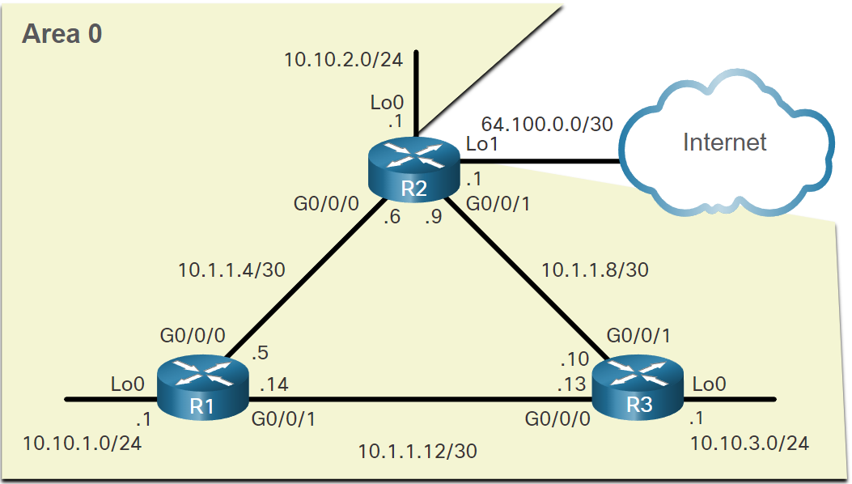

* + All that is required for R2 to reach the internet is a default static route to the service provider.
  + To propagate a default route, the edge router (R2) must be configured with the following:
    - A default static route using the **ip route 0.0.0.0 0.0.0.0 [next-hop-address | exit-intf]** command.
    - The **default-information originate** router configuration command. This instructs R2 to be the source of the default route information and propagate the default static route in OSPF updates.
  + In the following example, R2 is configured with a loopback to simulate a connection to the internet. Then a default route is configured and propagated to all other OSPF routers in the routing domain.
  + Note: When configuring static routes, best practice is to use the next-hop IP address. However, when simulating a connection to the internet, there is no next-hop IP address. Therefore, we use the exit-intf argument

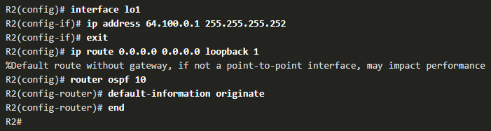

* Verify the propagated default route:
  + You can verify the default route settings on R2 using the **show ip route** command. You can also verify that R1 and R3 received a default route.
  + Notice that the route source on R1 and R3 is O*E2, signifying that it was learned using OSPFv2. The asterisk identifies this as a good candidate for the default route. The E2 designation identifies that it is an external route.

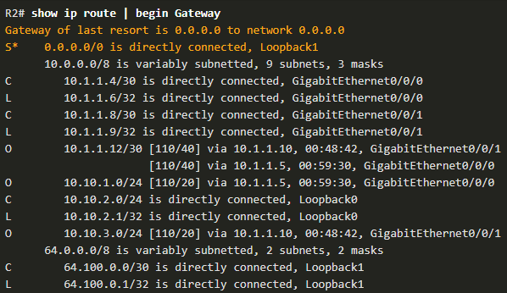

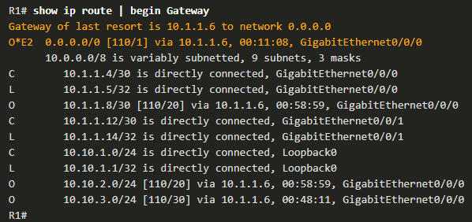

## 2.6 - Verify Single-Area OSPFv2

* As you know, the following two commands are particularly useful for verifying routing:
  + **show ip interface brief** - This verifies that the desired interfaces are active with correct IP addressing.
  + **show ip route** - This verifies that the routing table contains all the expected routes.
* Additional commands for determining that OSPF is operating as expected include the following:
  + **show ip ospf neighbor**
  + **show ip protocols**
  + **show ip ospf**
  + **show ip ospf interface [brief]**
* Use the show ip ospf neighbor command to verify that the router has formed an adjacency with its neighboring routers. If the router ID of the neighboring router is not displayed, or if it does not show as being in a state of FULL, the two routers have not formed an OSPFv2 adjacency.
  + If two routers do not establish adjacency, link-state information is not exchanged. Incomplete LSDBs can cause inaccurate SPF trees and routing tables. Routes to destination networks may not exist, or may not be the most optimum path.
  + Note: A non-DR or BDR router that has a neighbor relationship with another non-DR or BDR router will display a two-way adjacency instead of full.

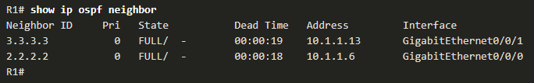

* + For each neighbor, this command displays the following:
    - Neighbor ID - This is the router ID of the neighboring router.
    - Pri - This is the OSPFv2 priority of the interface. This value is used in the DR and BDR election.
    - State - This is the OSPFv2 state of the interface. FULL state means that the router and its neighbor have identical OSPFv2 LSDBs. On multiaccess networks, such as Ethernet, two routers that are adjacent may have their states displayed as 2WAY. The dash indicates that no DR or BDR is required because of the network type.
    - Dead Time - This is the amount of time remaining that the router waits to receive an OSPFv2 Hello packet from the neighbor before declaring the neighbor down. This value is reset when the interface receives a Hello packet.
    - Address - This is the IPv4 address of the interface of the neighbor to which this router is directly connected.
    - Interface - This is the interface on which this router has formed adjacency with the neighbor.
* Two routers may not form an OSPFv2 adjacency if the following occurs:
  + The subnet masks do not match, causing the routers to be on separate networks.
  + The OSPFv2 Hello or Dead Timers do not match.
  + The OSPFv2 Network Types do not match.
  + There is a missing or incorrect OSPFv2 network command.

# 4 - ACL Concepts

## 4.1 - Purpose of ACLs

* What is an ACL?
  + Routers make routing decisions based on information in the packet header. Traffic entering a router interface is routed solely based on information within the routing table. The router compares the destination IP address with routes in the routing table to find the best match and then forwards the packet based on the best match route. That same process can be used to filter traffic using an access control list (ACL).
  + An ACL is a series of IOS commands that are used to filter packets based on information found in the packet header. By default, a router does not have any ACLs configured. However, when an ACL is applied to an interface, the router performs the additional task of evaluating all network packets as they pass through the interface to determine if the packet can be forwarded.
  + An ACL uses a sequential list of permit or deny statements, known as access control entries (ACEs).
  + Note: ACEs are also commonly called ACL statements.
  + When network traffic passes through an interface configured with an ACL, the router compares the information within the packet against each ACE, in sequential order, to determine if the packet matches one of the ACEs. This process is called packet filtering.
  + Several tasks performed by routers require the use of ACLs to identify traffic.

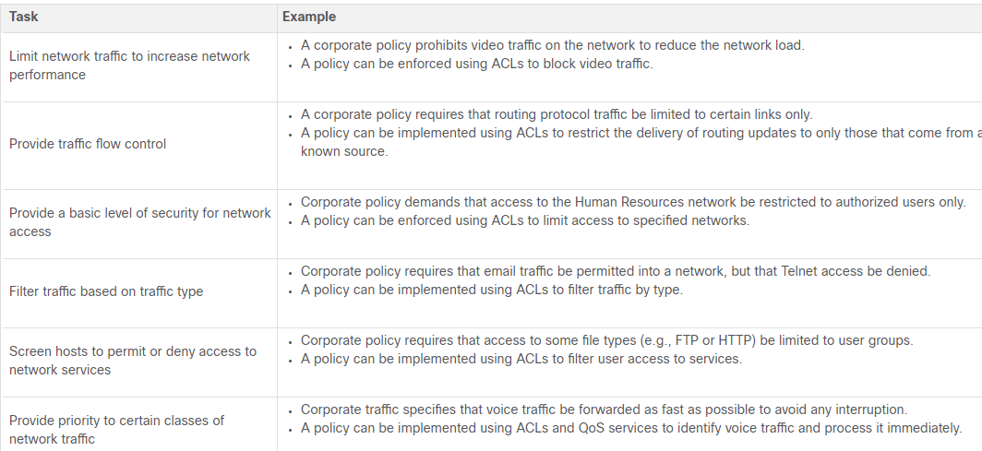

* Packet filtering:
  + Packet filtering controls access to a network by analyzing the incoming and/or outgoing packets and forwarding them or discarding them based on given criteria. Packet filtering can occur at Layer 3 or Layer 4.
* Cisco routers support two types of ACLs:
  + Standard ACLs - ACLs only filter at Layer 3 using the source IPv4 address only.
  + Extended ACLs - ACLs filter at Layer 3 using the source and / or destination IPv4 address. They can also filter at Layer 4 using TCP, UDP ports, and optional protocol type information for finer control.
* ACL Operation:
  + ACLs define the set of rules that give added control for packets that enter inbound interfaces, packets that relay through the router, and packets that exit outbound interfaces of the router.
  + ACLs can be configured to apply to inbound traffic and outbound traffic.
  + Note: ACLs do not act on packets that originate from the router itself.
  + An inbound ACL filters packets before they are routed to the outbound interface. An inbound ACL is efficient because it saves the overhead of routing lookups if the packet is discarded. If the packet is permitted by the ACL, it is then processed for routing. Inbound ACLs are best used to filter packets when the network attached to an inbound interface is the only source of packets that need to be examined.
  + An outbound ACL filters packets after being routed, regardless of the inbound interface. Incoming packets are routed to the outbound interface and then they are processed through the outbound ACL. Outbound ACLs are best used when the same filter will be applied to packets coming from multiple inbound interfaces before exiting the same outbound interface.
  + When an ACL is applied to an interface, it follows a specific operating procedure. For example, here are the operational steps used when traffic has entered a router interface with an inbound standard IPv4 ACL configured.
    1. The router extracts the source IPv4 address from the packet header.
    2. The router starts at the top of the ACL and compares the source IPv4 address to each ACE in a sequential order.
    3. When a match is made, the router carries out the instruction, either permitting or denying the packet, and the remaining ACEs in the ACL, if any, are not analyzed.
    4. If the source IPv4 address does not match any ACEs in the ACL, the packet is discarded because there is an implicit deny ACE automatically applied to all ACLs.
  + The last ACE statement of an ACL is always an implicit deny that blocks all traffic. By default, this statement is automatically implied at the end of an ACL even though it is hidden and not displayed in the configuration.
  + Note: An ACL must have at least one permit statement otherwise all traffic will be denied due to the implicit deny ACE statement.

## 4.2 - Wildcard Masks in ACLs

* Wildcard Mask Overview:
  + An IPv4 ACE uses a 32-bit wildcard mask to determine which bits of the address to examine for a match. Wildcard masks are also used by the Open Shortest Path First (OSPF) routing protocol.
  + A wildcard mask is similar to a subnet mask in that it uses the ANDing process to identify which bits in an IPv4 address to match. However, they differ in the way they match binary 1s and 0s. Unlike a subnet mask, in which binary 1 is equal to a match and binary 0 is not a match, in a wildcard mask, the reverse is true.
  + Wildcard masks use the following rules to match binary 1s and 0s:
    - Wildcard mask bit 0 - Match the corresponding bit value in the address
    - Wildcard mask bit 1 - Ignore the corresponding bit value in the address

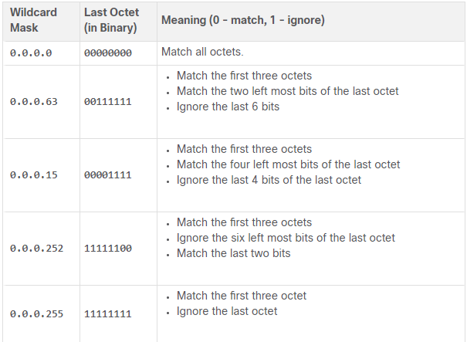

* Wildcard Mask Types:
  + Wildcard to Match a Host
    - In this example, the wildcard mask is used to match a specific host IPv4 address. Assume ACL 10 needs an ACE that only permits the host with IPv4 address 192.168.1.1. Recall that “0” equals a match and “1” equals ignore. To match a specific host IPv4 address, a wildcard mask consisting of all zeroes (i.e., 0.0.0.0) is required.
    - The 0.0.0.0 wildcard mask stipulates that every bit must match exactly. Therefore, when the ACE is processed, the wildcard mask will permit only the 192.168.1.1 address. The resulting ACE in ACL 10 would be **access-list 10 permit 192.168.1.1 0.0.0.0.**

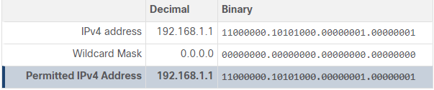

* + Wildcard Mask to Match an IPv4 Subnet
    - In this example, ACL 10 needs an ACE that permits all hosts in the 192.168.1.0/24 network. The wildcard mask 0.0.0.255 stipulates that the very first three octets must match exactly but the fourth octet does not.
    - When processed, the wildcard mask 0.0.0.255 permits all hosts in the 192.168.1.0/24 network. The resulting ACE in ACL 10 would be access-list 10 permit 192.168.1.0 0.0.0.255.

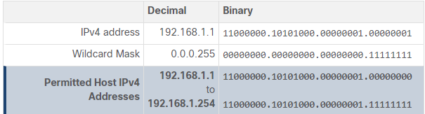

* + Wildcard Mask to Match an IPv4 Address Range
    - In this example, ACL 10 needs an ACE that permits all hosts in the 192.168.16.0/24, 192.168.17.0/24, …, 192.168.31.0/24 networks. The wildcard mask 0.0.15.255 would correctly filter that range of addresses.
    - The highlighted wildcard mask bits identify which bits of the IPv4 address must match. When processed, the wildcard mask 0.0.15.255 permits all hosts in the 192.168.16.0/24 to 192.168.31.0/24 networks. The resulting ACE in ACL 10 would be **access-list 10 permit 192.168.16.0 0.0.15.255**.

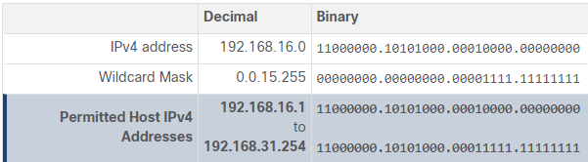

* Wildcard Mask Calculation:
  + Calculating wildcard masks can be challenging. One shortcut method is to subtract the subnet mask from 255.255.255.255.
  + Consider an example in which you need an ACL number 10 to match networks in the range between 192.168.16.0/24 to 192.168.31.0/24. This network range could be summarized as 192.168.16.0/20 which is a subnet mask of 255.255.240.0. Therefore, subtract 255.255.240.0 subnet mask from 255.255.255.255

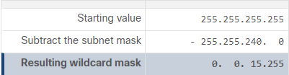

* + This solution produces the wildcard mask 0.0.15.255. Therefore, the ACE would be **access-list 10 permit 192.168.16.0 0.0.15.255**.
* Wildcard Mask Keywords:
  + Working with decimal representations of binary wildcard mask bits can be tedious. To simplify this task, the Cisco IOS provides two keywords to identify the most common uses of wildcard masking. Keywords reduce ACL keystrokes and make it easier to read the ACE.
  + The two keywords are:
    - host - This keyword substitutes for the 0.0.0.0 mask. This mask states that all IPv4 address bits must match to filter just one host address.
    - any - This keyword substitutes for the 255.255.255.255 mask. This mask says to ignore the entire IPv4 address or to accept any addresses.

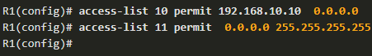

=

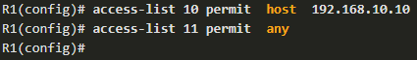

## 4.3 - Guidelines for ACL Creation

* Limited Number of ACLs per Interface:
  + There is a limit on the number of ACLs that can be applied on a router interface. For example, a dual-stacked (i.e., IPv4 and IPv6) router interface can have up to four ACLs applied.
  + Specifically, a router interface can have:
    - one outbound IPv4 ACL
    - one inbound IPv4 ACL
    - one inbound IPv6 ACL
    - one outbound IPv6 ACL

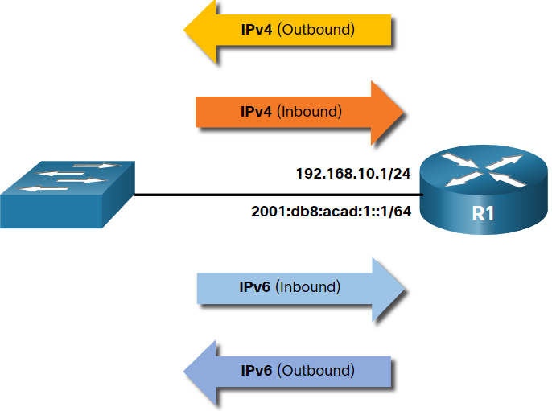

* ACL Best Practices:

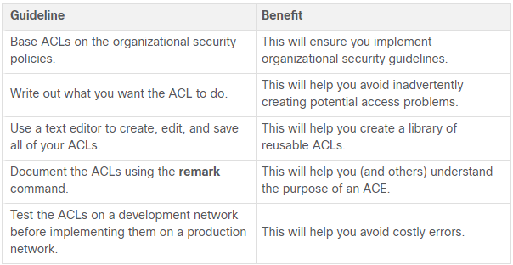

## 4.4 - Types of IPv4 ACLs

* Standard and Extended ACLs:
  + There are two types of IPv4 ACLs:
    - Standard ACLs - These permit or deny packets based only on the source IPv4 address.
    - Extended ACLs - These permit or deny packets based on the source IPv4 address and destination IPv4 address, protocol type, source and destination TCP or UDP ports and more.

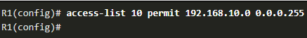



* Numbered ACLs:
  + ACLs number 1 to 99, or 1300 to 1999 are standard ACLs while ACLs number 100 to 199, or 2000 to 2699 are extended ACLs

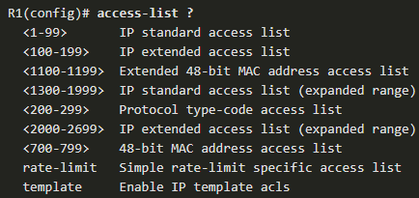

* Named ACLs:
  + Named ACLs is the preferred method to use when configuring ACLs. Specifically, standard and extended ACLs can be named to provide information about the purpose of the ACL. For example, naming an extended ACL FTP-FILTER is far better than having a numbered ACL 100.
  + The **ip access-list** global configuration command is used to create a named ACL.

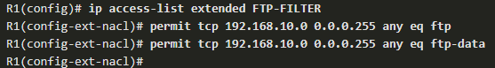

* + The following summarizes the rules to follow for named ACLs.
    - Assign a name to identify the purpose of the ACL.
    - Names can contain alphanumeric characters.
    - Names cannot contain spaces or punctuation.
    - It is suggested that the name be written in CAPITAL LETTERS.
    - Entries can be added or deleted within the ACL.
* Where to place ACLs:
  + Every ACL should be placed where it has the greatest impact on efficiency.

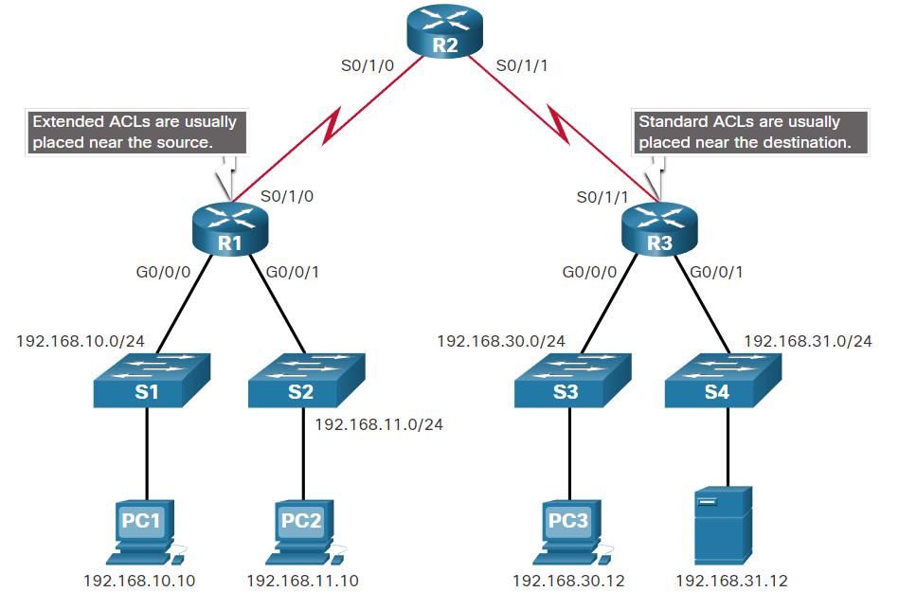

* + Extended ACLs should be located as close as possible to the source of the traffic to be filtered. This way, undesirable traffic is denied close to the source network without crossing the network infrastructure.
  + Standard ACLs should be located as close to the destination as possible. If a standard ACL was placed at the source of the traffic, the "permit" or "deny" will occur based on the given source address no matter where the traffic is destined.

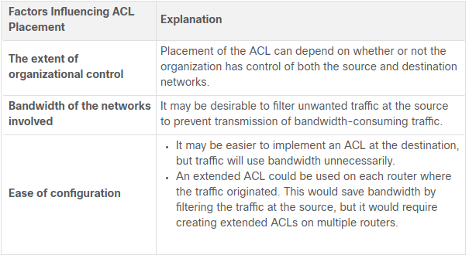

* + See cursus for example

# 5 - ACLs for IPv4 Configuration

## 5.1 - Configure Standard IPv4 ACLs

* Create an ACL:
  + All access control lists (ACLs) must be planned. However, this is especially true for ACLs requiring multiple access control entries (ACEs).
  + When configuring a complex ACL, it is suggested that you:
    - Use a text editor and write out the specifics of the policy to be implemented.
    - Add the IOS configuration commands to accomplish those tasks.
    - Include remarks to document the ACL.
    - Copy and paste the commands onto the device.
    - Always thoroughly test an ACL to ensure that it correctly applies the desired policy.
  + These recommendations enable you to create the ACL thoughtfully without impacting the traffic on the network.
* Numbered Standard IPv4 ACL Syntax:
  + To create a numbered standard ACL, use the following global configuration command:



* + Use the no access-list access-list-number global configuration command to remove a numbered standard ACL.

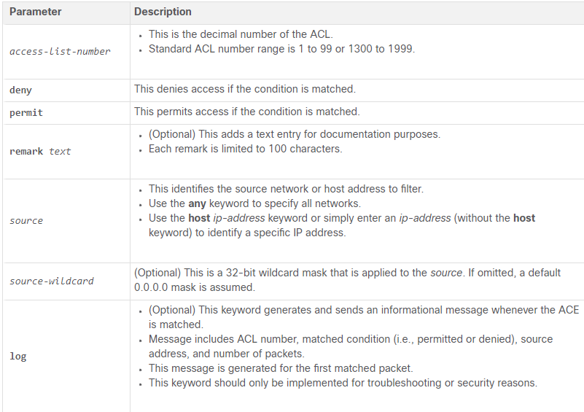

* Named standard IPv4 ACL Syntax:
  + Naming an ACL makes it easier to understand its function. To create a named standard ACL, use the following global configuration command:



* + This command enters the named standard configuration mode where you configure the ACL ACEs.
  + ACL names are alphanumeric, case sensitive, and must be unique. Capitalizing ACL names is not required but makes them stand out when viewing the running-config output. It also makes it less likely that you will accidentally create two different ACLs with the same name but with different uses of capitalization.
  + Note: Use the no ip access-list standard access-list-name global configuration command to remove a named standard IPv4 ACL.

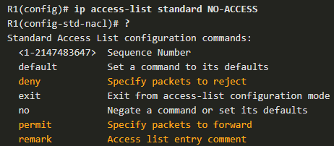

* Apply a Standard IPv4 ACL:
  + After a standard IPv4 ACL is configured, it must be linked to an interface or feature. The following command can be used to bind a numbered or named standard IPv4 ACL to an interface:



* + To remove an ACL from an interface, first enter the **no ip access-group** interface configuration command. However, the ACL will still be configured on the router. To remove the ACL from the router, use the **no access-list** global configuration command.
* For examples check cursus

## 5.2 - Modify IPv4 ACLs

* Two Methods to Modify an ACL:
  + After an ACL is configured, it may need to be modified. ACLs with multiple ACEs can be complex to configure. Sometimes the configured ACE does not yield the expected behaviors. For these reasons, ACLs may initially require a bit of trial and error to achieve the desired filtering result.
  + This section will discuss two methods to use when modifying an ACL:
    - Use a Text Editor
    - Use Sequence Numbers
* Text Editor Method:
  + ACLs with multiple ACEs should be created in a text editor. This allows you to plan the required ACEs, create the ACL, and then paste it into the router interface. It also simplifies the tasks to edit and fix an ACL.
  + For example, assume ACL 1 was entered incorrectly using 19 instead of 192 for the first octet, as shown in the running configuration.

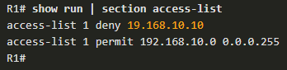

* + To correct the error:
    - Copy the ACL from the running configuration and paste it into the text editor.
    - Make the necessary edits changes.
    - Remove the previously configured ACL on the router otherwise, pasting the edited ACL commands will only append (i.e., add) to the existing ACL ACEs on the router.
    - Copy and paste the edited ACL back to the router.

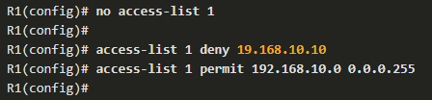

* Sequence Numbers Method:
  + An ACL ACE can also be deleted or added using the ACL sequence numbers. Sequence numbers are automatically assigned when an ACE is entered. These numbers are listed in the **show access-lists** command. The **show running-config** command does not display sequence numbers.
  + In the previous example, the incorrect ACE for ACL 1 is using sequence number 10, as shown in the example.

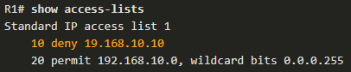

* + Use the **ip access-list standard** command to edit an ACL. Statements cannot be overwritten using the same sequence number as an existing statement. Therefore, the current statement must be deleted first with the **no 10** command. Then the correct ACE can be added using sequence number 10 is configured. Verify the changes using the **show access-lists** command

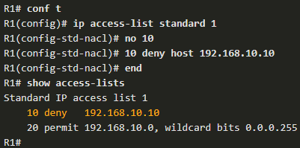

* Modify a Named ACL Example:

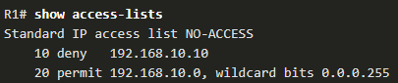

* + Assume that host 192.168.10.5 from the 192.168.10.0/24 network should also have been denied. If you entered a new ACE, it would be appended to the end of the ACL. Therefore, the host would never be denied because ACE 20 permits all hosts from that network.
  + The solution is to add an ACE denying host 192.168.10.5 in between ACE 10 and ACE 20, such as ACE 15, as shown in the example. Also notice that the new ACE was entered without using the host keyword. The keyword is optional when specifying a destination host.
  + Use the show access-lists command to verify the ACL now has a new ACE 15 inserted appropriately before the permit statement.
  + Notice that sequence number 15 is displayed prior to sequence number 10. We might expect the order of the statements in the output to reflect the order in which they were entered. However, the IOS puts host statements in an order using a special hashing function. The resulting order optimizes the ACL to search by host entries first, and then by network entries.
  + Note: The hashing function is only applied to host statements in an IPv4 standard access list.

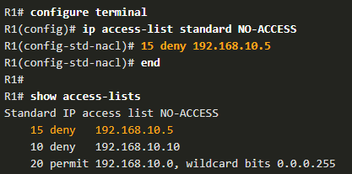

* ACL statistics:
  + Notice that the **show access-lists** command in the example shows statistics for each statement that has been matched. The deny ACE in the NO-ACCESS ACL has been matched 20 times and the permit ACE has been matched 64 times.
  + Note that the implied **deny any** the last statement does not display any statistics. To track how many implicit denied packets have been matched, you must manually configure the deny any command at the end of the ACL.
  + Use the **clear access-list counters** command to clear the ACL statistics. This command can be used alone or with the number or name of a specific ACL.

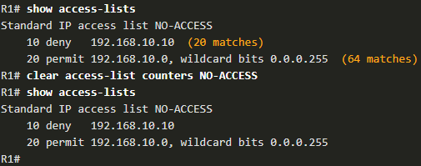

## 5.3 - Secure VTY Ports with a Standard IPv4 ACL

* The access-class command:
  + ACLs typically filter incoming or outgoing traffic on an interface. However, an ACL can also be used to secure remote administrative access to a device using the vty lines.
  + Use the following two steps to secure remote administrative access to the vty lines:
    - Create an ACL to identify which administrative hosts should be allowed remote access.
    - Apply the ACL to incoming traffic on the vty lines.
  + Use the following command to apply an ACL to the vty lines:



* + The **in** keyword is the most commonly used option to filter incoming vty traffic. The out parameter filters outgoing vty traffic and is rarely applied.
  + The following should be considered when configuring access lists on vty lines:
    - Both named and numbered access lists can be applied to vty lines.
    - Identical restrictions should be set on all the vty lines, because a user can attempt to connect to any of them.
* Example:
  + To increase secure access, a username and password will be created, and the login local authentication method will be used on the vty lines. The command in the example creates a local database entry for a user ADMIN and password class.
  + A named standard ACL called ADMIN-HOST is created and identifies PC1. Notice that the deny any has been configured to track the number of times access has been denied.
  + The vty lines are configured to use the local database for authentication, permit Telnet traffic, and use the ADMIN-HOST ACL to restrict traffic.

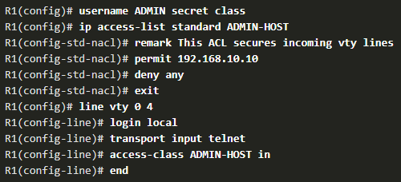

* + In a production environment, you would set the vty lines to only allow SSH

## 5.4 - Configure Extended IPv4 ACLs

* Extended ACLs:
  + Standard ACLs only filter on source address. When more precise traffic-filtering control is required, extended IPv4 ACLs can be created.
  + Extended ACLs are used more often than standard ACLs because they provide a greater degree of control. They can filter on source address, destination address, protocol (i.e., IP, TCP, UDP, ICMP), and port number. This provides a greater range of criteria on which to base the ACL.
  + Like standard ACLs, extended ACLs can be created as:
    - Numbered Extended ACL - Created using the **access-list *access-list-number*** global configuration command.
    - Named Extended ACL - Created using the **ip access-list extended *access-list-name***.
* Numbered Extended IPv4 ACL Syntax:
  + The procedural steps for configuring extended ACLs are the same as for standard ACLs. The extended ACL is first configured, and then it is activated on an interface. However, the command syntax and parameters are more complex to support the additional features provided by extended ACLs.
  + To create a numbered extended ACL, use the following global configuration command:



* + Use the no access-list access-list-number global configuration command to remove an extended ACL.

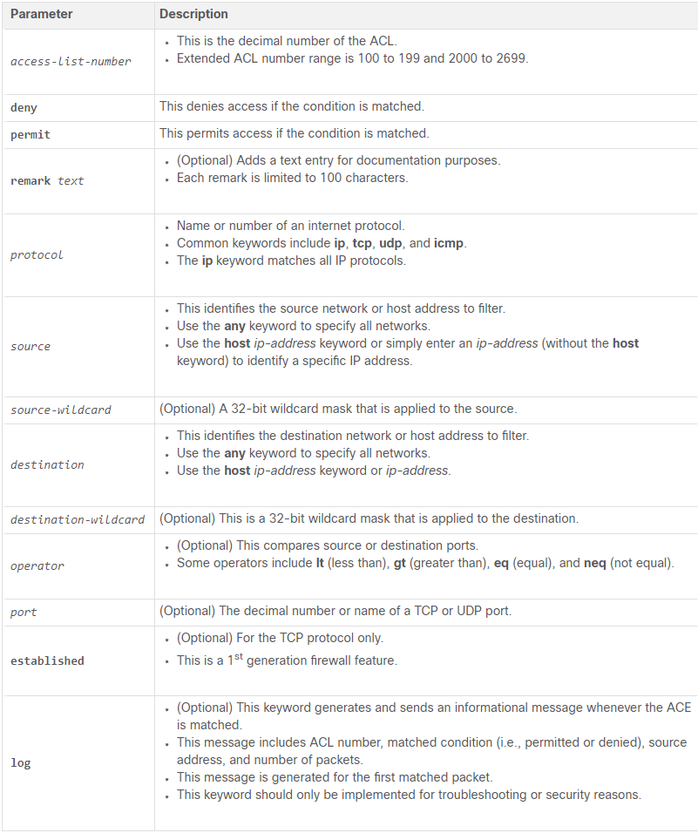

* + The command to apply an extended IPv4 ACL to an interface is the same as the command used for standard IPv4 ACLs.



* + To remove an ACL from an interface, first enter the no ip access-group interface configuration command. To remove the ACL from the router, use the no access-list global configuration command.
  + Note: The internal logic applied to the ordering of standard ACL statements does not apply to extended ACLs. The order in which the statements are entered during configuration is the order they are displayed and processed.
* Protocols and ports:
  + Protocol options:

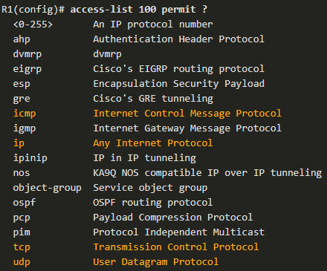

* + - Note: If an internet protocol is not listed, then the IP protocol number could be specified. For instance, the ICMP protocol number 1, TCP is 6, and UDP is 17.
  + Port Keyword Options:
    - Selecting a protocol influences port options. For instance, selecting the tcp protocol would provide TCP related ports options
    - Port names or number can be specified. However, port names make it easier to understand the purpose of an ACE. Notice how some common ports names (e.g., SSH and HTTPS) are not listed. For these protocols, port numbers will have to be specified.

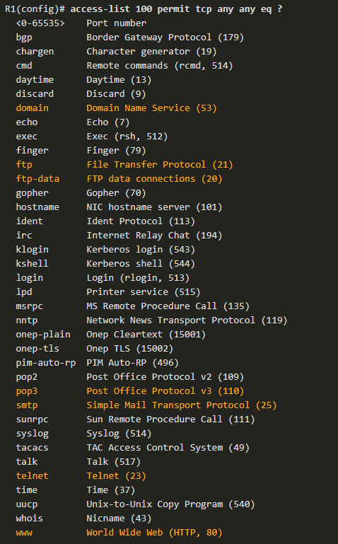

* Protocols and Port Numbers Configuration Examples:
  + This example configures an extended ACL 100 to filter HTTP traffic.

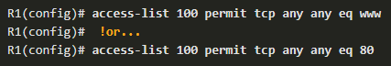

* + Configuring the port number is required when there is not a specific protocol name listed such as SSH (port number 22) or an HTTPS (port number 443)

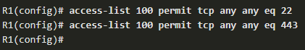

* Apply a Numbered Extended IPv4 ACL:
  + In this example, the ACL permits both HTTP and HTTPS traffic from the 192.168.10.0 network to go to any destination.
  + Extended ACLs can be applied in various locations. However, they are commonly applied close to the source. Therefore, ACL 110 was applied inbound on the R1 G0/0/0 interface.

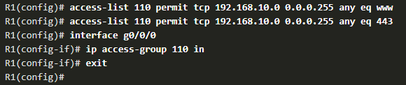

* TCP Established Extended ACL:
  + TCP can also perform basic stateful firewall services using the TCP established keyword. The keyword enables inside traffic to exit the inside private network and permits the returning reply traffic to enter the inside private network

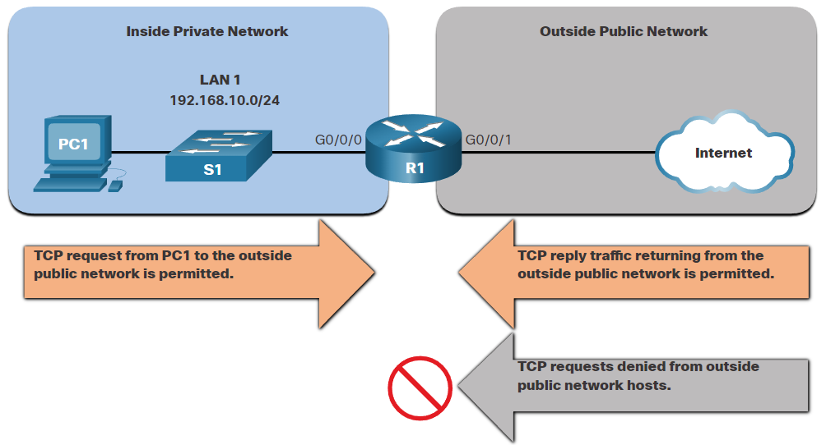

* + However, TCP traffic generated by an outside host and attempting to communicate with an inside host is denied.
  + The established keyword can be used to permit only the return HTTP traffic from requested websites, while denying all other traffic.
  + In the topology, the design for this example shows that ACL 110, which was previously configured, will filter traffic from the inside private network. ACL 120, using the established keyword, will filter traffic coming into the inside private network from the outside public network.

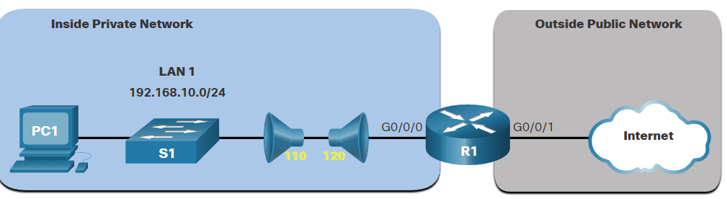

* + In the example, ACL 120 is configured to only permit returning web traffic to the inside hosts. The new ACL is then applied outbound on the R1 G0/0/0 interface. The show access-lists command displays both ACLs. Notice from the match statistics that inside hosts have been accessing the secure web resources from the internet.

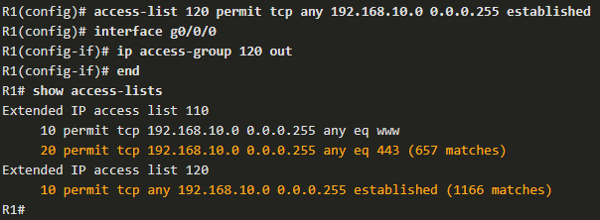

* + Notice that the permit secure HTTPS counters (i.e., eq 443) in ACL 110 and the return established counters in ACL 120 have increased.
  + The established parameter allows only responses to traffic that originates from the 192.168.10.0/24 network to return to that network. Specifically, a match occurs if the returning TCP segment has the ACK or reset (RST) flag bits set. This indicates that the packet belongs to an existing connection. Without the established parameter in the ACL statement, clients could send traffic to a web server, and receive traffic returning from the web server. All traffic would be permitted.
* Named Extended IPv4 ACL Syntax:
  + Naming an ACL makes it easier to understand its function. To create a named extended ACL, use the following global configuration command:



* + This command enters the named extended configuration mode. Recall that ACL names are alphanumeric, case sensitive, and must be unique.
* Named Extended IPv4 ACL Example:
  + The topology in the figure is used to demonstrate configuring and applying two named extended IPv4 ACLs to an interface:
    - SURFING - This will permit inside HTTP and HTTPS traffic to exit to the internet.
    - BROWSING - This will only permit returning web traffic to the inside hosts while all other traffic exiting the R1 G0/0/0 interface is implicitly denied.

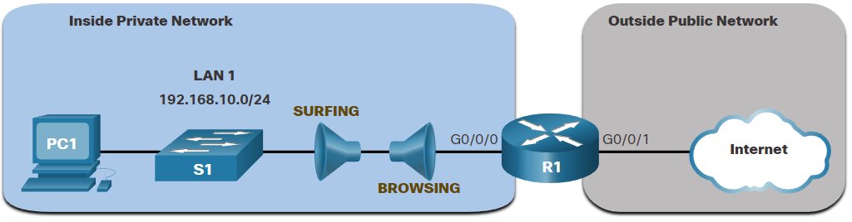

* + The SURFING ACL permits HTTP and HTTPS traffic from inside users to exit the G0/0/1 interface connected to the internet. Web traffic returning from the internet is permitted back into the inside private network by the BROWSING ACL.
  + The SURFING ACL is applied inbound and the BROWSING ACL applied outbound on the R1 G0/0/0 interface, as shown in the output.
  + Inside hosts have been accessing the secure web resources from the internet. The show access-lists command is used to verify the ACL statistics. Notice that the permit secure HTTPS counters (i.e., eq 443) in the SURFING ACL and the return established counters in the BROWSING ACL have increased.

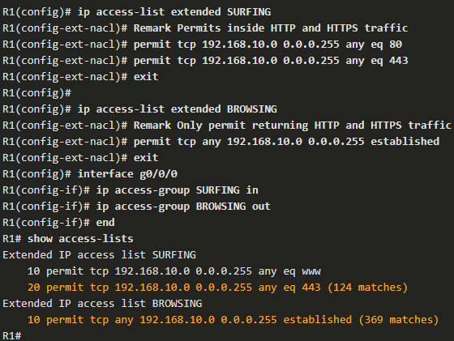

* Edit Extended ACLs:
  + Like standard ACLs, an extended ACL can be edited using a text editor when many changes are required. Otherwise, if the edit applies to one or two ACEs, then sequence numbers can be used.
  + Example:

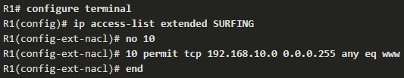

* Verify Extended ACLs:
  + The **show ip interface** command is used to verify the ACL on the interface and the direction in which it was applied
  + The **show access-lists** command can be used to confirm that the ACLs work as expected. The command displays statistic counters that increase whenever an ACE is matched.
    - Note: Traffic must be generated to verify the operation of the ACL.
    - Also, notice that extended ACLs do not implement the same internal logic and hashing function as standard ACLs. The output and sequence numbers displayed in the show access-lists command output is the order in which the statements were entered. Host entries are not automatically listed prior to range entries.
  + The show running-config command can be used to validate what was configured.

# 6 - NAT for IPv4

## 6.1 - NAT Characteristics

* IPv4 Private Address Space:
  + As you know, there are not enough public IPv4 addresses to assign a unique address to each device connected to the internet. Networks are commonly implemented using private IPv4 addresses, as defined in RFC 1918

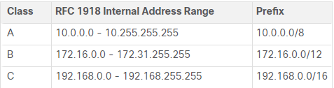

* + These private addresses are used within an organization or site to allow devices to communicate locally. However, because these addresses do not identify any single company or organization, private IPv4 addresses cannot be routed over the internet. To allow a device with a private IPv4 address to access devices and resources outside of the local network, the private address must first be translated to a public address.
  + NAT provides the translation of private addresses to public addresses. This allows a device with a private IPv4 address to access resources outside of their private network, such as those found on the internet. NAT, combined with private IPv4 addresses, has been the primary method of preserving public IPv4 addresses. A single, public IPv4 address can be shared by hundreds, even thousands of devices, each configured with a unique private IPv4 address
* What is NAT?
  + NAT has many uses, but its primary use is to conserve public IPv4 addresses. It does this by allowing networks to use private IPv4 addresses internally and providing translation to a public address only when needed. NAT has a perceived benefit of adding a degree of privacy and security to a network, because it hides internal IPv4 addresses from outside networks.
  + NAT-enabled routers can be configured with one or more valid public IPv4 addresses. These public addresses are known as the NAT pool. When an internal device sends traffic out of the network, the NAT-enabled router translates the internal IPv4 address of the device to a public address from the NAT pool. To outside devices, all traffic entering and exiting the network appears to have a public IPv4 address from the provided pool of addresses.
  + A NAT router typically operates at the border of a stub network. A stub network is one or more networks with a single connection to its neighboring network, one way in and one way out of the network

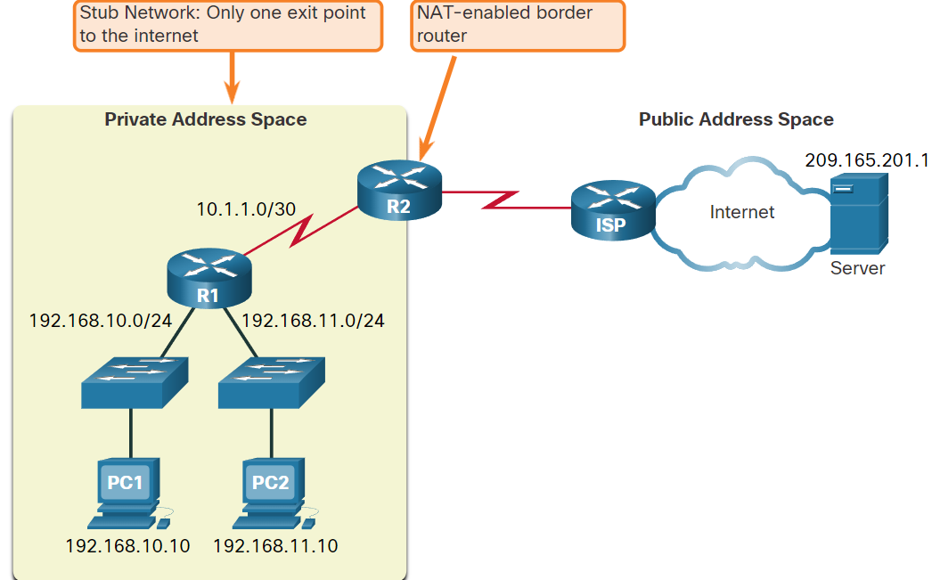

* + When a device inside the stub network wants to communicate with a device outside of its network, the packet is forwarded to the border router. The border router performs the NAT process, translating the internal private address of the device to a public, outside, routable address.
  + Note: The connection to the ISP may use a private address or a public address that is shared among customers. For the purposes of this module, a public address is shown.
* NAT Terminology:
  + In NAT terminology, the inside network is the set of networks that is subject to translation. The outside network refers to all other networks.
  + When using NAT, IPv4 addresses have different designations based on whether they are on the private network, or on the public network (internet), and whether the traffic is incoming or outgoing.
  + NAT includes four types of addresses:
    - Inside local address
    - Inside global address
    - Outside local address
    - Outside global address
  + When determining which type of address is used, it is important to remember that NAT terminology is always applied from the perspective of the device with the translated address:
    - Inside address - The address of the device which is being translated by NAT.
    - Outside address - The address of the destination device.
  + NAT also uses the concept of local or global with respect to addresses:
    - Local address - A local address is any address that appears on the inside portion of the network.
    - Global address - A global address is any address that appears on the outside portion of the network.
  + The terms, inside and outside, are combined with the terms local and global to refer to specific addresses.

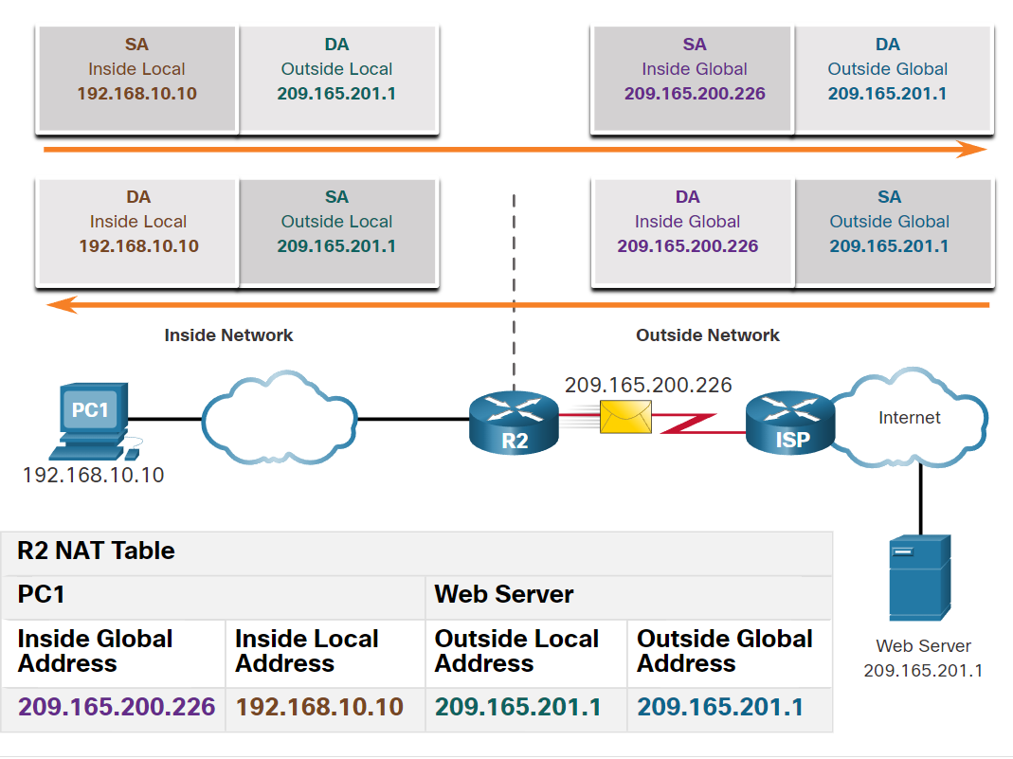

* + Most often the outside local and outside global addresses are the same.

## 6.2 - Types of NAT

* Static NAT:
  + Static NAT uses a one-to-one mapping of local and global addresses. These mappings are configured by the network administrator and remain constant.

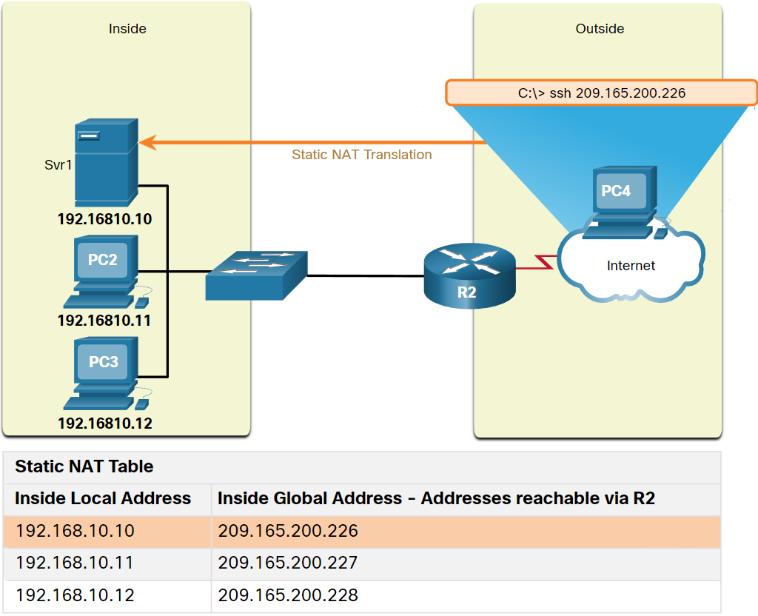

* + Static NAT is particularly useful for web servers or devices that must have a consistent address that is accessible from the internet, such as a company web server. It is also useful for devices that must be accessible by authorized personnel when offsite, but not by the general public on the internet. For example, a network administrator from PC4 can use SSH to gain access to the inside global address of Svr1 (209.165.200.226). R2 translates this inside global address to the inside local address 192.168.10.10 and connects the session to Svr1.
  + Static NAT requires that enough public addresses are available to satisfy the total number of simultaneous user sessions.
* Dynamic NAT:
  + Dynamic NAT uses a pool of public addresses and assigns them on a first-come, first-served basis. When an inside device requests access to an outside network, dynamic NAT assigns an available public IPv4 address from the pool.

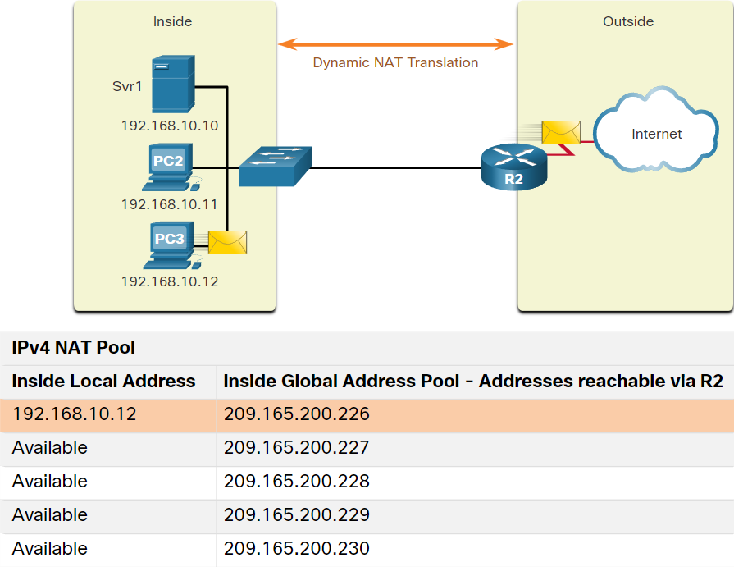

* + Similar to static NAT, dynamic NAT requires that enough public addresses are available to satisfy the total number of simultaneous user sessions.
* Port Address Translation:
  + Port Address Translation (PAT), also known as NAT overload, maps multiple private IPv4 addresses to a single public IPv4 address or a few addresses. This is what most home routers do. The ISP assigns one address to the router, yet several members of the household can simultaneously access the internet. This is the most common form of NAT for both the home and the enterprise.
  + With PAT, multiple addresses can be mapped to one or to a few addresses, because each private address is also tracked by a port number. When a device initiates a TCP/IP session, it generates a TCP or UDP source port value, or a specially assigned query ID for ICMP, to uniquely identify the session. When the NAT router receives a packet from the client, it uses its source port number to uniquely identify the specific NAT translation.
  + PAT ensures that devices use a different TCP port number for each session with a server on the internet. When a response comes back from the server, the source port number, which becomes the destination port number on the return trip, determines to which device the router forwards the packets. The PAT process also validates that the incoming packets were requested, thus adding a degree of security to the session.
* Next Available Port:
  + In the previous example, the client port numbers, 1331 and 1555, did not change at the NAT-enabled router. This is not a very likely scenario, because there is a good chance that these port numbers may have already been attached to other active sessions.
  + PAT attempts to preserve the original source port. However, if the original source port is already used, PAT assigns the first available port number starting from the beginning of the appropriate port group 0-511, 512-1,023, or 1,024-65,535. When there are no more ports available and there is more than one external address in the address pool, PAT moves to the next address to try to allocate the original source port. This process continues until there are no more available ports or external IPv4 addresses.
  + When packets are returned from outside the network, if the source port number was previously modified by the NAT-enable router, the destination port number will now be changed back to the original port number by the NAT-enabled router.
* NAT and PAT comparison:

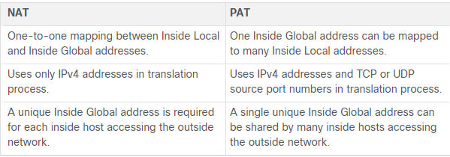

* + NAT:

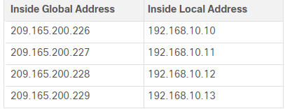

* + PAT:

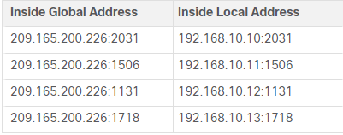

* Packets Without a Layer 4 Segment:
  + What about IPv4 packets carrying data other than a TCP or UDP segment? These packets do not contain a Layer 4 port number. PAT translates most common protocols carried by IPv4 that do not use TCP or UDP as a transport layer protocol. The most common of these is ICMPv4. Each of these types of protocols is handled differently by PAT. For example, ICMPv4 query messages, echo requests, and echo replies include a Query ID. ICMPv4 uses the Query ID to identify an echo request with its corresponding echo reply. The Query ID is incremented with each echo request sent. PAT uses the Query ID instead of a Layer 4 port number.
  + Note: Other ICMPv4 messages do not use the Query ID. These messages and other protocols that do not use TCP or UDP port numbers vary and are beyond the scope of this curriculum.

## 6.3 - NAT Advantages and Disadvantages

* Advantages of NAT:
  + NAT conserves the legally registered addressing scheme by allowing the privatization of intranets. NAT conserves addresses through application port-level multiplexing. With NAT overload (PAT), internal hosts can share a single public IPv4 address for all external communications. In this type of configuration, very few external addresses are required to support many internal hosts.
  + NAT increases the flexibility of connections to the public network. Multiple pools, backup pools, and load-balancing pools can be implemented to ensure reliable public network connections.
  + NAT provides consistency for internal network addressing schemes. On a network not using private IPv4 addresses and NAT, changing the public IPv4 address scheme requires the readdressing of all hosts on the existing network. The costs of readdressing hosts can be significant. NAT allows the existing private IPv4 address scheme to remain while allowing for easy change to a new public addressing scheme. This means an organization could change ISPs and not need to change any of its inside clients.
  + Using RFC 1918 IPv4 addresses, NAT hides the IPv4 addresses of users and other devices. Some people consider this a security feature; however, most experts agree that NAT does not provide security. A stateful firewall is what provides security on the edge of the network.
* Disadvantages of NAT:
  + One disadvantage of using NAT is related to network performance, particularly for real time protocols such as VoIP. NAT increases forwarding delays because the translation of each IPv4 address within the packet headers takes time. The first packet is always process-switched going through the slower path. The router must look at every packet to decide whether it needs translation. The router must alter the IPv4 header, and possibly alter the TCP or UDP header. The IPv4 header checksum, along with the TCP or UDP checksum must be recalculated each time a translation is made. Remaining packets go through the fast-switched path if a cache entry exists; otherwise, they too are delayed.
  + The forwarding delays caused by the NAT process becomes more of an issue as the pools of public IPv4 addresses for ISPs become depleted. Many ISPs are having to assign customers a private IPv4 address instead of a public IPv4 address. This means the customer's router translates the packet from its private IPv4 address to the private IPv4 address of the ISP. Before forwarding the packet to another provider, the ISP will then perform NAT again, translating its private IPv4 addresses to one of its limited number of public IPv4 addresses. This process of two layers of NAT translation is known as Carrier Grade NAT (CGN).
  + Another disadvantage of using NAT is that end-to-end addressing is lost. This is known as the end-to-end principle. Many internet protocols and applications depend on end-to-end addressing from the source to the destination. Some applications do not work with NAT. For example, some security applications, such as digital signatures, fail because the source IPv4 address changes before reaching the destination. Applications that use physical addresses, instead of a qualified domain name, do not reach destinations that are translated across the NAT router. Sometimes, this problem can be avoided by implementing static NAT mappings.
  + End-to-end IPv4 traceability is also lost. It becomes much more difficult to trace packets that undergo numerous packet address changes over multiple NAT hops, making troubleshooting challenging.
  + Using NAT also complicates the use of tunneling protocols, such as IPsec, because NAT modifies values in the headers, causing integrity checks to fail.
  + Services that require the initiation of TCP connections from the outside network, or stateless protocols, such as those using UDP, can be disrupted. Unless the NAT router has been configured to support such protocols, incoming packets cannot reach their destination. Some protocols can accommodate one instance of NAT between participating hosts (passive mode FTP, for example), but fail when both systems are separated from the internet by NAT.

## 6.4 - Static NAT

* Static NAT scenario:
  + Static NAT is a one-to-one mapping between an inside address and an outside address. Static NAT allows external devices to initiate connections to internal devices using the statically assigned public address. For instance, an internal web server may be mapped to a specific inside global address so that it is accessible from outside networks.

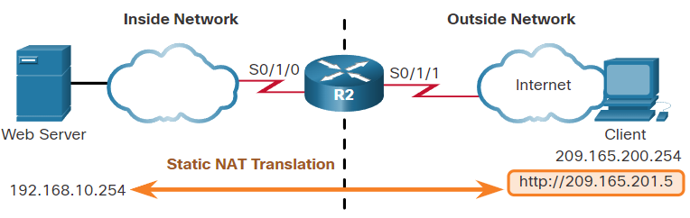

* + The figure shows an inside network containing a web server with a private IPv4 address. Router R2 is configured with static NAT to allow devices on the outside network (internet) to access the web server. The client on the outside network accesses the web server using a public IPv4 address. Static NAT translates the public IPv4 address to the private IPv4 address.
* Configure Static NAT:
  + Step 1. The first task is to create a mapping between the inside local address and the inside global addresses. For example, the 192.168.10.254 inside local address and the 209.165.201.5 inside global address in the figure are configured as a static NAT translation.



* + Step 2. After the mapping is configured, the interfaces participating in the translation are configured as inside or outside relative to NAT. In the example, the R2 Serial 0/1/0 interface is an inside interface and Serial 0/1/1 is an outside interface.

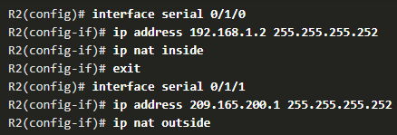

* + With this configuration in place, packets arriving on the inside interface of R2 (Serial 0/1/0) from the configured inside local IPv4 address (192.168.10.254) are translated and then forwarded towards the outside network. Packets arriving on the outside interface of R2 (Serial 0/1/1), that are addressed to the configured inside global IPv4 address (209.165.201.5), are translated to the inside local address (192.168.10.254) and then forwarded to the inside network.
* Analyse Static NAT

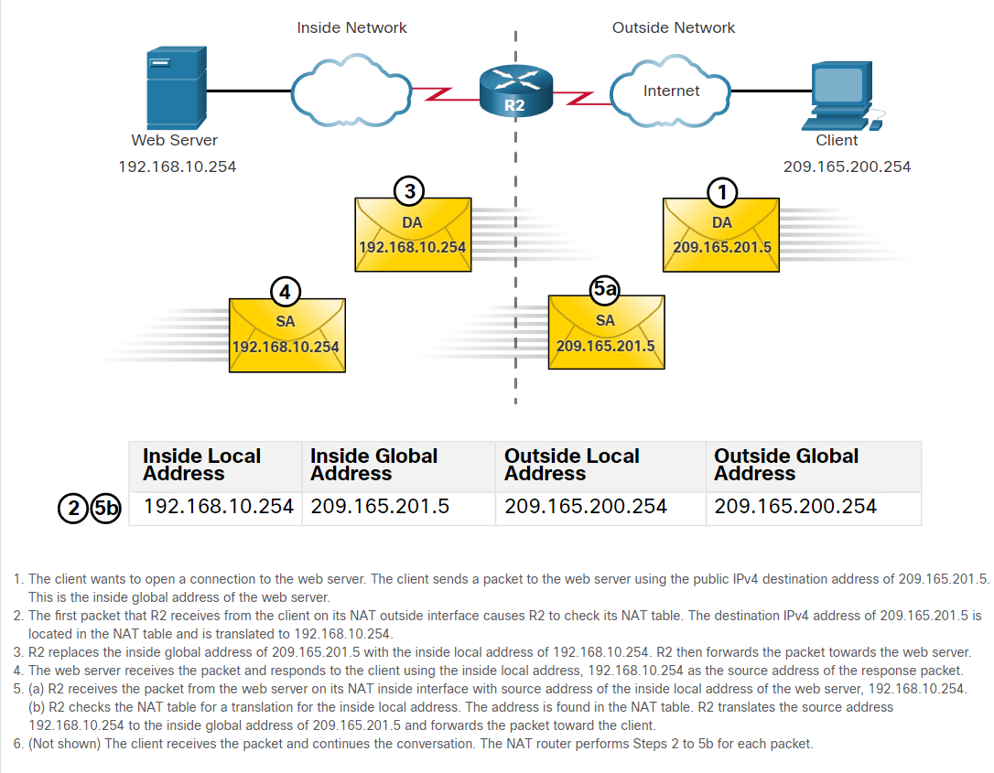

* Verify Static NAT:
  + To verify NAT operation, issue the **show ip nat translations** command. This command shows active NAT translations. Because the example is a static NAT configuration, the translation is always present in the NAT table regardless of any active communications.
  + Another useful command is **show ip nat statistics**, which displays information about the total number of active translations, NAT configuration parameters, the number of addresses in the pool, and the number of addresses that have been allocated.
  + To verify that the NAT translation is working, it is best to clear statistics from any past translations using the **clear ip nat statistics** command before testing.

## 6.5 - Dynamic NAT

* Dynamic NAT Scenario:
  + Although static NAT provides a permanent mapping between an inside local address and an inside global address, dynamic NAT automatically maps inside local addresses to inside global addresses. These inside global addresses are typically public IPv4 addresses. Dynamic NAT, like static NAT, requires the configuration of the inside and outside interfaces participating in NAT with the **ip nat inside** and **ip nat outside** interface configuration commands. However, where static NAT creates a permanent mapping to a single address, dynamic NAT uses a pool of addresses.

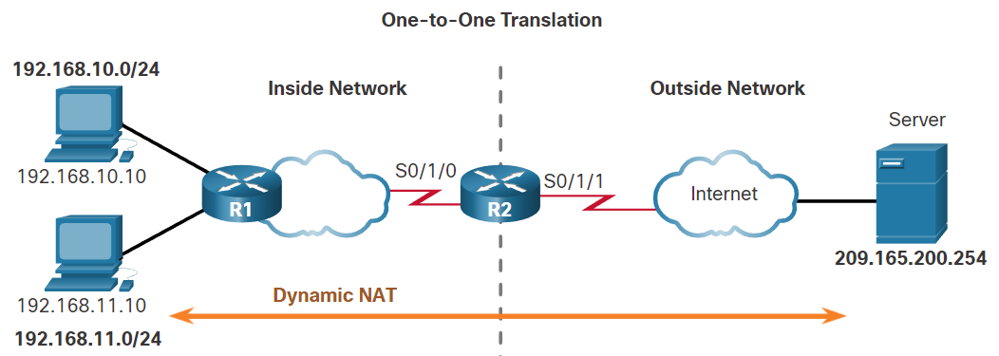

* + The example topology shown in the figure has an inside network using addresses from the RFC 1918 private address space. Attached to router R1 are two LANs, 192.168.10.0/24 and 192.168.11.0/24. Router R2, the border router, is configured for dynamic NAT using a pool of public IPv4 addresses 209.165.200.226 through 209.165.200.240.
  + The pool of public IPv4 addresses (inside global address pool) is available to any device on the inside network on a first-come first-served basis. With dynamic NAT, a single inside address is translated to a single outside address. With this type of translation there must be enough addresses in the pool to accommodate all the inside devices needing concurrent access to the outside network. If all addresses in the pool are in use, a device must wait for an available address before it can access the outside network.
  + Note: Translating between public and private IPv4 addresses is by far the most common use of NAT. However, NAT translations can occur between pair of IPv4 addresses.
* Configure Dynamic NAT:
  + - Step 1: Define the pool of addresses that will be used for translation using the **ip nat pool** command. This pool of addresses is typically a group of public addresses. The addresses are defined by indicating the starting IPv4 address and the ending IPv4 address of the pool. The netmask or prefix-length keyword indicates which address bits belong to the network and which bits belong to the host for that range of addresses.



* + Step 2: Configure a standard ACL to identify (permit) only those addresses that are to be translated. An ACL that is too permissive can lead to unpredictable results. Remember there is an implicit deny all statement at the end of each ACL.



* + Step 3: Bind the ACL to the pool, using the following command syntax:
    - Router(config)# **ip nat inside source list *{access-list-number | access-list-name}* pool *pool-name***



* + Step 4: Identify which interfaces are inside, in relation to NAT; this will be any interface that connects to the inside network.

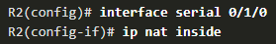

* + Step 5: Identify which interfaces are outside, in relation to NAT; this will be any interface that connects to the outside network.

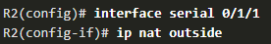

* Analyze Dynamic NAT – Inside to Outside:

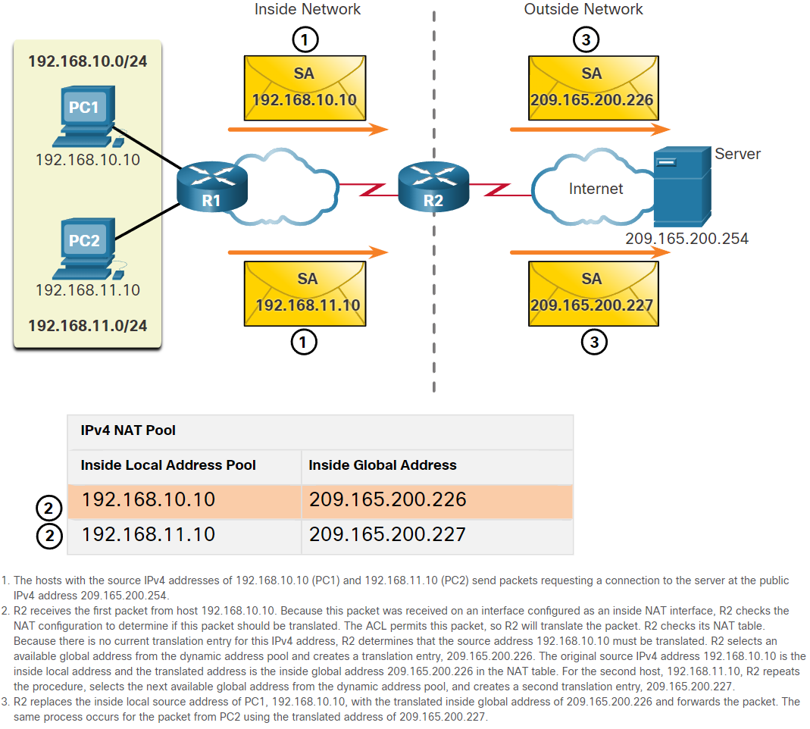

* Analyze Dynamic NAT – Outside to Inside:

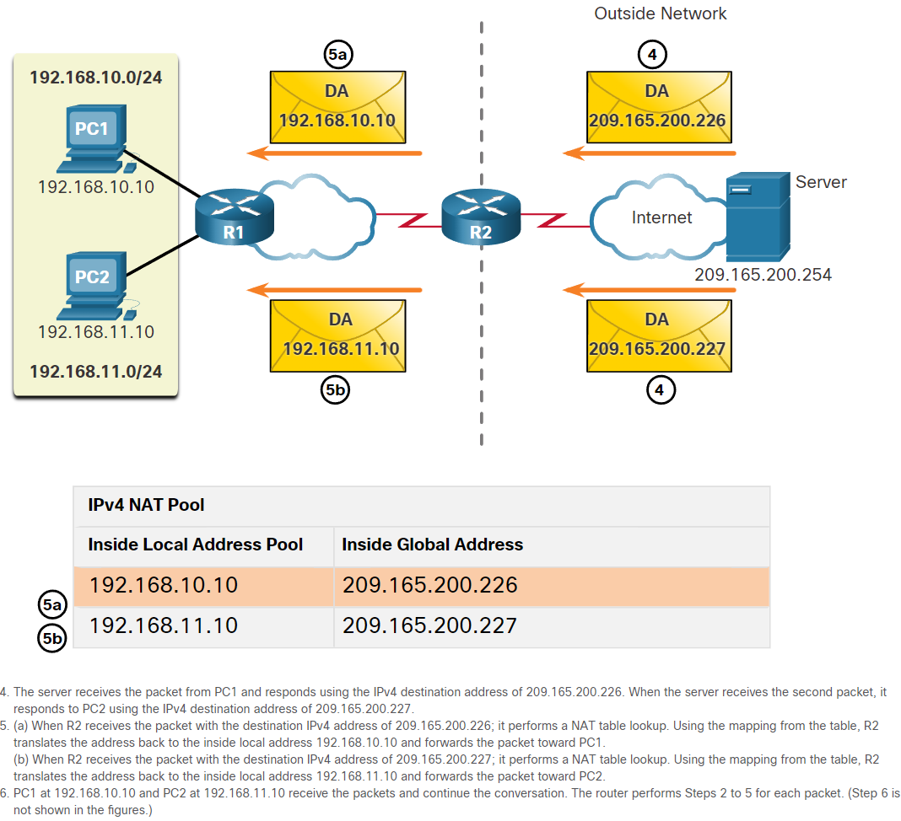

* Verify Dynamic NAT:
  + The output of the **show ip nat translations** command displays all static translations that have been configured and any dynamic translations that have been created by traffic.
  + Adding the **verbose** keyword displays additional information about each translation, including how long ago the entry was created and used.
  + By default, translation entries time out after 24 hours, unless the timers have been reconfigured with the **ip nat translation timeout *timeout-seconds*** command in global configuration mode.
  + To clear dynamic entries before the timeout has expired, use the **clear ip nat translation** privileged EXEC mode command

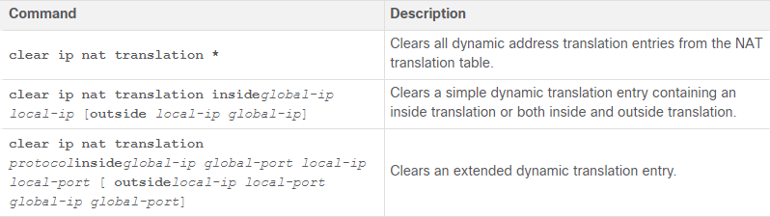

* + Note: Only the dynamic translations are cleared from the table. Static translations cannot be cleared from the translation table.
  + Another useful command, **show ip nat statistics**, displays information about the total number of active translations, NAT configuration parameters, the number of addresses in the pool, and how many of the addresses have been allocated.
  + **Show running-config**

## 6.6 – PAT

* PAT Scenario:
  + There are two ways to configure PAT, depending on how the ISP allocates public IPv4 addresses. In the first instance, the ISP allocates a single public IPv4 address that is required for the organization to connect to the ISP and in the other, it allocates more than one public IPv4 address to the organization.

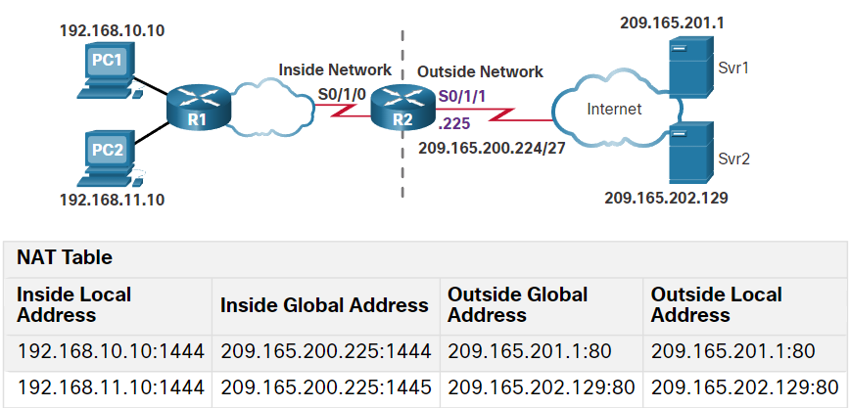

* Configure PAT to use a Single IPv4 Address:
  + To configure PAT to use a single IPv4 address, simply add the keyword **overload** to the **ip nat inside source** command. The rest of the configuration is the similar to static and dynamic NAT configuration except that with PAT, multiple hosts can use the same public IPv4 address to access the internet.
  + In the example, all hosts from network 192.168.0.0/16 (matching ACL 1) that send traffic through router R2 to the internet will be translated to IPv4 address 209.165.200.225 (IPv4 address of interface S0/1/1). The traffic flows will be identified by port numbers in the NAT table because the overload keyword is configured.

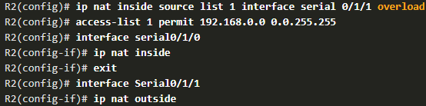

* Configure PAT to use an Address Pool:
  + An ISP may allocate more than one public IPv4 address to an organization. In this scenario the organization can configure PAT to use a pool of IPv4 public addresses for translation.
  + If a site has been issued more than one public IPv4 address, these addresses can be part of a pool that is used by PAT. The small pool of addresses is shared among a larger number of devices, with multiple hosts using the same public IPv4 address to access the internet. To configure PAT for a dynamic NAT address pool, simply add the keyword **overload** to the **ip nat inside source** command.

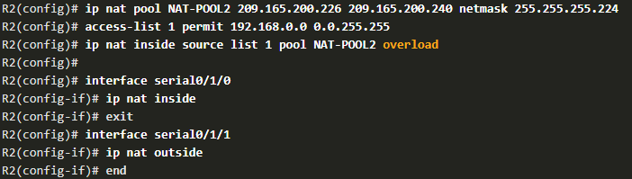

* + In the example, NAT-POOL2 is bound to an ACL to permit 192.168.0.0/16 to be translated. These hosts can share an IPv4 address from the pool because PAT is enabled with the keyword overload.
* Analyze PAT - PC to Server:

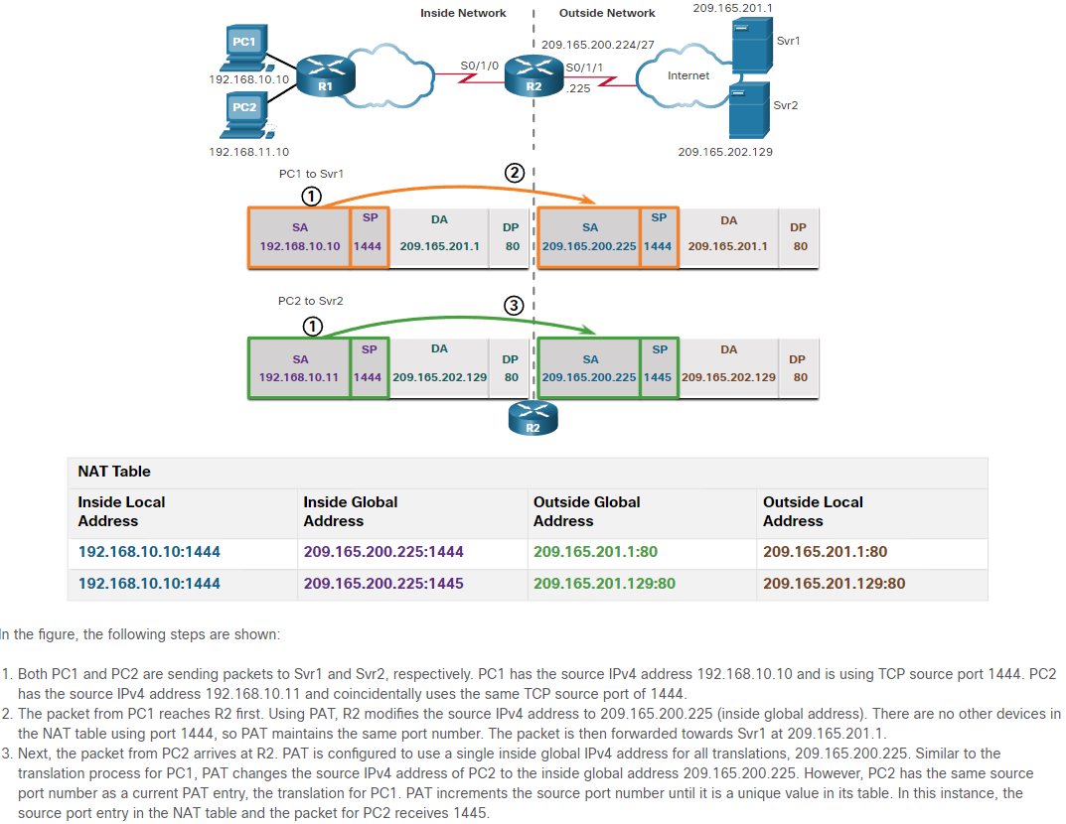

* + The process of NAT overload is the same whether a pool of addresses is used, or a single address is used.
* Analyze PAT - Server to PC:

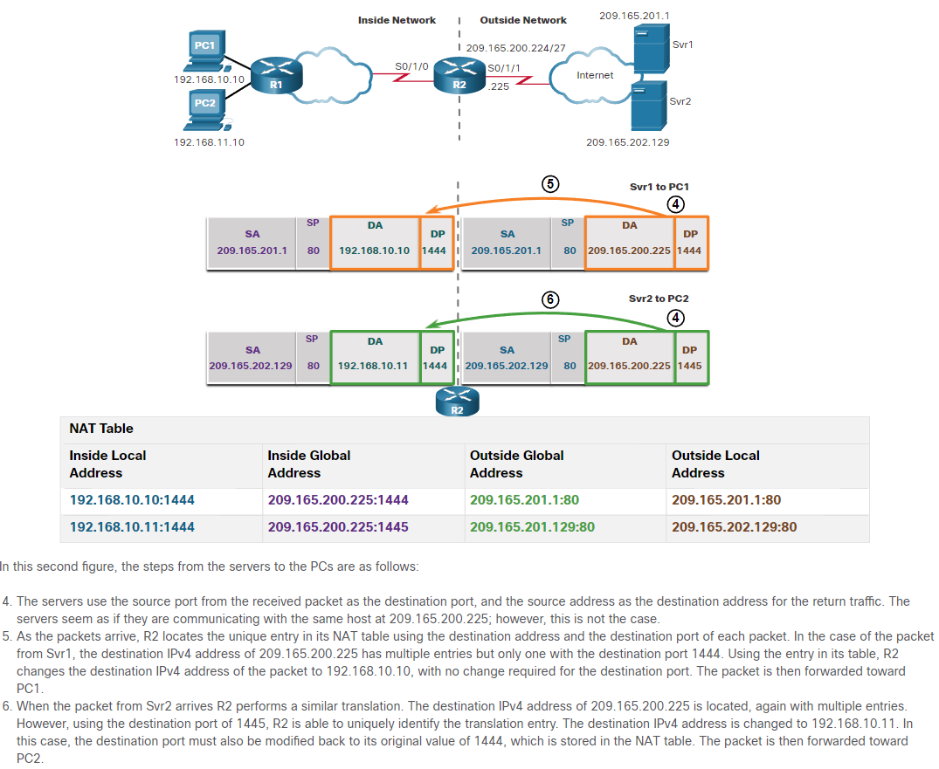

* Verify PAT:
  + The same commands used to verify static and dynamic NAT are used to verify PAT, as shown in the example output. The **show ip nat translations** command displays the translations from two different hosts to different web servers.
  + The **show ip nat statistics** command verifies that NAT-POOL2 has allocated a single address for both translations. Included in the output is information about the number and type of active translations, NAT configuration parameters, the number of addresses in the pool, and how many have been allocated.

## 6.7 - NAT64

* NAT for IPv6?
  + Because many networks use both IPv4 and IPv6, there needs to be a way to use IPv6 with NAT.
  + IPv6, with a 128-bit address, provides 340 undecillion addresses. Therefore, address space is not an issue. IPv6 was developed with the intention of making NAT for IPv4 with translation between public and private IPv4 addresses unnecessary. However, IPv6 does include its own IPv6 private address space, unique local addresses (ULAs).
  + IPv6 unique local addresses (ULA) are similar to RFC 1918 private addresses in IPv4 but have a different purpose. ULA addresses are meant for only local communications within a site. ULA addresses are not meant to provide additional IPv6 address space, nor to provide a level of security.
  + IPv6 does provide for protocol translation between IPv4 and IPv6 known as NAT64.
* NAT64:
  + NAT for IPv6 is used in a much different context than NAT for IPv4. The varieties of NAT for IPv6 are used to transparently provide access between IPv6-only and IPv4-only networks, as shown in the figure. It is not used as a form of private IPv6 to global IPv6 translation.

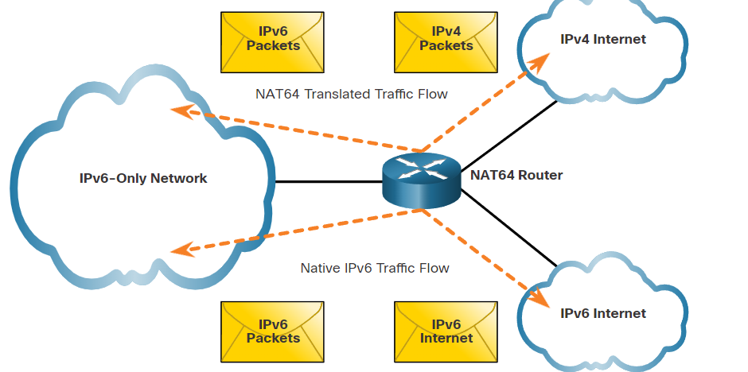

* + Ideally, IPv6 should be run natively wherever possible. This means IPv6 devices communicating with each other over IPv6 networks. However, to aid in the move from IPv4 to IPv6, the IETF has developed several transition techniques to accommodate a variety of IPv4-to-IPv6 scenarios, including dual-stack, tunneling, and translation.
  + Dual-stack is when the devices are running protocols associated with both IPv4 and IPv6. Tunneling for IPV6 is the process of encapsulating an IPv6 packet inside an IPv4 packet. This allows the IPv6 packet to be transmitted over an IPv4-only network.
  + NAT for IPv6 should not be used as a long-term strategy, but as a temporary mechanism to assist in the migration from IPv4 to IPv6. Over the years, there have been several types of NAT for IPv6 including Network Address Translation-Protocol Translation (NAT-PT). NAT-PT has been deprecated by IETF in favor of its replacement, NAT64. NAT64 is beyond the scope of this curriculum.